Table 1. Descriptive statistics of the analytical sample, all 13 included countries pooled.

|  |  |  |  |  |  |  |  |
| --- | --- | --- | --- | --- | --- | --- | --- |
| Cohort |  | Survey wave, year | | | | | |
|  |  | Wave 1 | Wave 2 | Wave 4 | Wave 5 | Wave 6 | Wave 7 |
|  |  | 2004 | 2007 | 2011 | 2013 | 2015 | 2017 |
| 1940-1944 | Men (n) | 1757 | 2263 | 1588 | 1494 | 1463 | 1319 |
| Women (n) | 2031 | 2662 | 1846 | 1774 | 1769 | 1633 |
| Mean age (years) | 61.9 | 64.9 | 68.9 | 70.9 | 72.9 | 74.9 |
| ADL limitations (%) | 7.1 | 7.7 | 8.6 | 10.0 | 10.8 | 11.9 |
| IADL limitations (%) | 13.2 | 15.3 | 15.8 | 18.4 | 21.6 | 22.6 |
| 1935-1939 | Men (n) | 1634 | 2076 | 1383 | 1282 | 1267 | 1069 |
| Women (n) | 1788 | 2231 | 1520 | 1455 | 1451 | 1261 |
| Mean age (years) | 66.9 | 69.9 | 73.9 | 75.9 | 77.9 | 79.9 |
| ADL limitations (%) | 6.9 | 9.6 | 14.0 | 15.9 | 17.6 | 19.5 |
| IADL limitations (%) | 17.6 | 21.0 | 25.3 | 28.5 | 34.1 | 40.7 |
| 1930-1934 | Men (n) | 1269 | 1585 | 1038 | 953 | 859 | 693 |
| Women (n) | 1442 | 1759 | 1169 | 1117 | 1087 | 865 |
| Mean age (years) | 71.9 | 74.9 | 78.9 | 80.9 | 82.8 | 84.8 |
| ADL limitations (%) | 11.6 | 15.3 | 22.0 | 23.5 | 27.0 | 30.8 |
| IADL limitations (%) | 24.7 | 31.8 | 35.8 | 43.2 | 48.9 | 56.0 |
| 1925-1929 | Men (n) | 870 | 1013 | 591 | 475 | 390 | 265 |
| Women (n) | 1127 | 1331 | 863 | 746 | 666 | 464 |
| Mean age (years) | 76.9 | 79.9 | 83.8 | 85.7 | 87.7 | 89.7 |
| ADL limitations (%) | 16.7 | 21.8 | 30.1 | 36.1 | 43.8 | 46.1 |
| IADL limitations (%) | 31.5 | 38.6 | 48.0 | 56.8 | 66.7 | 71.8 |
| 1920-1924 | Men (n) | 464 | 520 | 256 | 189 | 133 | 69 |
| Women (n) | 682 | 760 | 383 | 302 | 218 | 136 |
| Mean age (years) | 81.7 | 84.7 | 88.6 | 90.5 | 92.4 | 94.3 |
| ADL limitations (%) | 27.1 | 33.8 | 48.6 | 54.0 | 56.0 | 61.8 |
| IADL limitations (%) | 43.8 | 53.0 | 70.5 | 70.5 | 77.5 | 80.1 |

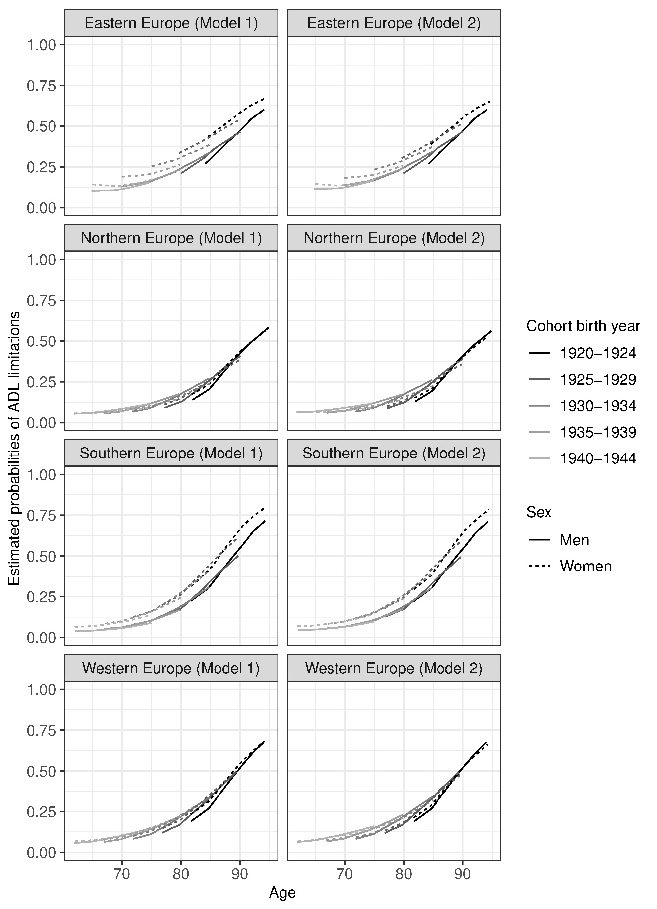

Figure 1. Estimated Probabilities of ADL limitations in European regions, 2004 – 2017 without (Model 1) and with adjustments for education and income (Model 2). Estimated from mixed effects logistic regression models, see Supplementary tables 1-10.

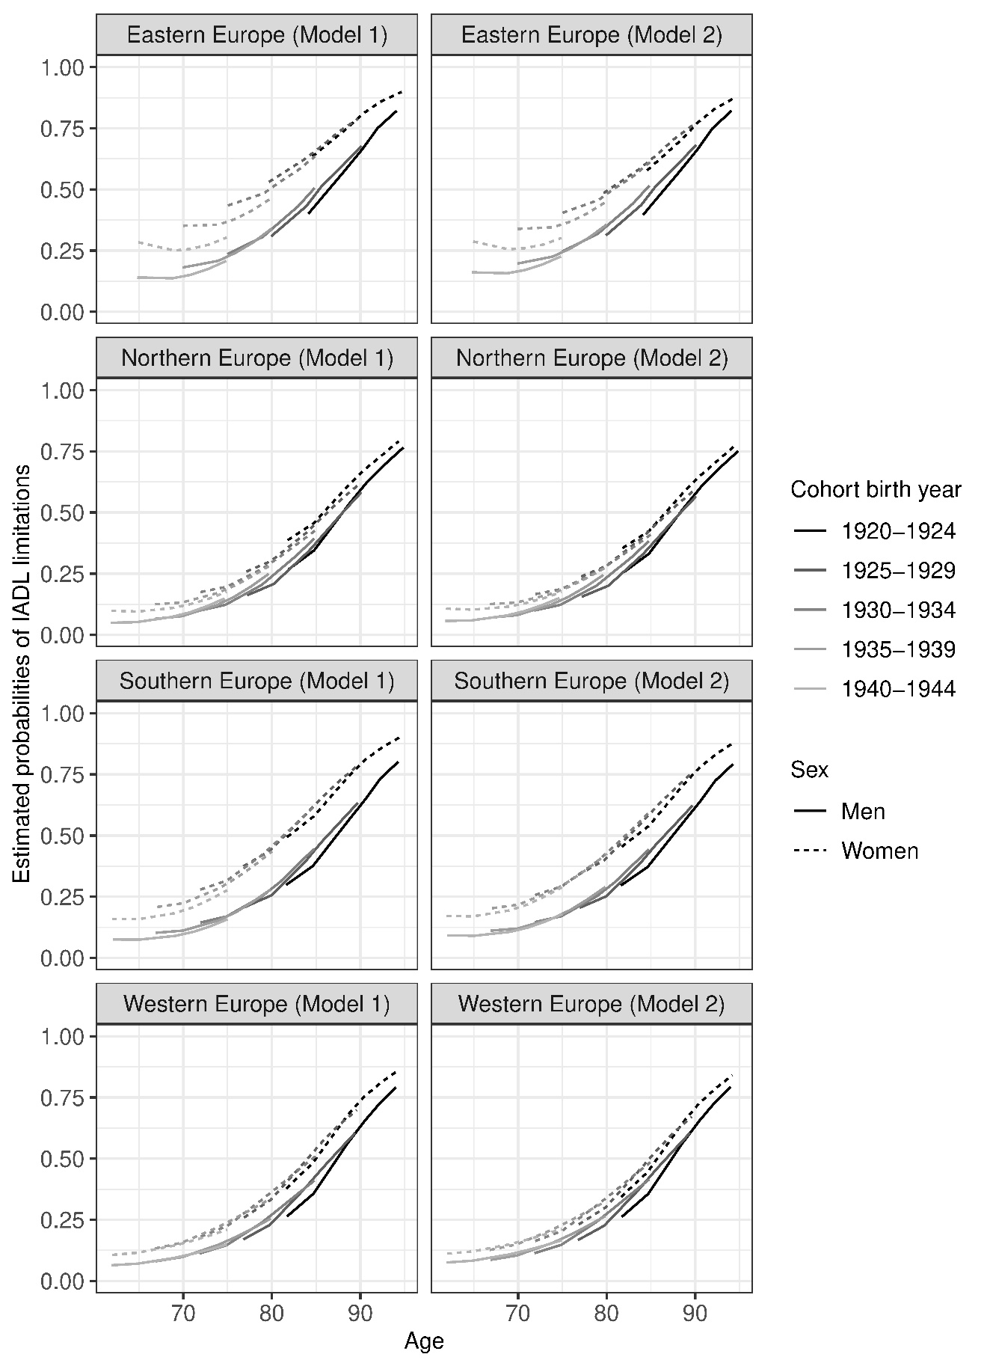

Figure 2. Estimated Probabilities of ADL limitations in European regions, 2004 – 2017 without (Model 1) and with adjustments for education and income (Model 2). Estimated from mixed effects logistic regression models, see Supplementary tables 11-18.