**Title:** Gendered cohort trajectories for informal caregiving in Europe between 2004 and 2015

**Authors:** Ricardo Rodrigues*1, Johan Rehnberg2,3, Cassandra Simmons1, Stefania Ilinca1, Eszter Zólyomi1, Afshin Vafaei5,6, Selma Kadi1, Janet Jull4, Afshin Vafaei5,6, Susan Phillips5,6, Stefan Fors2,7

*Corresponding author

Ricardo Rodrigues

rodrigues@euro.centre.org, European Centre for Social Welfare Policy & Research, Berggasse 17, 1090 Vienna, Austria.

1 European Centre for Social Welfare Policy & Research, Vienna, Austria.

2 Aging Research Center, Karolinska Institutet & Stockholm University, Stockholm, Sweden.

3 Department of Public Health Sciences, Stockholm University, Stockholm, Sweden.

4 School of Rehabilitation Therapy, Queen’s University, Kingston, Canada.

5 Department of Public Health Sciences, Queen’s University, Kingston, ON, Canada.

6 Department of Family Medicine, Queen’s University, Kingston, ON, Canada.

7 Center for Epidemiology and Community Medicine, Region Stockholm, Stockholm, Sweden.

**Abstract**

**Background and research questions**

Evolving societal trends such as changing gender norms and increasing labour participation of women in the labour market have often been portrayed as factors endangering informal caregiving in the face of population ageing. Relatively less attention has been paid to the possibility that some evolving gender norms will lead to a higher share of men providing informal care, resulting in a more egalitarian division of unpaid care. This paper aims to take a dynamic time view on gender patterns in informal caregiving for older people across Europe to answer the following research questions: is caregiving becoming more gender equal across cohorts in Europe? Are sex/gender cohort trajectories of informal caregiving differentiated across care regimes?

**Methods**

We apply multilevel growth curve models to a panel sample of individuals aged 50 and older, grouped into 5 year cohorts and followed across 5 waves of the Survey of Health, Ageing and Retirement in Europe (SHARE), stratified by sex/gender and adjusted for education, employment, living arrangements, chronic health conditions and self-rated health.

**Results and discussion**

**Introduction**

Pervasive gender inequalities have long characterized the provision of informal care to older adults. Women are not only being more likely to provide informal care (OECD, 2011; Rodrigues et al. 2013), but also more likely to provide intensive care and experience higher levels of burden as a result (Penning & Wu, 2016; Pinquart & Sörensen, 2006). The exception to this has been spousal care, where the gender gap in caregiving is smaller as older retired men being more likely to provide informal care to their spouses (Dahlberg, Demack & Bambra 2007; Kahn, McGill & Bianchi 2011; Patterson & Margolis, 2019). The gender gap in informal caregiving has been linked to gendered norms of familial obligation that impose an expectation of altruism from women in the form of care responsibilities or portray women as nurturers and caregivers (Badgett & Folbre, 1999). Other suggested explanations point to economic reasons. Gender employment and pay gaps leave women more likely to take on a caring role out of their availability of time (Arber & Ginn, 1995) and/or lower opportunity cost to provide care (Carmichael, Charles and Hulme 2010; Heitmueller, 2007).

Over the past decades, a number of socio-demographic trends have raised the prospect of a reduction in the supply of informal care, particularly by women, which could result in a shortage of care at a time where the population is ageing and prevalence of cognitive and physical impairment do not show signs of abating (Agree & Glaser 2009; WHO, 2007; OECD, 2011a, Ahrenfeldt et al., 2018). For men, the impact of some of these changes is apparently less straightforward, resulting in an ambiguous effect on the gender gap in informal caregiving. However, apart from some studies focusing on the availability of potential carers (cf. Ryan et al. 2012, Suanet et al. 2013), there is a dearth of evidence on how gender patterns in informal caregiving for older people are evolving across Europe. This is a gap this study aims to address.

The past decades have witnessed an increasing rate of women participating in the labour market, which is suspected to reduce the availability of women to provide informal care (OECD, 2011). In fact, a number of studies find that paid employment has a negative impact on informal caregiving (Carmichael, Charles & Hulme, 2010; He & McHenry, 2016). The extension of working lives resulting from the postponement of the statutory retirement age in some countries may have also reduced available time for providing informal care (Rodrigues & Ilinca 2021). These effects seem to be more pronounced among women.

Shifting gender norms and societal expectations may also play a role in the provision of informal care, with a direct impact on the gender care gap. Recent studies have confirmed that attitudes concerning gender roles and the division of labour have shifted from “traditional”, meaning care provided by women, to more egalitarian and therefore gender balanced across European countries (Knight & Brinton, 2017). The renegotiation of gender roles, namely through the increased labour market participation of women and increased role of men in childcare and housework (Altintas & Sullivan, 2017; Sullivan 2004), may have also transferred to the realm of elder care, leading to a reduction in informal older care by women, and simultaneously an increase in care provided by men.

Other societal and demographic changes are more ambiguous in their impact on gender inequalities in informal caregiving. For example, a decline in marriage and increase in divorce (ONS, 2017) may have resulted in decreased availability of spousal care in later age by men. This may be counterbalanced, however, by the increased cohabitation witnessed in the past decades (OECD, 2011b; Brown & Wright 2017). Similarly, the gender gap in life expectancy has steadily diminished (HMD 2015) and although there is no sign of abating age hypergamy – i.e. men being older than their partners – over time (Wilson & Smallwood, 2008), this may translate into higher availability of men to provide spousal care in older age groups. Increasing divorce rates may impact gendered caregiving in other ways. Divorces typically occur in earlier life stages, and as such they may have unencumbered women from the obligation to provide intergenerational care for in-laws..

The overarching impact of these societal changes, i.e. whether men and/or women have decreased/increased their provision of care and whether the resulting gender care gap is widening or narrowing, remains, however, ambiguous and understudied (cf. Ryan et al. 2012). In fact, some of these trends may have directly decreased the availability of women to provide care, leaving room for care responsibilities to shift to men. At the same time, despite a shift to more egalitarian attitudes towards gender roles over the last decades, persisting gender norms may result in the care burden still falling on women, requiring them to reconcile care and employment. A general reduction in availability of informal care may reinforce the societal expectation of women as care providers, therefore increasing the proportion of women providing care.

Paramount to the discussion of gender inequalities in informal caregiving in Europe are the institutions and systems in which care decisions are made. More specifically, gendered expectations of care responsibilities may be reinforced by social benefits provided by the state and these vary considerably across European countries (Leitner 2003; Schmid, Brandt and Haberkern 2012). For example, in the Nordic countries, public support for those in need of care mainly takes the form of benefits (i.e. care services) and social policies as a whole are structured to prioritize gender equality, while in Southern Europe limited care service provision alongside low female labour market participation rates reinforce the family, and more specifically women, as the default caregiving option (Bettio & Plantenga 2004; Earles, 2011). The expectation of the family to primarily provide care with some public support for these responsibilities (i.e. cash-for-care) in the Continental cluster (e.g. in Austria and Germany) has placed this group of countries somewhere in the middle of the Nordic and Southern care regimes in terms of gendered equality in informal care (Bettio & Plantenga 2004; Schmid, Brandt & Haberkern 2012; Hammer & Österle 2003).

The past decades have witnessed changes in the availability and affordability of formal care options across care regimes. Countries in Continental Europe have expanded the provision of formal care, while the Northern cluster has simultaneously reduced coverage for low levels of care needs as part of cost containment measures (Ranci & Pavolini, 2015; Szebehely & Trydegard 2012). In view of the substitutability of formal and informal care for these lower levels of care (Bonsang, 2009; Balia & Brau 2013), welfare retrenchment may have been compensated for by an increase in informal care. Cash benefits have also expanded across a number of countries over the last decades, with a view of allowing informal carers to be compensated for their work (Zigante 2018; Spasova et al. 2018). Given what is known about the impact of limited care services and availability of cash benefits (Ungerson & Yeandle,2007), the effect of these policy changes is likely to have been differentiated across gender lines.

This study has therefore two main research questions. The first one is whether there has been an evolution in the gender gap in informal caregiving in light of the societal changes mentioned above, and if so, whether this evolution is due to changes in informal caregiving by women and/or men. Based on the variation of care policies and how they have evolved across European countries, our second research question is whether the gender gap in informal caregiving has evolved differently across care regimes.

**Data and methods**

*Sample*

Data was extracted from all panel waves of the Survey of Health, Ageing and Retirement in Europe (SHARE) that included information on support and informal care in the community – i.e. waves 1, 2, 4, 5 and 6, collected in 11 European countries between 2004 and 2015. We included countries that participated in at least three waves, including wave 1 or wave 2, with the exception of Poland and the Czech Republic due to sample sizes. We maintained in the analytical sample only those individuals who entered the SHARE sample in the first wave (collected in 2004), were aged 50 or over at the time of the first interview, who participated in at least one subsequent panel wave and who provided valid responses for all outcome and control variables.

The individuals who fulfilled the inclusion criteria were grouped into 6 birth cohorts, spanning 5-year intervals for those born between 1930 and 1954. To ensure sufficient sample size for the analysis, the oldest birth cohort included all individuals born before 1929. In order to carry out regional analyses while maintaining sufficiently large samples to ensure robustness, we further grouped individual observations into 3 country clusters that have been previously found to reflect similarities within those in the same group (Carrieri, Di Novi & Orso, 2017; Albertini & Pavolini. 2017):

* Continental (Austria, Germany, France, Switzerland, Belgium, Netherlands)
* Southern (Spain, Italy, Greece),
* Nordic (Sweden, Denmark)

The final analytic sample included 71 166 observations from 22 872 individuals, 39 470 of which belong to women (representing 55.5% of the sample) and 31 696 to men.

*Measures*

Provision of informal care was defined first of all as a binary variable, with positive responses for all survey respondents who reported i) having helped regularly with personal care, such as washing, getting out of bed, or dressing another person living in the same household and/ or ii) having given personal care or practical household help to a family member living outside their household, a friend or neighbor. Respondents who refused to respond or responded “I don’t know” for both questions were excluded. Specifying the main outcome variable in this way allowed us to capture provision of personal care and household helped over the twelve months preceding the interview, both within and between households. In our analysis, we also differentiated between provision of informal care inside and outside the household, defined as binary variables, taking the definitions outlined under points i) and ii) above respectively.

Additional covariates include self-reported health (categorical through a five-element Likert scale increasing in value: excellent, very good, good, fair, and poor) and number of chronic conditions (count variable). We further controlled for respondent highest educational achievement (categorical variable: primary, secondary, tertiary), current employment status (binary variable operationalized as having any type of employment as opposed to not being employed) and the presence of a partner living in the same household as the respondent (binary variable operationalized as living with partner or without one).

*Analytical strategy*

Our analytical strategy closely follows that by Marshall et al. (2015) for social networks, adapted to model cohort differences in providing informal care.

We first constructed mixed effects logistic regression models to estimate the probability of providing informal care. The model includes a random effect at the respondent level for each period or wave to account for individual heterogeneity and trajectories in providing informal care. All the other independent variables otherwise were entered into the model as fixed effects. This methodological approach affords us two advantages: 1) to account for the unbalanced nature of our panel as not all respondents have full information for all observed waves and 2) to account for individual-level variability in the decision to provide care. Failing to account for the latter point would result in biased standard errors. All models are specified to include a direct sex/gender effect, as well as interactions between sex/gender and cohort and time (measured as the elapsed calendar year since the first wave at the time of the interview), which allow for different slope estimates across cohort, time and sex/gender. We further include interaction terms between time and cohort and a quadratic term for time effects to capture non-linearity in individual slopes.

We estimate both unadjusted models which capture the effects of time, cohort and sex/gender, and adjusted models which further account for a set of potential confounders, including the presence of a partner living in the household, health status and number of chronic conditions of the respondent, education attainment and employment status (cf. Suanet et al., 2013). The results are presented as average marginal effects (AME) for ease of interpretation across models and are calculated as the difference in estimated probabilities by gender over each cohort. To disentangle age and cohort effects, we additionally present graphs of the trajectories of providing care across sex/gender and cohort using predicted probabilities from the adjusted models described above, akin to the method taken in the health literature to measure disability trajectories in older age (Marshall et al. 2015; Rogers et al. 2017), in order to compare cohort differences across overlapping ages. Throughout the analysis, we use calibrated cross-sectional individual weights, calculated for the entire survey sample at the baseline wave in which each individual joined the sample. All analyses were performed using STATA version15.

**Results**

Table 1 presents selected sample characteristics between waves 1 and 6 (2004 to 2015). The probability to provide informal care is higher for both women and men in later born cohorts, which are also on average younger. Compared with men, women have a higher probability of providing informal care for the three later born cohorts (1950-54, 1945-49 and 1940-49) across nearly all periods or waves considered. In the four earlier born cohorts, the prevalence of informal caregiving among men progressively surpasses that of women. In these same four cohorts, the overall prevalence of informal caregiving is lower for for both women and men in comparison to the later born cohorts.

[TABLE 1 HERE]

Table 2 presents changes in the estimated gender gap in informal caregiving across cohorts for the unadjusted model, as well for the model accounting for differences in employment, education, living arrangements and health (adjusted model) across cohorts. In the unadjusted model, women are more likely to provide informal care among cohorts born in or after 1940. In the youngest / latest born cohort (1950-54), women had a 7.2 percentage point *higher* probability of providing care than men. For the earliest born cohort, the gender gap is the inverse and men are more likely to provide informal care than women. In the 1900-29 cohort, women had a 6.2 percentage point *lower* probability to provide care compared to men. Patterns of findings are identical for the adjusted model, although the size of the gender gap increases in absolute value for the later born cohorts in comparison with the unadjusted model. For the earliest age cohort (1900-29), on the contrary, the absolute size of the gender gap in caregiving (in this case favouring men) is much reduced in the adjusted model: the AME for women is reduced from -0.062 to -0.040.

[TABLE 2 HERE]

Figure 1, provides the graphic representation of the informal caregiving trajectories for each cohort over the 11 year period they are observed in our sample, for women and men separately. This graphic representation allows for a more concrete differentiation between cohort and age effects, by displaying predicted probabilities to provide informal care across overlapping age ranges for different cohorts. For women we observe limited differences between cohorts for overlapping age ranges, i.e. the probability to provide informal care does not seem to have changed significantly for women. For men, Figure 1 suggests that later born cohorts have a lower probability to provide informal care. The larger gender gaps among latter born cohorts seem thus to be driven by a reduction in men’s probability to provide informal care.

[FIGURE 1 HERE]

In the age ranges in which the cohorts born in 1940 or after were included in our sample, informal care is likely to be provided outside the household to older relatives, while in earlier born cohorts spousal care is much more relevant. Figures 2a and 2b present the informal caregiving trajectories for each cohort, disaggregated by type of informal care provided. For informal care provided outside the household (Figure 2a), we observe a steady decrease in its prevalence for later born cohorts for men and women. This decrease is more pronounced among men (i.e. the distance between cohort lines), particularly for the cohorts born between 1940 and 1949. There is therefore an increasing gender care gap in this type of care for later born cohorts. Conversely, the prevalence of informal care provided inside the household (Figure 2b) increases among later born cohorts for both men and women, without a clear effect on the gender gap.

[FIGURE 2a AND 2b HERE]

We evaluated the variations across different care regimes by running the final adjusted model separately for the three types of care regimes (Table 3). The Continental regime shows practically the same gender gap pattern as observed for the pooled sample of countries For the other two care regimes, the gender gap pattern is differentiated. For the Southern care regime, women are more likely to be informal carers in all cohorts with the exception of the two oldest ones (years). The gender care gap is particularly high among the latest born cohorts in this cluster. Still in Table 3, there is no evidence of a statistically significant gender care gap in the Northern cluster for any of the cohorts analysed. Figure 4 shows these same patterns graphically for age and cohort. In the Continental cluster, women are providing more informal care in later born cohorts, while for men there is no clear cohort trend. In the Southern care cluster, later born cohorts are less likely to provide informal care where age ranges between cohorts overlap. While this is observed for both women and men, it is more evident for the latter. For the Northern cluster there is no clear cohort trend for either women or men.

[TABLE 3 HERE]

[FIGURE 3 HERE]

**Discussion**

This study makes a novel contribution to the literature on informal caregiving and on gender inequalities in care by analysing gendered cohort trajectories of informal caregiving across Europe. We find that women were more likely to provide informal care than men among later born cohorts, while the reverse is observed among the earliest cohorts. These patterns hold after adjusting for changes in socio-economic conditions, health and living arrangements across cohorts, as well as for both care provided outside and inside the household.

We are able to further disentangle cohort and age effects, to ascertain whether the gender gap in informal caregiving has changed between cohorts over overlapping age ranges. For women, the probability to provide informal care has not changed significantly as a whole, but this masks contradictory trends across different types of care. While informal care outside the household became less prevalent, there was an increase in the prevalence of care provided to older people outside the household. For men, later born cohorts had a lower probability to provide informal across overlapping age ranges. The patterns we observe for informal care inside and outside the household are similar to women’s, albeit the decrease in care outside the household seems more pronounced for men. The gender care gap seems therefore to be widening among later born cohorts, driven by men’s lower probability to provide informal, particularly outside the household.

Findings also uncover dissimilar trends across different clusters of countries in Europe. After accounting for differences in socio-economic condition, health and living arrangements, women in the Continental care regimes were more likely to provide informal care in later born cohorts where age ranges overlap, resulting in a diminishing gender care gap. Among Southern European countries, later born cohorts are less likely to provide informal care, but this is especially the case for men, leading to a widening gender gap among later born cohorts. In the Northern cluster we find the least gender differences in prevalence of caregiving, particularly among later born cohorts.

The downward trend in the probability to provide care outside the household for women seems to confirm the, until now, untested propositions that societal changes such as increased education and employment would result in a lower availability of later born women to provide care. Indeed, there has been a steady increase in labour market participation of women, often as a result of increased incentives to postpone exit from the labour market due to retirement (Fischer & Müller, 2020, Rodrigues & Ilinca, 2021). The fact that this downward trend is maintained and even amplified after accounting for these differences as it is observed only among care provided outside the household, may also indicate changing expectations or willingness to provide informal care among women who have come of age in a period marked by significant gender equality progress in a number of areas (Eurobarometer, 2007; OECD 2012). The possible impact of shifting gender norms deserves some qualification though, as the prevalence of informal care outside the household for men has not only failed to increase, but has actually reduced in our sample. Informal care therefore stands out in relation to other unpaid activities where men’s engagement has increased in the past decades (Evertsson & & Nermo, 2007; Bernhardt et al. 2009; Koslowski, 2011). Other possible explanations for this decline may also include changing patterns in the geographical proximity of kin-networks. A US-based study found that children of later born cohorts of older people had a higher likelihood of residing close by (Ryan et al., 2012). However, it is difficult to generalize these findings for Europe for which no comparable evidence exists to date.

The rekindling of informal care has been one of the underlying drivers of policy changes in the area of care for older people in Europe, even if care itself has gained prominence and been recognized as a new social risk (Ranci & Pavolini, 2015). Against this backdrop, the trends depicted in this study could also be viewed as the result of policy processes that have nonetheless resulted in an increased provision of care services, or at the very least of the means to outsource care from the family to the market (Le Bihan et al., 2019). In other words, the reduction in the prevalence of informal caregiving outside the household may actually point to an increased *de facto* de-familialization. The raising prevalence of care inside the household for both men and women seems to be mostly driven by demographics. As the gender differential in life expectancy has diminished, the share of older people living as couples has steadily increased in relation to those living alone (ONS, 2017), rendering care inside the household more available than before. Spousal care may also become more available as older people are able to age better (Ahrenfeldt et al., 2018).

This study relies on a large dataset with several points of data collection, providing sufficient power to analyse sex/gender differences even at higher age groups, while accounting for within cohort heterogeneity. Furthermore, data is collected for several European countries using harmonized measures and questionnaires to ensure comparability. One remaining concern however, is the definition of informal caregiving inside the household, which in SHARE is limited to personal care. This could under-estimate the prevalence of informal care inside the household. More central to the subject of our study is what this means to the gender care gap. On the latter the impact is not straightforward. By leaving out help with household tasks, which are predominantly carried out by women, the definition employed by SHARE would risk under-estimating women’s probability to provide care. This is still an under-research aspect however, and a study on the possible under-reporting of informal care in the English Longitudinal Study of Ageing (ELSA) actually found women to be less likely to under-report informal caregiving (Rutherford & Bu, 2017). Another potential limitation is the absence of care intensity from our analysis due to data limitations. Not only is the prevalence of high intensity care unequally distributed across sexes, with a higher concentration among women (Schmid, Brandt & Haberkern, 2012), but other studies have found that changes in the probability of providing informal do not necessarily match changes in intensity (Janus & Doty 2018; Rodrigues & Ilinca 2021). Nonetheless, our analytical strategy did differentiate between care inside and outside the household, therefore at least partially accounting for changes in care intensity as the former involves providing a higher number of hours of care. The response rate for the baseline of our study (i.e. wave 1 of SHARE), ranged between 36.4% and 92.7%. Non-respondents are likely to be a selected group in terms of a number of characteristics that correlate with informal caregiving, namely health and income, which may bias results. The longitudinal nature of this study and the sample exclusion criteria may further exacerbate this non-response bias. We used the calibrated cross-sectional weights provided by SHARE to account for selective non-response and minimize the impact of this non-response on the estimates. Furthermore, non-responses seem not to be systematically concentrated on particular regional clusters (see Appendix 1), thus minimizing their potential impact on the care regime analysis.

These findings have important policy implications. The fall in the prevalence of informal caregiving among later born cohorts providing care outside the household could indeed result in unmet needs among older people in need of care (Kalánková et al., 2021). Available data do not allow us to reasonably speculate whether reductions in the prevalence of informal caregiving are being completely offset by care inside the household or increased time devoted to care by fewer caregivers (Janus & Doty 2018), even though care inside the household is on average of higher intensity already. The raising relevance of care inside the household however, entails different needs and risks in terms of care support, not least of all given the potential for adverse outcomes that is associated with co-residing care (Schultz & Beach 1997; Burton, 2003) in a population that is itself becoming older [insert reference, maybe from before on care needs]. For example, a recent pan-European study found pervasive gender differences in how spousal care is provided, with women much more likely to be solo-caregivers (Bertogg & Strauss, 2020). The permanence of the gender gap in caregiving questions the effectiveness of policies aimed at achieving greater gender equality and seems to give credence to Goldscheider’s (2000) proposition that the realm of unpaid work carried out at home would lag behind in terms of gender parity. At the same time, the observed regional cluster differences, with the Nordic countries having achieved some modicum of gender equality in caregiving in later born cohorts, show the potential for public policies to achieve a more gender balanced provision of care in Europe.

**References**

Agree E.M., & Glaser, K. (2009) Demography of informal caregiving. In: Uhlenberg P (ed) International handbook of population aging, vol I. Springer, New York, pp 647–668

Badgett, M.V.L. & Folbre, N. (1999), Assigning care: Gender norms and economic outcomes. International Labour Review, 138: 311-326. https://doi.org/10.1111/j.1564-913X.1999.tb00390.x

Balia, S., and Brau, R. (2014), A country for old-men? Long-term home care utilization in Europe, Health Economics, 23: 1185– 1212, doi: 10.1002/hec.2977

Bettio, F. & Plantenga, J. (2004) Comparing Care Regimes in Europe, Feminist Economics, 10:1, 85-113, DOI: 10.1080/1354570042000198245

Bonsang, E. (2009). Does informal care from children to their elderly parents substitute for formal care in Europe?. Journal of health economics, 28(1), 143–154. https://doi.org/10.1016/j.jhealeco.2008.09.002

Brown, S. L., & Wright, M. R. (2017). Marriage, Cohabitation, and Divorce in Later Life. Innovation in aging, 1(2), igx015. https://doi.org/10.1093/geroni/igx015

Carmichael, F., Charles, S., & Hulme, C. (2010). Who will care? Employment participation and willingness to supply informal care. Journal of health economics, 29(1), 182–190. https://doi.org/10.1016/j.jhealeco.2009.11.003

Dahlberg, L., Demack, S., & Bambra, C. (2007). Age and gender of informal carers: a population-based study in the UK. Health & social care in the community, 15(5), 439–445. https://doi.org/10.1111/j.1365-2524.2007.00702.x

Earles, K. (2011), Swedish Family Policy – Continuity and Change in the Nordic Welfare State Model. Social Policy & Administration, 45: 180-193. https://doi.org/10.1111/j.1467-9515.2010.00763.x

Hammer, E., & Österle, A. (2003). Welfare State Policy and Informal Long-Term Care Giving in Austria: Old Gender Divisions and New Stratification Processes Among Women. Journal of Social Policy, 32(1), 37-53. doi:10.1017/S0047279402006888

Heitmueller, A. (2007). “The Chicken or the Egg? Endogeneity in Labour Market Participation of Informal Carers in England.” Journal of Health Economics 26(3): 536–59.

Kahn, J. R., McGill, B. S., & Bianchi, S. M. (2011). Help to Family and Friends: Are There Gender Differences at Older Ages?. Journal of marriage and the family, 73(1), 77–92. https://doi.org/10.1111/j.1741-3737.2010.00790.x

Knight, C.R. & Brinton M.C. (2017) One Egalitarianism or Several? Two Decades of Gender-Role Attitude Change in Europe. American Journal of Sociology, 122(5), 1485- 1532. https://doi.org/10.1086/689814

Leitner, S. (2003) Varieties of familialism: The caring function of the family in comparative perspective, European Societies, 5:4, 353-375, DOI: 10.1080/1461669032000127642

OECD (2011a), “Informal carers”, in Health at a Glance 2011: OECD Indicators, OECD Publishing, Paris. DOI: https://doi.org/10.1787/health_glance-2011-70-en

OECD (2011b), "Families are changing", in Doing Better for Families, OECD Publishing, Paris, https://doi.org/10.1787/9789264098732-3-en.

Rodrigues, R., Schulmann, K., Schmidt, A., Kalavrezou, N., & Matsaganis. M. (2013), The indirect costs of long-term care. Brussels, DG Employment, Social Affairs & Inclusion (Research note 8).

Patterson, S. E., & Margolis, R. (2019). The Demography of Multigenerational Caregiving: A Critical Aspect of the Gendered Life Course. Socius. https://doi.org/10.1177/2378023119862737

Penning M. J., Wu Z. (2016). Caregiver stress and mental health: Impact of caregiving relationship and gender. The Gerontologist, 56, 1102–1113. doi:10.1093/geront/gnv038

Pinquart, M., & Sörensen, S. (2006). Gender differences in caregiver stressors, social resources, and health: an updated meta-analysis. The journals of gerontology. Series B, Psychological sciences and social sciences, 61(1), P33–P45. https://doi.org/10.1093/geronb/61.1.p33

Rodrigues, R., & Ilinca, S. (2021). How does she do it all? Effects of education on reconciliation of employment and informal caregiving among Austrian women. Soc Policy Adm. 1– 19. https://doi.org/10.1111/spol.12706

Ryan L.H., Smith J., Antonucci T.C., & Jackson J.S. (2012). Cohort differences in the availability of informal caregivers: are the Boomers at risk? Gerontol 52:177–188. https://doi.org/10.1093/geront/gnr142.

Schmid, T., Brandt, M. & Haberkern, K. (2012). Gendered Support to Older Parents: Do Welfare States Matter? European Journal of Ageing, 9(1), 39-50.

Spasova, S., Baeten, R., Coster, S., Ghailani, D., Peña-Casas, R., & Vanhercke, B. (2018) Challenges in long-term care in Europe. A study of national policies, European Social Policy Network (ESPN), European Commission

Ungerson, C., & Yeandle, S. (2007) Conclusion: dilemmas, contradiction and changes. In: Ungerson, C., Yeandle, S. (eds) Cash for Care in Developed Welfare State. London: Palgrave Macmillan, 187–206.

WHO (2007). *Women, ageing and health: a framework for action: focus on gender.* Geneva: World Health Organization

Zigante, V. (2018). Informal care in Europe: Exploring Formalisation, Availability and Quality. Brussels, European Commission: Directorate-General for Employment, Social Affairs and Inclusion.

Table 1. Descriptive statistics of the analytical sample for 11 European countries, 2004-15

|  |  |  |  |  |  |  |
| --- | --- | --- | --- | --- | --- | --- |
| Cohort |  | Survey wave, year | | | | |
|  |  | Wave 1 | Wave 2 | Wave 4 | Wave 5 | Wave 6 |
|  |  | 2004 | 2007 | 2011 | 2013 | 2015 |
| 1950-1954 | Men (n) | 1390 | 1829 | 954 | 938 | 1297 |
|  | Women (n) | 1704 | 2236 | 1220 | 1216 | 1629 |
|  | Mean age (years) | 52.3 | 54.9 | 59.1 | 61.1 | 63.1 |
|  | Gives care (% of males) | 45.0 | 40.5 | 40.04 | 40.3 | 37.2 |
|  | Gives care (% of females) | 48.5 | 49.0 | 46.0 | 46.1 | 40.5 |
| 1945-1949 | Men (n) | 1430 | 1996 | 1006 | 996 | 1395 |
|  | Women (n) | 1816 | 2322 | 1320 | 1302 | 1633 |
|  | Mean age (years) | 57.1 | 59.7 | 64.0 | 65.9 | 67.9 |
|  | Gives care (% of males) | 42.9 | 40.5 | 38.6 | 40.9 | 34.8 |
|  | Gives care (% of females) | 46.5 | 44.1 | 41.7 | 42.8 | 36.4 |
| 1940-1944 | Men (n) | 1304 | 1727 | 938 | 846 | 1187 |
| Women (n) | 1514 | 2023 | 1137 | 1088 | 1403 |
| Mean age (years) | 62.1 | 64.7 | 68.9 | 71.0 | 72.9 |
| Gives care (% of males) | 40.3 | 37.8 | 33.3 | 35.2 | 31.0 |
| Gives care (% of females) | 40.6 | 40.6 | 41.1 | 38.1 | 28.9 |
| 1935-1939 | Men (n) | 1136 | 1535 | 831 | 729 | 1014 |
| Women (n) | 1295 | 1681 | 966 | 919 | 1122 |
| Mean age (years) | 67.1 | 69.6 | 73.9 | 75.9 | 77.9 |
| Gives care (% of males) | 36.4 | 37.4 | 30.2 | 29.5 | 26.3 |
| Gives care (% of females) | 37.9 | 32.5 | 34.0 | 33.3 | 22.8 |
| 1930-1934 | Men (n) | 851 | 1228 | 618 | 552 | 682 |
| Women (n) | 1014 | 1304 | 808 | 746 | 832 |
| Mean age (years) | 72.1 | 74.6 | 78.9 | 80.9 | 82.8 |
| Gives care (% of males) | 32.3 | 27.3 | 27.5 | 25.2 | 20. 1 |
| Gives care (% of females) | 28.4 | 26.3 | 27.0 | 25.7 | 17.3 |
| 1900-1929 | Men (n) | 743 | 1143 | 574 | 427 | 400 |
| Women (n) | 1147 | 1612 | 1021 | 765 | 675 |
| Mean age (years) | 79.1 | 81.9 | 86.0 | 87.5 | 89.1 |
| Gives care (% of males) | 26.2 | 26.3 | 24.4 | 20.8 | 18.3 |
| Gives care (% of females) | 23.9 | 20.0 | 18.8 | 15.6 | 11.7 |

Notes: Non-weighted results.

Table 2: Average Marginal Effects (AMEs) for gender differences in providing informal care across cohorts for 11 European countries, 2004-15

|  |  |  |
| --- | --- | --- |
|  | AME for women | |
|  | Unadjusted model | Adjusted model |
| Cohort 1950-54 (0) | 0.072*** | 0.079*** |
| Cohort 1945-49 (1) | 0.061*** | 0.070*** |
| Cohort 1940-44 (2) | 0.027* | 0.042** |
| Cohort 1935-39 (3) | -0.008 | 0.016 |
| Cohort 1930-34 (4) | -0.014 | 0.004 |
| Cohort 1900-29 (5) | -0.062*** | -0.040** |
| No. obs. (no. groups) | 71166 (22872) | 71166 (22872) |
| Log-likelihood | -165100000 | -163700000 |

Notes: *p<0.05; **p<0.01;*** p<0.001.

Unadjusted model includes only gender, cohort and time, as well as interactions between these variables. Adjusted models include also as covariates partner living in the household, self-rated health, education, employment and no. of chronic conditions. Estimated using a mixed effects logistic regression model. Weighted results.

Table 3: Average Marginal Effects (AMEs) for gender differences in providing informal care across cohorts by care regime, for 2004-15

|  |  |  |  |
| --- | --- | --- | --- |
|  | AME for women | | |
|  | Adjusted model - Continental | Adjusted model - Southern | Adjusted model – Northern |
| Cohort 1950-54 (0) | 0.060** | 0.106*** | 0.005 |
| Cohort 1945-49 (1) | 0.044* | 0.098*** | -0.008 |
| Cohort 1940-44 (2) | 0.020 | 0.066** | -0.009 |
| Cohort 1935-39 (3) | -0.025 | 0.059** | -0.021 |
| Cohort 1930-34 (4) | -0.032 | 0.032 | -0.038 |
| Cohort 1900-29 (5) | -0.070** | -0.008 | -0.042 |
| No. obs. (no. groups) | 35136 (11148) | 21238 (7169) | 14792(4555) |
| Log-likelihood | -90001574 | -62306010 | -9917456.8 |

Notes: *p<0.05; **p<0.01; *** p<0.001.

Models adjusted for partner living in the household, self-rated health, education, employment and no. of chronic conditions. Estimated using a mixed effects logistic regression model. Continental includes Austria, France, Germany, Switzerland, Belgium; Southern includes Spain, Italy and Greece; Northern includes the Netherlands, Denmark and Sweden. Weighted results.

Figure 1: Estimated Probabilities of giving care, by gender in 11 European countries, 2004 – 15 (from adjusted mixed effects logistic regression models)



Notes: models adjusted for partner living in the household, self-rated health, education, employment and no. of chronic conditions. Predicted probabilities correspond to results estimated in Table 2 above. Weighted results.

Figure 2a: Estimated Probabilities of giving care outside the household, by gender in 11 European countries, 2004 – 15 (from adjusted mixed effects logistic regression models)

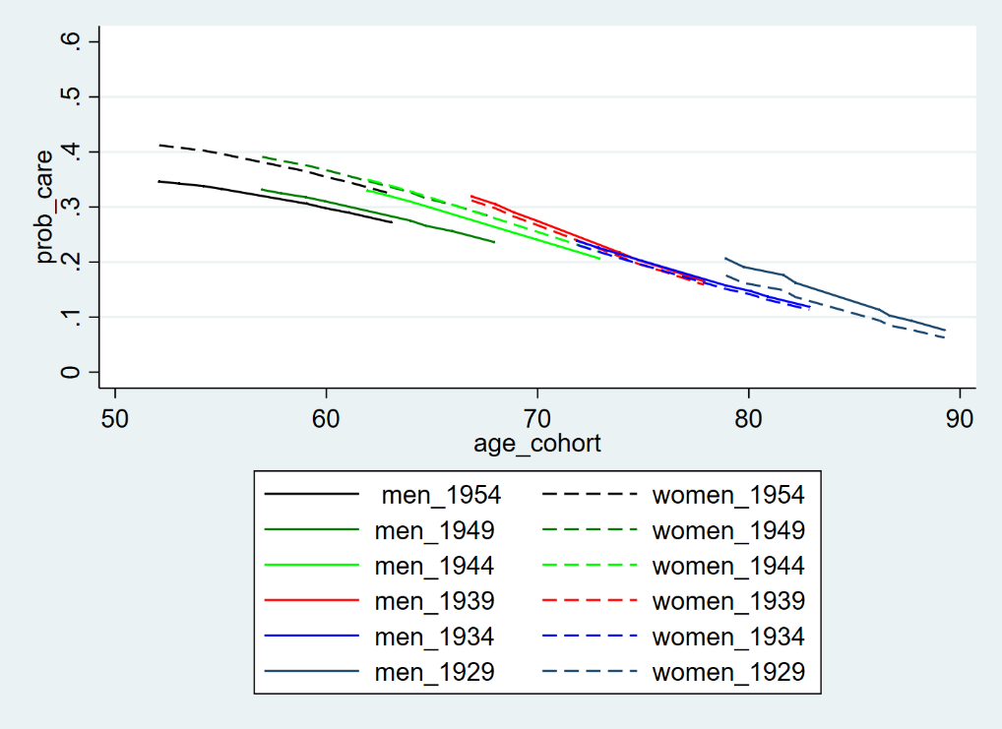

Notes: Models adjusted for partner living in the household, self-rated health, education, employment and no. of chronic conditions. Weighted results.

Figure 2b: Estimated Probabilities of giving care inside the household, by gender in 11 European countries, 2004 – 15 (adjusted mixed effects logistic regression models)

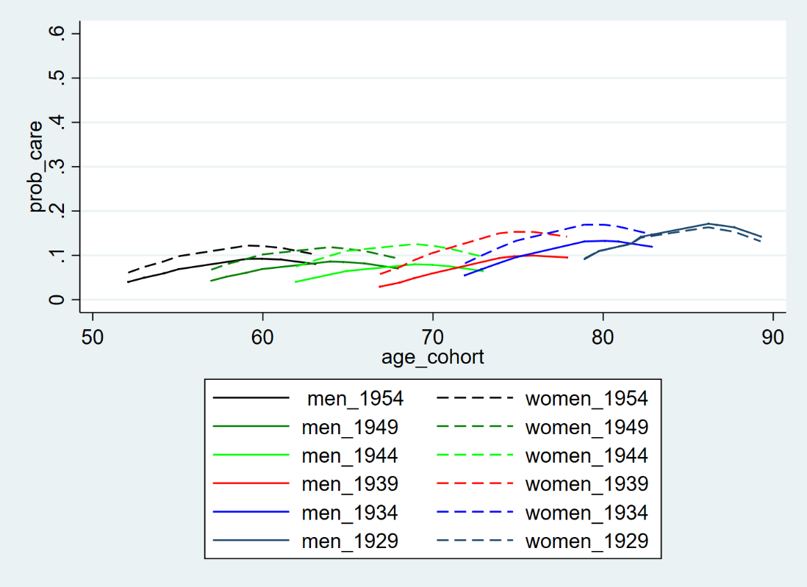

Notes: Models adjusted for partner living in the household, self-rated health, education, employment and no. of chronic conditions. Weighted results.

Figure 3: Estimated probabilities of giving care, by gender and care regime, 2004 – 15 (adjusted mixed effects logistic regression models)

|  |  |
| --- | --- |
| Continental care regime | Southern care regime |
|  |  |
| Northern care regime |  |
|  |  |

Notes: Models adjust for partner living in the household, self-rated health, education, employment and no. of chronic conditions. Continental includes Austria, France, Germany, the Netherlands, Switzerland, Belgium; Southern includes Spain, Italy and Greece; Northern includes Denmark and Sweden. Predicted probabilities correspond to results estimated in Table 3 above. Weighted results.

Appendix 1 – Individual response rates (in percentage) by country at baseline (wave 1)

|  |  |
| --- | --- |
| Country | Individual response rate (upper bound estimate) |
| Austria | 45.3 |
| France | 92.7 |
| Germany | 50.3 |
| Netherlands | 54.1 |
| Switzerland | 38.3 |
| Belgium | 36.4 |
| Spain | 37.9 |
| Italy | 43.7 |
| Greece | 63.6 |
| Denmark | 62.5 |
| Sweden | 45.5 |
| Total | 52.9 |

Source: Adapted from Bergman et al. (2019).