**Title:** Gendered cohort trajectories for informal caregiving in Europe between 2004 and 2015.

**Abstract**

**Background and research questions**

Evolving societal trends such as changing gender norms and increasing labour participation of women in the labour market have often been portrayed as factors endangering informal caregiving in the face of population ageing. Relatively less attention has been paid to the possibility that some evolving gender norms will lead to a higher share of men providing informal care, resulting in a more egalitarian division of unpaid care. This paper aims to take a dynamic time view on gender patterns in informal caregiving for older people across Europe to answer the following research questions: is caregiving becoming more gender equal across cohorts in Europe? Are sex/gender cohort trajectories of informal caregiving differentiated across care regimes?

**Methods**

We apply multilevel growth curve models to a panel sample of individuals aged 50 and older, grouped into 5 year cohorts and followed across 5 waves of the Survey of Health, Ageing and Retirement in Europe (SHARE), stratified by sex/gender and adjusted for education, employment, living arrangements, chronic health conditions and self-rated health.

**Results and discussion**

**Introduction**

Pervasive gender inequalities have long characterized the provision of informal care to older adults, with women not only being more likely to provide informal care (OECD, 2011; Rodrigues et al. 2013), but also more likely to provide intensive care and experience higher levels of burden as a result (Penning & Wu, 2016; Pinquart & Sörensen, 2006). The exception to this has been spousal care, where gender inequalities in older age diminish as the result of older retired men being more likely to provide informal care to their spouses (Dahlberg, Demack & Bambra 2007; Kahn, McGill & Bianchi 2011; Patterson & Margolis, 2019). These gender inequalities in informal caregiving have been linked to gendered norms of familial obligation that impose an expectation of altruism from women in the form of care responsibilities or portray women as nurturers and caregivers (Badgett & Folbre, 1999). Other suggested explanations point to economic reasons. Gender employment and pay gaps leave women more likely to take on a caring role out of their availability of time (Arber & Ginn, 1995) and/or lower opportunity cost to provide care (Carmichael, Charles and Hulme 2010; Heitmueller, 2007).

Over the past decades, a number of socio-demographic trends have raised the prospect of a reduction in the supply of informal care by women, threatening a shortage of care at a time where the population is ageing (Agree & Glaser 2009; WHO, 2007; OECD, 2011a). For men, the impact of some of these changes is less straightforward, thus resulting in an ambiguous effect on the gender gap in informal caregiving. The past decades have witnessed an increasing rate of women participating in the labour market, which is suspected to reduce the availability of women to provide informal care (OECD, 2011). In fact, a number of studies find that paid employment has a negative impact on informal caregiving (Carmichael, Charles & Hulme, 2010; He & McHenry, 2016). The extension of working lives resulting from the postponement of the statutory retirement age in some countries may have also reduced available time for providing informal care and this may have particularly affected women (Rodrigues & Ilinca 2021).

Shifting gender norms and societal expectations may also play a role. Recent studies have confirmed that attitudes concerning gender roles and the division of labour have shifted from traditional to more egalitarian across European countries (Knight & Brinton, 2017). The renegotiation of gender roles, namely through the increased labour market participation of women and increased role of men in childcare and housework (Altintas & Sullivan, 2017; Sullivan 2004), may have also transferred to the realm of elder care, leading to a reduction in informal older care by women, and simultaneously an increase in care provided by men.

Other societal and demographic changes are more ambiguous in their impact on gender inequalities in informal caregiving. A case in point is the decline in marriage and increase in divorce. This may have resulted in decreased availability of spousal care in later age, which is often carried out by men. As divorces typically occur in earlier life stages, however, they may have unencumbered women from the obligation to care for in-laws. The impact of these changes to marriage and divorce patterns may be counterbalanced however, by the increased cohabitation witnessed in the past decades (OECD, 2011b; Brown & Wright 2017). The gender gap in life expectancy has steadily diminished (HMD 2015) and although there is no sign of abating age hypergamy – i.e. men being older than their partners – over time (Wilson & Smallwood, 2008), this may translate into higher availability of men to provide spousal care in older age groups.

The overarching impact of these societal changes, i.e. whether men and/or women have decreased/increased their provision of care and whether the resulting gender gap is widening or narrowing, remains, however, ambiguous and understudied (cf. Ryan et al. 2011). In fact, some of these trends may have directly decreased the availability of women to provide care, leaving room for care responsibilities to shift to men. At the same time, despite a shift to more egalitarian attitudes towards gender roles over the last decades, persisting gender norms may result in the care burden still falling on women, requiring them to reconcile care and employment. A general reduction in availability of informal care may reinforce the societal expectation of women as informal care providers, therefore increasing the proportion of women providing care. The first research question we aim to answer is, therefore, whether there has been an evolution in the gender gap in informal caregiving in light of these societal changes, and if so, whether this evolution is due to changes in informal caregiving by women and/or men.

Paramount to the discussion of gender inequalities in informal caregiving are the institutions and systems in which care decisions are made. More specifically, gendered expectations of care responsibilities may be reinforced by social benefits provided by the state (Leitner 2003; Schmid, Brandt and Haberkern 2012). In the Nordic countries, where care services are generously provided by the public sector and other social policies strongly prioritize gender equality (i.e. those pertaining to labour market participation and childcare responsibilities), informal care is relatively gender-balanced (Bettio & Plantenga 2004; Earles, 2011). Conversely, limited care service provision in Southern Europe alongside low female labour market participation rates reinforce the family, and more specifically women, as the default care giving option (Bettio & Plantenga 2004). The expectation of the family to primarily provide care with some public support for these responsibilities (i.e. cash-for-care) in the Continental cluster ((France, Germany?) has placed this region somewhere in the middle of the Nordic and Southern care regime in terms of gendered equality in informal care (Bettio & Plantenga 2004; Schmid, Brandt & Haberkern 2012; Hammer & Österle 2003), as cash benefits tend to reinforce gender roles in care by disincentivizing women from taking up formal employment (Ungerson & Yeandle, 2007).

The past decades have witnessed changes in the availability and affordability of formal care options across care regimes. Countries in Continental Europe have expanded the provision of formal care, while the Northern cluster has simultaneously reduced coverage levels as part of cost containment measures (Pavoloni & Ranci, 2008; Szebehely & Trydegard 2012). To the extent that formal care services substitute for informal care, at least for lower levels of care needs requiring unskilled care (Bonsang, 2009; Balia & Brau 2013), reductions in the availability and affordability of formal care options may have been compensated for by an increase in informal care. The past decades have also witnessed changes to pension policies and other social protection measures favouring informal carers that may have increased the provision of informal care (Bergeot & Fontaine 2020, Rodrigues & Ilinca 2021; Spasova et al. 2018). Cash benefits have also expanded across a number of countries over the last decades, with a view of allowing informal carers to be compensated for their work (Zigante 2018; Spasova et al. 2018). Given what is known about the impact of limited care services and availability of cash benefits, the effect of these policy changes is likely to have been differentiated across gender lines. Based on the variation of changes in welfare policies and availability of formal care across European countries, our second research question is whether the gender gap in informal caregiving has evolved differently across care regimes.

**Data and methods**

*Sample*

Data was extracted from all panel waves of the Survey of Health, Ageing and Retirement in Europe (SHARE) that included information on support and informal care in the community – i.e. waves 1, 2, 4, 5 and 6, collected in 11 European countries between 2004 and 2015. We included countries that participated in at least three waves, including wave 1 or wave 2, with the exception of Poland and the Czech Republic due to sample sizes. We maintained in the analytical sample only those individuals who entered the SHARE sample in the first (collected in 2004) or second wave (collected in 2006), were aged 50 or over at the time of the first interview, who participated in at least one subsequent panel wave and who provided valid responses for all outcome and control variables.

The individuals who fulfilled the inclusion criteria were grouped into 6 birth cohorts, spanning 5-year intervals for those born between 1930 and 1954. To ensure sufficient sample size for the analysis, the oldest birth cohort includes all individuals born before 1929. In order to carry out regional analyses while maintaining sufficiently large samples to ensure robustness, we further grouped individual observations into 3 country clusters – reflecting well-established care regimes (Carrieri, Di Novi & Orso, 2017; Albertini & Pavolini. 2017):

* Continental (Austria, Germany, France, Switzerland, Belgium, Netherlands)
* Southern (Spain, Italy, Greece),
* Nordic (Sweden, Denmark)

The final analytic sample includes 71 166 observations from 22 872 individuals, 39 470 of which are women (representing 55.5% of the sample) and 31 696 are men.

*Measures*

Provision of informal care is defined first of all as a binary variable, with positive responses for all individuals who reported i) having helped regularly with personal care, such as washing, getting out of bed, or dressing another person living in the same household and/ or ii) having given personal care or practical household help to a family member living outside their household, a friend or neighbor. Individuals who refused to respond or responded “I don’t know” for both questions were excluded. Specifying the main outcome variable in this way allows us to capture provision of personal care and household helped over the twelve months preceding the interview, both within and between households. In our analysis, we further differentiate between provision of informal care inside and outside the household, defined once again as binary variables, taking the definitions outlined under points i) and ii) above respectively.

The health status of the responded is captured by control variables for self-reported health (categorical through a five-element Likert scale increasing in value: excellent, very good, good, fair, and poor) and number of chronic conditions (count variable). We further controlled for highest educational achievement (categorical variable: primary, secondary, tertiary), current employment status (binary variable operationalized as having any type of employment as opposed to not being employed) and the presence of a partner living in the same household as the respondent (binary variable operationalized as living with partner or without one).

*Analytical strategy*

Our analytical strategy closely follows that by Marshall et al. (2015) for frailty trajectories and Suanet et al. (2013) for social networks, repurposed to model cohort differences in providing informal care.

We first constructed mixed effects logistic regression models to estimate the probability of providing informal care. The model includes a random effect at the respondent level for each period or wave to account for individual heterogeneity and trajectories in providing informal care. All independent variables otherwise were entered into the model as fixed effects. This methodological approach affords us two advantages: 1) to account for the unbalanced nature of our panel and 2) to account for individual-level variability in the decision to provide care. Failing to account for the latter point would result in biased standard errors. All models are specified to include a direct sex/gender effect, as well as interactions between sex/gender and cohort and time (measured as the elapsed calendar year since the first wave at the time of the interview), which allow for different slope estimates across cohort, time and sex/gender. We further include interaction terms between time and cohort and a quadratic term for time effects to capture non-linearity in individual slopes.

We estimate both unadjusted models which capture the effects of time, cohort and sex/gender, and adjusted models which further account for a set of potential confounders, including the presence of a partner living in the household, health status and number of chronic conditions of the respondent, education attainment and employment status. The results are presented as average marginal effects (AME) for ease of interpretation across models and are calculated as the difference in estimated probabilities by gender over each cohort. We additionally present graphs of the trajectories of providing care across sex/gender and cohort using predicted probabilities from the adjusted models described above, akin to the method taken in the health literature to measure disability trajectories in older age (Marshall et al. 2015; Rogers et al. 2017), in order to compare cohort differences across overlapping ages. Throughout the analysis, we use calibrated cross-sectional individual weights, calculated for the entire survey sample at the baseline wave in which each individual joined the sample. All analyses were performed using STATA version15.

**Results**

Table 1 presents selected sample characteristics between waves 1 and 6 (2004 to 2015). The probability to provide informal care is higher for both women and men in later born cohorts, which are also on average younger. Compared with men, women have a higher probability of providing informal care for the three later born cohorts (1950-54, 1945-49 and 1940-49) across nearly all periods or waves considered. In the four earlier born cohorts, the prevalence of informal caregiving among men progressively surpasses that of women, even if overall the prevalence of informal carer is lower for these cohorts for both women and men in comparison to later born cohorts.

[TABLE 1 HERE]

Table 2 presents changes in the estimated gender gap in informal caregiving across cohorts (unadjusted model), as well as the same changes after accounting for differences in employment, education, living arrangements and health (adjusted model) across cohorts. In the unadjusted model, women are more likely to provide informal care among cohorts born in or after 1940. For the earliest born cohort, the gender gap is the inverse and men are more likely to provide informal care than women. Patterns of findings are identical for the adjusted model, although the size of the gender gap increases in absolute value for the later born cohorts in comparison with the unadjusted model. For the earliest age cohort, on the contrary, the size of the gender gap in caregiving favouring men is much reduced in the adjusted model.

[TABLE 2 HERE]

Figure 1, provides the graphic representation of the informal caregiving trajectories for each cohort over an 11 year period, for women and men separately. This graphic representation allows for a more concrete differentiation between cohort and age effects, by displaying predicted probabilities to provide informal care across overlapping age ranges for different cohorts. For women we observe limited differences between cohorts for overlapping age ranges, i.e. the probability to provide informal care does not seem to have changed significantly for women. For men, Figure 2 suggests that later born cohorts have a lower probability to provide informal care. The larger gender gaps among latter born cohorts seem thus to be driven by a reduction in men’s probability to provide informal care.

[FIGURE 1 HERE]

In the age ranges in which the cohorts born in 1940 or after were observed in our sample, informal care is likely to be provided outside the household to older relatives, while in earlier born cohorts informal care is likely to be mostly comprised of spousal care. Figures 2a and 2b present the informal caregiving trajectories for each cohort, disaggregated by type of informal care provided. For informal care provided outside the household (Figure 2a), we observe a steady decrease in its prevalence for later born cohorts for men and women. This decrease is more pronounced among men (i.e. the distance between cohort lines), particularly for the cohorts born between 1940 and 1949. There is therefore an increasing gender care gap in this type of care for later born cohorts. Conversely, the prevalence of informal care provided inside the household (Figure 2b) increases among later born cohorts for both men and women, without a clear effect on the gender gap.

[FIGURE 2a AND 2b HERE]

We subsequently evaluated the variations across different care regimes by running the final adjusted model separately for the three types of care regimes (Table 3). The Continental regime shows practically the same gender gap pattern as observed for the pooled sample of countries For the other two care regimes, the gender gap pattern is differentiated. For the Southern care regime, women are more likely to be informal carers in all cohorts with the exception of the two oldest ones. The gender care gap is particularly high among the latest born cohorts in this cluster. For the Northern cluster there is no evidence of a statistically significant gender care gap for any of the cohorts analysed. Figure 4 shows these same patterns graphically for age and cohort. In the Continental cluster, women are providing more informal care in later born cohorts, while for men there is no clear cohort trend. In the Southern care cluster, later born cohorts are less likely to provide informal care where age ranges between cohorts overlap. While this is observed for both women and men, it is more evident for the latter. For the Northern cluster there is also no clear cohort trend for either women or men.

[TABLE 3 HERE]

[FIGURE 3 HERE]

**Discussion**

**What we found:**

1. **gender gap exists but it is dynamic and changes by ‘cohort’.**
2. **as cohorts get older the gap reverses (more men are care givers in older cohort)**
3. **variation between ‘clusters’ pf countries: a function of care regime and/or cultural views of informal care**

**Interpretation:**

**Age effect versus cohort effect, the difference are because participants are from different times in which gender norms were establishes or only because after 40 cohorts are older? In other words, will 50 cohorts behave the same as 30 when they become 20 years older or there are specific 50 (or 30 cohort) behaviours.**

**Strength:**

**Robust data, analysis that considers within cohorts homogeneities**

**Limitations:**

**Drop-outs? Possibly underadjusted models (no health behaviours, etc data)**

Agree E.M., & Glaser, K. (2009) Demography of informal caregiving. In: Uhlenberg P (ed) International handbook of population aging, vol I. Springer, New York, pp 647–668

Badgett, M.V.L. & Folbre, N. (1999), Assigning care: Gender norms and economic outcomes. International Labour Review, 138: 311-326. https://doi.org/10.1111/j.1564-913X.1999.tb00390.x

Balia, S., and Brau, R. (2014), A COUNTRY FOR OLD MEN? LONG-TERM HOME CARE UTILIZATION IN EUROPE, Health Econ., 23: 1185– 1212, doi: 10.1002/hec.2977

Bolin, K., Lindgren, B., & Lundborg, P. (2008). Informal and formal care among single-living elderly in Europe. Health economics, 17(3), 393–409. https://doi.org/10.1002/hec.1275

Bergeot, J, Fontaine, R. (2020). The heterogeneous effect of retirement on informal care behavior. Health Economics. 29: 1101– 1116. https://doi.org/10.1002/hec.4121

Bettio, F. & Plantenga, J. (2004) Comparing Care Regimes in Europe, Feminist Economics, 10:1, 85-113, DOI: 10.1080/1354570042000198245

Bolin, K., Lindgren, B., & Lundborg, P. (2008). Informal and formal care among single-living elderly in Europe. Health economics, 17(3), 393–409. https://doi.org/10.1002/hec.1275

Bonsang, E. (2009). Does informal care from children to their elderly parents substitute for formal care in Europe?. Journal of health economics, 28(1), 143–154. https://doi.org/10.1016/j.jhealeco.2008.09.002

Brown, S. L., & Wright, M. R. (2017). Marriage, Cohabitation, and Divorce in Later Life. Innovation in aging, 1(2), igx015. https://doi.org/10.1093/geroni/igx015

Campbell, L. D., & Martin-Matthews, A. (2003). The gendered nature of men's filial care. The journals of gerontology. Series B, Psychological sciences and social sciences, 58(6), S350–S358. https://doi.org/10.1093/geronb/58.6.s350

Care Alliance Ireland (2015). Family Caring in Ireland. https://www.carealliance.ie/userfiles/files/Family_Caring_In_Ireland_March2015.pdf

Carmichael, F., Charles, S., & Hulme, C. (2010). Who will care? Employment participation and willingness to supply informal care. Journal of health economics, 29(1), 182–190. https://doi.org/10.1016/j.jhealeco.2009.11.003

Cipollone, A., Patacchini, E. & Vallanti, G. (2014) Female labour market participation in Europe: novel evidence on trends and shaping factors. IZA J Labor Stud 3, 18. https://doi.org/10.1186/2193-9012-3-18

Dahlberg, L., Demack, S., & Bambra, C. (2007). Age and gender of informal carers: a population-based study in the UK. Health & social care in the community, 15(5), 439–445. https://doi.org/10.1111/j.1365-2524.2007.00702.x

Earles, K. (2011), Swedish Family Policy – Continuity and Change in the Nordic Welfare State Model. Social Policy & Administration, 45: 180-193. https://doi.org/10.1111/j.1467-9515.2010.00763.x

Fingerman, K.L., Pilleman, K.A., Silverstein, M., & Suitor, J.J. (2012) The baby boomers’ intergenerational relationships. The Gerontologist 52, 199–209.

Hammer, E., & Österle, A. (2003). Welfare State Policy and Informal Long-Term Care Giving in Austria: Old Gender Divisions and New Stratification Processes Among Women. Journal of Social Policy, 32(1), 37-53. doi:10.1017/S0047279402006888

Heger, D. & Korfhage, T. (2020) Short- and Medium-Term Effects of Informal Eldercare on Labor Market Outcomes, Feminist Economics, 26:4, 205-227, DOI: 10.1080/13545701.2020.1786594

Heitmueller, A. (2007). “The Chicken or the Egg? Endogeneity in Labour Market Participation of Informal Carers in England.” Journal of Health Economics 26(3): 536–59.

Kahn, J. R., McGill, B. S., & Bianchi, S. M. (2011). Help to Family and Friends: Are There Gender Differences at Older Ages?. Journal of marriage and the family, 73(1), 77–92. https://doi.org/10.1111/j.1741-3737.2010.00790.x

Knight, C.R. & Brinton M.C. (2017) One Egalitarianism or Several? Two Decades of Gender-Role Attitude Change in Europe. American Journal of Sociology, 122(5), 1485- 1532. https://doi.org/10.1086/689814

Kolodziej, I.W.K., Reichert, A.R. & Schmitz, H. (2018), New Evidence on Employment Effects of Informal Care Provision in Europe. Health Serv Res, 53: 2027-2046. https://doi.org/10.1111/1475-6773.12840

Kruijswijk, W., Da Roit, B., & Hoogenboom, M. (2015). Elasticity of care networks and the gendered division of care. Ageing and Society, 35(4), 675-703. doi:10.1017/S0144686X13000822

Leitner, S. (2003) Varieties of familialism: The caring function of the family in comparative perspective, European Societies, 5:4, 353-375, DOI: 10.1080/1461669032000127642

Moen, P., Robison, J., & Fields, V. (1994). Women's work and caregiving roles: a life course approach. Journal of gerontology, 49(4), S176–S186. https://doi.org/10.1093/geronj/49.4.s176

OECD (2011a), “Informal carers”, in Health at a Glance 2011: OECD Indicators, OECD Publishing, Paris. DOI: https://doi.org/10.1787/health_glance-2011-70-en

OECD (2011b), "Families are changing", in Doing Better for Families, OECD Publishing, Paris, https://doi.org/10.1787/9789264098732-3-en.

Rodrigues, R., Schulmann, K., Schmidt, A., Kalavrezou, N., & Matsaganis. M. (2013), The indirect costs of long-term care. Brussels, DG Employment, Social Affairs & Inclusion (Research note 8).

Patterson, S. E., & Margolis, R. (2019). The Demography of Multigenerational Caregiving: A Critical Aspect of the Gendered Life Course. Socius. https://doi.org/10.1177/2378023119862737

Pavolini, E., & Ranci, C. (2008). Restructuring the welfare state: Reforms in long-term care in Western European countries. Journal of European Social Policy, 18(3), 246–259. https://doi.org/10.1177/0958928708091058.

Penning M. J., Wu Z. (2016). Caregiver stress and mental health: Impact of caregiving relationship and gender. The Gerontologist, 56, 1102–1113. doi:10.1093/geront/gnv038

Pinquart, M., & Sörensen, S. (2006). Gender differences in caregiver stressors, social resources, and health: an updated meta-analysis. The journals of gerontology. Series B, Psychological sciences and social sciences, 61(1), P33–P45. https://doi.org/10.1093/geronb/61.1.p33

Rodrigues, R., & Ilinca, S. (2021). How does she do it all? Effects of education on reconciliation of employment and informal caregiving among Austrian women. Soc Policy Adm. 1– 19. https://doi.org/10.1111/spol.12706

Ryan L.H., Smith J., Antonucci T.C., & Jackson J.S. (2012). Cohort differences in the availability of informal caregivers: are the Boomers at risk? Gerontol 52:177–188. https://doi.org/10.1093/geront/gnr142.

Schmid, T., Brandt, M. & Haberkern, K. (2012). Gendered Support to Older Parents: Do Welfare States Matter? European Journal of Ageing, 9(1), 39-50.

Spasova, S., Baeten, R., Coster, S., Ghailani, D., Peña-Casas, R., & Vanhercke, B. (2018) Challenges in long-term care in Europe. A study of national policies, European Social Policy Network (ESPN), European Commission

Stabile, M., Laporte, A., & Coyte, P. C. (2006). Household responses to public home care programs. Journal of health economics, 25(4), 674–701. https://doi.org/10.1016/j.jhealeco.2005.03.009

Stuifbergen M.C., van Delden J.J.M., & Dykstra P.A. (2008). The implications of today’s family structures for support giving to older parents. Ageing Soc 28:413–434. doi:10.1017/S0144686X07006666

UNECE (2020) Gender equality in ageing societies. https://unece.org/fileadmin/DAM/pau/age/Policy_briefs/ECE_WG-1_34.pdf

Ungerson, C., & Yeandle, S. (2007) Conclusion: dilemmas, contradiction and changes. In: Ungerson, C., Yeandle, S. (eds) Cash for Care in Developed Welfare State. London: Palgrave Macmillan, 187–206.

WHO (2007). *Women, ageing and health: a framework for action: focus on gender.* Geneva: World Health Organization

Zigante, V. (2018). Informal care in Europe: Exploring Formalisation, Availability and Quality. Brussels, European Commission: Directorate-General for Employment, Social Affairs and Inclusion.

Table 1. Descriptive statistics of the analytical sample for 11 European countries, 2004-15

|  |  |  |  |  |  |  |
| --- | --- | --- | --- | --- | --- | --- |
| Cohort |  | Survey wave, year | | | | |
|  |  | Wave 1 | Wave 2 | Wave 4 | Wave 5 | Wave 6 |
|  |  | 2004 | 2007 | 2011 | 2013 | 2015 |
| 1950-1954 | Men (n) | 1390 | 1829 | 954 | 938 | 1297 |
|  | Women (n) | 1704 | 2236 | 1220 | 1216 | 1629 |
|  | Mean age (years) | 52.3 | 54.9 | 59.1 | 61.1 | 63.1 |
|  | Gives care (% of males) | 45.0 | 40.5 | 40.04 | 40.3 | 37.2 |
|  | Gives care (% of females) | 48.5 | 49.0 | 46.0 | 46.1 | 40.5 |
| 1945-1949 | Men (n) | 1430 | 1996 | 1006 | 996 | 1395 |
|  | Women (n) | 1816 | 2322 | 1320 | 1302 | 1633 |
|  | Mean age (years) | 57.1 | 59.7 | 64.0 | 65.9 | 67.9 |
|  | Gives care (% of males) | 42.9 | 40.5 | 38.6 | 40.9 | 34.8 |
|  | Gives care (% of females) | 46.5 | 44.1 | 41.7 | 42.8 | 36.4 |
| 1940-1944 | Men (n) | 1304 | 1727 | 938 | 846 | 1187 |
| Women (n) | 1514 | 2023 | 1137 | 1088 | 1403 |
| Mean age (years) | 62.1 | 64.7 | 68.9 | 71.0 | 72.9 |
| Gives care (% of males) | 40.3 | 37.8 | 33.3 | 35.2 | 31.0 |
| Gives care (% of females) | 40.6 | 40.6 | 41.1 | 38.1 | 28.9 |
| 1935-1939 | Men (n) | 1136 | 1535 | 831 | 729 | 1014 |
| Women (n) | 1295 | 1681 | 966 | 919 | 1122 |
| Mean age (years) | 67.1 | 69.6 | 73.9 | 75.9 | 77.9 |
| Gives care (% of males) | 36.4 | 37.4 | 30.2 | 29.5 | 26.3 |
| Gives care (% of females) | 37.9 | 32.5 | 34.0 | 33.3 | 22.8 |
| 1930-1934 | Men (n) | 851 | 1228 | 618 | 552 | 682 |
| Women (n) | 1014 | 1304 | 808 | 746 | 832 |
| Mean age (years) | 72.1 | 74.6 | 78.9 | 80.9 | 82.8 |
| Gives care (% of males) | 32.3 | 27.3 | 27.5 | 25.2 | 20. 1 |
| Gives care (% of females) | 28.4 | 26.3 | 27.0 | 25.7 | 17.3 |
| 1900-1929 | Men (n) | 743 | 1143 | 574 | 427 | 400 |
| Women (n) | 1147 | 1612 | 1021 | 765 | 675 |
| Mean age (years) | 79.1 | 81.9 | 86.0 | 87.5 | 89.1 |
| Gives care (% of males) | 26.2 | 26.3 | 24.4 | 20.8 | 18.3 |
| Gives care (% of females) | 23.9 | 20.0 | 18.8 | 15.6 | 11.7 |

Notes: Non-weighted results.

Table 2: Average Marginal Effects (AMEs) for gender differences across cohorts for 11 European countries, 2004-15

|  |  |  |
| --- | --- | --- |
|  | AME for gender | |
|  | Unadjusted model | Adjusted model |
| Cohort 1950-54 (0) | 0.072*** | 0.079*** |
| Cohort 1945-49 (1) | 0.061*** | 0.070*** |
| Cohort 1940-44 (2) | 0.027* | 0.042** |
| Cohort 1935-39 (3) | -0.008 | 0.016 |
| Cohort 1930-34 (4) | -0.014 | 0.004 |
| Cohort 1900-29 (5) | -0.062*** | -0.040** |
| No. obs. (no. groups) | 71166 (22872) | 71166 (22872) |
| Log-likelihood | -165100000 | -163700000 |

*p<0.05; **p<0.01;*** p<0.001.

Unadjusted model includes only gender, cohort and time, as well as interactions between these variables. Adjusted models include also partner living in the household, self-rated health, education, employment and no. of chronic conditions. Estimated using a mixed effects logistic regression model. Weighted results.

Table 3: Average Marginal Effects (AMEs) for gender differences across cohorts by care regime, for 2004-15

|  |  |  |  |
| --- | --- | --- | --- |
|  | AME for gender | | |
|  | Adjusted model - Continental | Adjusted model - Southern | Adjusted model - Northern |
| Cohort 1950-54 (0) | 0.060** | 0.106*** | 0.005 |
| Cohort 1945-49 (1) | 0.044* | 0.098*** | -0.008 |
| Cohort 1940-44 (2) | 0.020 | 0.066** | -0.009 |
| Cohort 1935-39 (3) | -0.025 | 0.059** | -0.021 |
| Cohort 1930-34 (4) | -0.032 | 0.032 | -0.038 |
| Cohort 1900-29 (5) | -0.070** | -0.008 | -0.042 |
| No. obs. (no. groups) | 35136 (11148) | 21238 (7169) | 14792(4555) |
| Log-likelihood | -90001574 | -62306010 | -9917456.8 |

*p<0.05; **p<0.01; *** p<0.001.

Adjusted models include also partner living in the household, self-rated health, education, employment and no. of chronic conditions. Estimated using a mixed effects logistic regression model. Continental includes Austria, France, Germany, Switzerland, Belgium; Southern includes Spain, Italy and Greece; Northern includes the Netherlands, Denmark and Sweden. Weighted results.

Figure 1: Estimated Probabilities of giving care, by gender in 11 European countries, 2004 – 15 (from adjusted mixed effects logistic regression models)



Notes: models adjusted for partner living in the household, self-rated health, education, employment and no. of chronic conditions. Predicted probabilities correspond to results estimated in Table 2 above. Weighted results.

Figure 2a: Estimated Probabilities of giving care outside the household, by gender in 11 European countries, 2004 – 15 (adjusted model estimated from adjusted mixed effects logistic regression models)

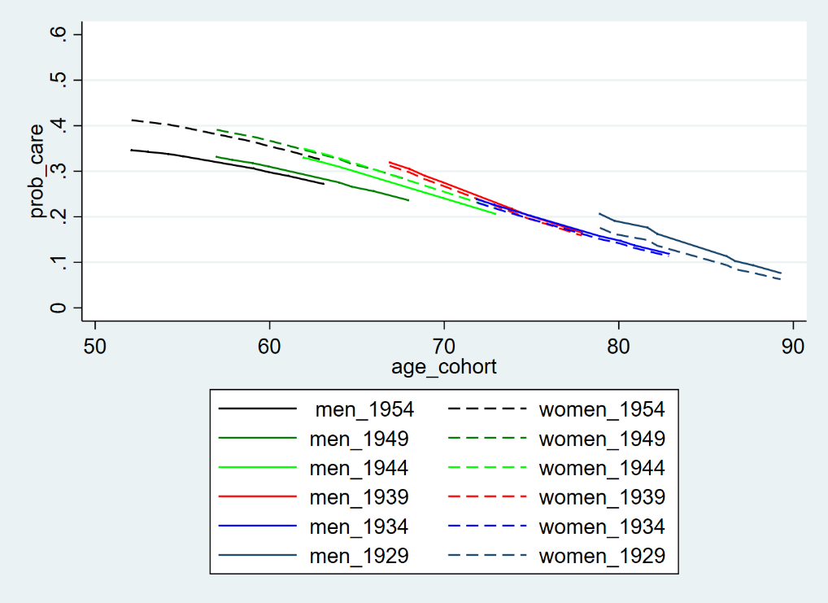

Notes: Adjusted models include also partner living in the household, self-rated health, education, employment and no. of chronic conditions. Weighted results.

Figure 2b: Estimated Probabilities of giving care inside the household, by gender in 11 European countries, 2004 – 15 (adjusted model estimated from adjusted mixed effects logistic regression models)

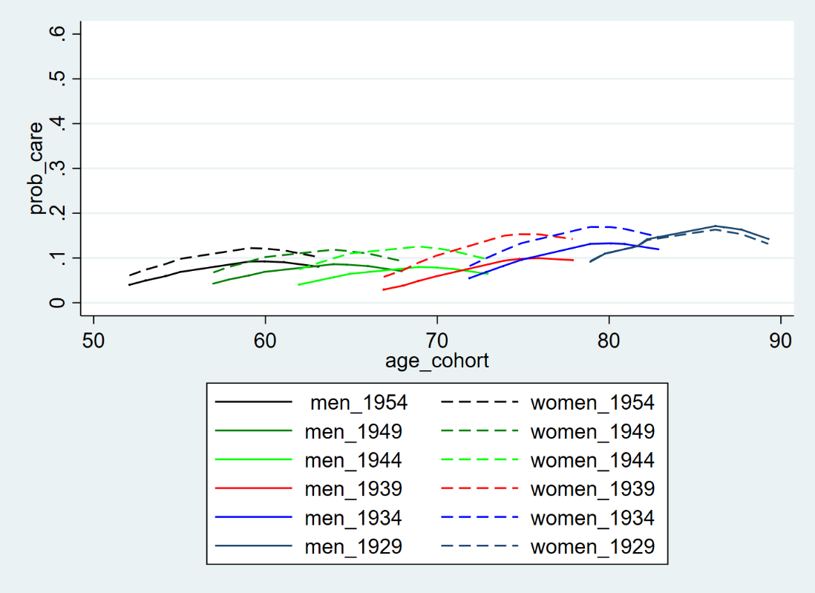

Notes: Adjusted models include also partner living in the household, self-rated health, education, employment and no. of chronic conditions. Weighted results.

Figure 3: Estimated probabilities of giving care, by gender and care regime, 2004 – 15 (estimated from adjusted mixed effects logistic regression models)

|  |  |
| --- | --- |
| Continental care regime | Southern care regime |
|  |  |
| Northern care regime |  |
|  |  |

Notes: Adjusted models include also partner living in the household, self-rated health, education, employment and no. of chronic conditions. Continental includes Austria, France, Germany, the Netherlands, Switzerland, Belgium; Southern includes Spain, Italy and Greece; Northern includes Denmark and Sweden. Predicted probabilities correspond to results estimated in Table 3 above. Weighted results.