**Sample selection:** observations first appear in wave 1 OR wave 2 and in at least one additional wave besides.

Outcome variables:

Probability to provide informal care: includes care provided inside (only personal care – according to SHARE definition) and outside (personal care and household care) the household.

Frequency/intensity of informal care: high frequency outside and care inside (providing care to someone OUTSIDE the household daily OR to two or more people at least once a week OR providing personal care INSIDE the household) and frequency outside only (providing care to someone outside the household at least once a week)

Other notes: last cohort groups all born before 1929. Geographical clusters are similar to Stefan et al (2021): Continental (Austria, Germany, the Netherlands, France, Belgium, Switzerland), Southern (Spain, Italy and Greece) and Nordic (Sweden and Denmark).

Model includes a random model accounting for individual trajectories of caregiving (accounting for wave) and fixed effects model with cohort, wave and sex and interactions between them (incl. quadratic terms). We also control for education (primary, secondary, tertiary), living with partner/spouse in same household (yes/no) and self-rated health (excellent, very good, good, fair, poor).

For socio-economic analysis: we used income terciles per country at the time individuals are first observed in the sample (similar to Marshall et al 2015).

“Roads not travelled” for now: using individual countries as exemplary countries instead of clusters; care use (formal and informal care); different clusters (experimented with shifting the Netherlands to the Nordic, with no major changes) and measures of socio-economic status (experimented with wealth terciles but models had a better fit with income), sensitivity test on informal care definition (removing those providing care outside the hh only once a month or less).

For the article(s) some of the results would be shown in a table format (e.g. broken down by cohort -see Suanet et al. 2013: Table 3) as this would help to establish where gender/income differences are statistically significant in each cohort/cluster.

**Table 1. Descriptive statistics of the analytical sample, all 10 included countries pooled – informal caregiving.**

|  |  |  |  |  |  |  |  |
| --- | --- | --- | --- | --- | --- | --- | --- |
| Cohort |  | Survey wave, year | | | | | |
|  |  | Wave 1 | Wave 2 | Wave 4 | Wave 5 | Wave 6 | Wave 7 |
|  |  | 2004 | 2007 | 2011 | 2013 | 2015 | 2017 |
| 1950-1954 | Men (n) | 1390 | 1841 | 954 | 941 | 1302 | 1071 |
|  | Women (n) | 1706 | 2277 | 1221 | 1220 | 1635 | 1327 |
|  | Mean age (years) | 52.3 | 54.9 | 59.1 | 61.1 | 63.1 | 65.1 |
|  | Gives care (%) | 46.9 | 45.2 | 43.4 | 43.5 | 39.0 | 38.7 |
| 1945-1949 | Men (n) | 1433 | 2002 | 1009 | 1001 | 1408 | 1114 |
|  | Women (n) | 1818 | 1326 | 1326 | 1311 | 1646 | 1369 |
|  | Mean age (years) | 57.1 | 59.7 | 64.0 | 65.9 | 67.9 | 69.9 |
|  | Gives care (%) | 44.9 | 42.4 | 40.3 | 41.9 | 35.6 | 35.1 |
| 1940-1944 | Men (n) | 1306 | 1735 | 943 | 852 | 1197 | 937 |
| Women (n) | 1514 | 2031 | 1140 | 1094 | 1413 | 1164 |
| Mean age (years) | 62.1 | 64.7 | 68.9 | 71.0 | 72.9 | 74.9 |
| Gives care (%) | 40.5 | 39.4 | 37.5 | 36.7 | 29.2 | 30.0 |
| 1935-1939 | Men (n) | 1137 | 1544 | 842 | 740 | 1024 | 775 |
| Women (n) | 1296 | 1687 | 978 | 925 | 1135 | 884 |
| Mean age (years) | 67.1 | 69.7 | 73.9 | 75.9 | 77.9 | 79.9 |
| Gives care (%) | 37.2 | 34.7 | 31.9 | 31.4 | 24.3 | 24.2 |
| 1930-1934 | Men (n) | 851 | 1231 | 624 | 559 | 693 | 488 |
| Women (n) | 1014 | 1311 | 820 | 775 | 869 | 611 |
| Mean age (years) | 72.1 | 74.6 | 78.9 | 80.9 | 82.8 | 84.8 |
| Gives care (%) | 30.2 | 26.8 | 27.2 | 25.1 | 18.4 | 18.7 |
| 1900-1929 | Men (n) | 744 | 1159 | 619 | 472 | 437 | 232 |
| Women (n) | 1147 | 1652 | 1119 | 860 | 763 | 448 |
| Mean age (years) | 79.1 | 82.0 | 86.2 | 87.7 | 89.3 | 90.9 |
| Gives care (%) | 24.8 | 22.5 | 19.8 | 16.4 | 13.4 | 13.7 |

**Cohort analysis - SEX**

Evolution of caregiving by sex, **overall sample** without Eastern Europe (upper: unadjusted model; lower: model adjusted by education, living with partner in same household and self-rated health)

Men are marginally less likely to provide care in younger cohorts (i.e. in comparison with older cohorts for same age), while women in younger cohorts are more likely to provide care, especially among lower ages (adjusted model). Sex inequalities in caregiving are increasing in the younger section of the curve (<70ish years old), where intergenerational care is predominant; and decreasing in older section of the curve, where caregiving is mostly intra-generational. Adjusting for covariates diminishes inequalities only in older section of the curve. Sex differences are higher than income ones (see p.7).

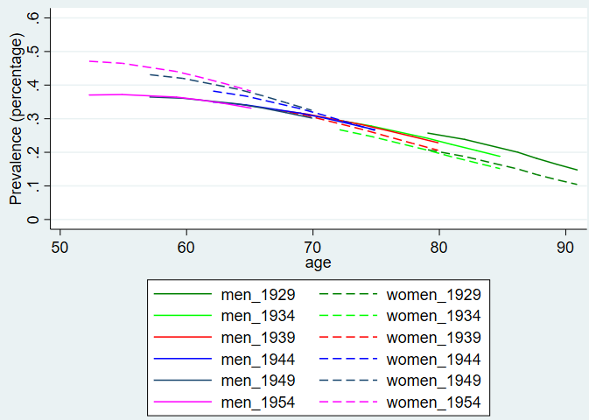

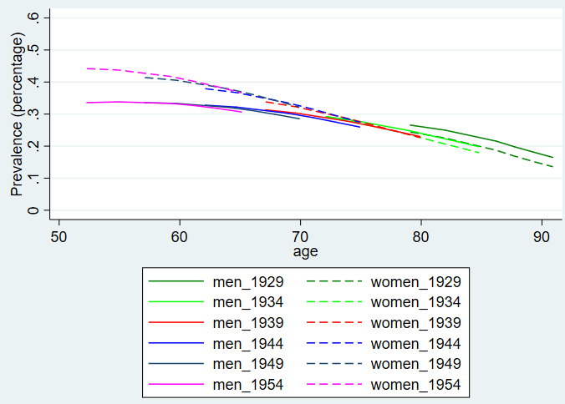

Evolution of caregiving, by sex **Continental Europe** (upper: unadjusted model; lower: model adjusted by education, living with partner in same household and self-rated health)

Women in younger cohorts are providing more care, while for men this holds unequivocally only for lower age groups (adjusted model). Men become more likely to provide informal care around the statutory retirement age (influence of male breadwinner model?).

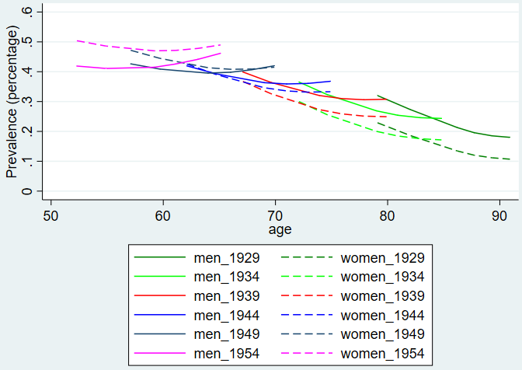

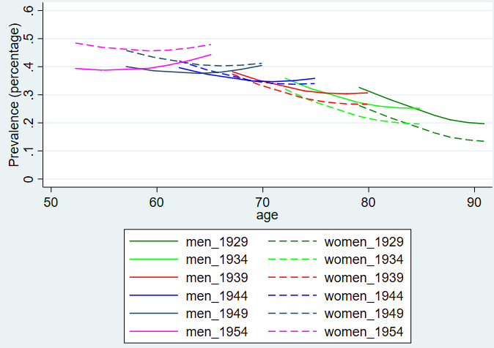

Evolution of caregiving by sex, **Southern Europe** (upper: unadjusted model; lower: model adjusted by education, living with partner in same household and self-rated health)

Both women and men are less likely to provide informal care among younger cohorts. In this cluster, men only become more likely than women to provide care among the very oldest age groups and the difference is probably not significant (family constellations and gender norms means that older women provide care outside the household as well at older age groups, or/and older men’s health status is worse than their spouses). Men’s caregiving profile is very similar across age groups.

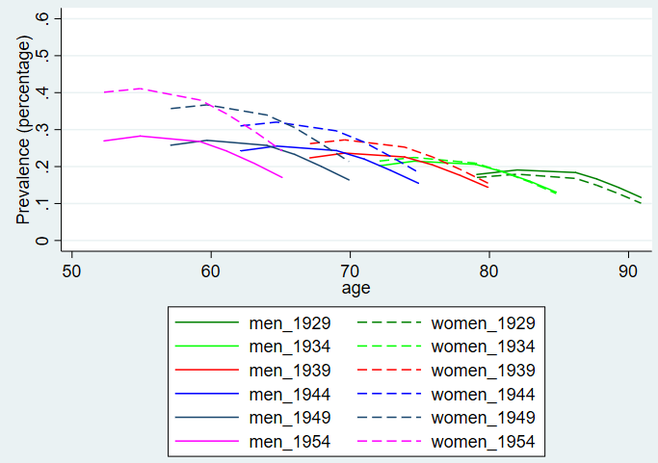

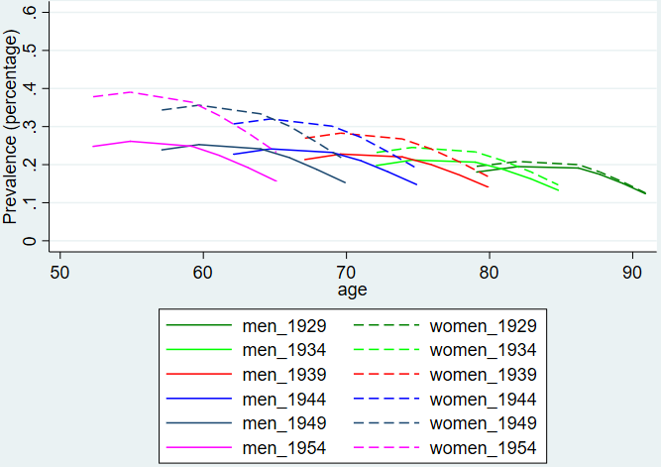

Evolution of caregiving by sex, **Nordic Europe** (upper: unadjusted model; lower: model adjusted by education, living with partner in same household and self-rated health)

Both women and men in younger age cohorts are more likely to provide care, across the age distribution. Women are only (marginally) more likely than men to provide informal care in the very young age groups, after which men are more likely to become carers (gender norms or/and provision of care services renders informal care a low intensity task more suitable to be equally shared?).

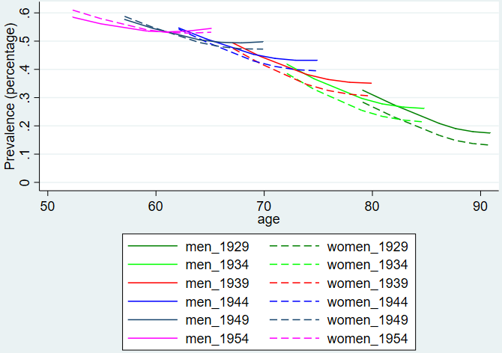

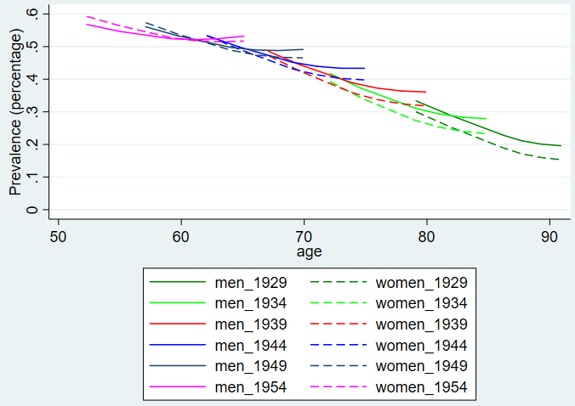

**Cohort analysis - INCOME**

Evolution of caregiving by income, **overall sample** without Eastern Europe (upper: unadjusted model; lower: model adjusted by education, living with partner in same household and self-rated health)

Poorer individuals in younger cohorts are more likely to provide informal care, while richer individuals are less likely to provide care in these younger cohorts (i.e. in comparison with older cohorts at same age); there are hardly any inequalities in the younger section of the graph (adjusted model), while richer individuals are more likely to provide care at older age groups (mostly intragenerational care) although this difference is also diminishing for younger cohorts (as a result of improved health and/or diminishing income differentials in living arrangements?). Adjustment for covariates all but eliminates income inequalities (between 1st and 3rd tercile).

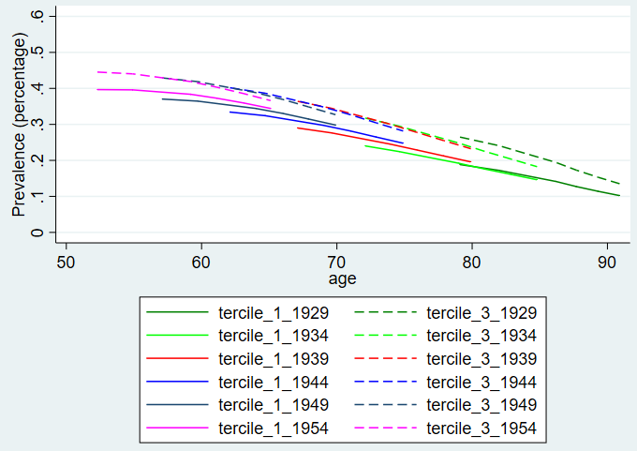

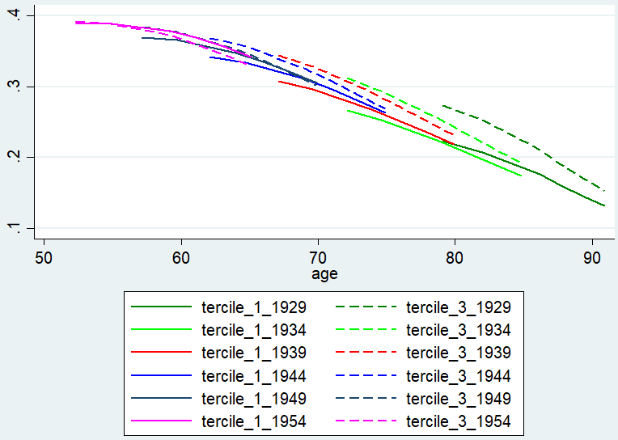

Evolution of caregiving, by income, **Continental Europe** (upper: unadjusted model; lower: model adjusted by education, living with partner in same household and self-rated health)

Poorer individuals are more likely to provide care in younger cohorts, while for richer individuals this is less evident, particularly for older age groups. Adjustment for covariates strongly diminishes inequalities between 1st and 3rd tercile, particularly for younger age groups.

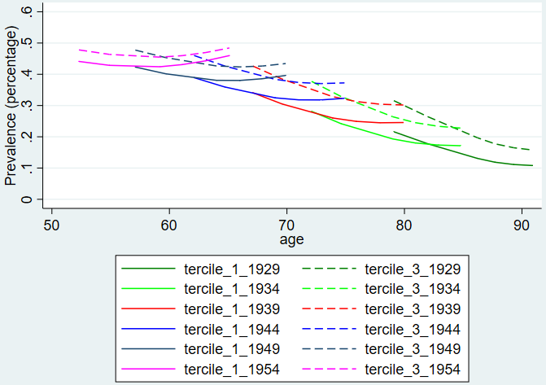

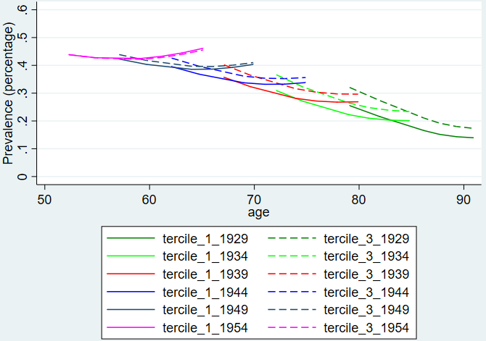

Evolution of caregiving, by income, **Southern Europe** (upper: unadjusted model; lower: model adjusted by education, living with partner in same household and self-rated health)

Both poorer and richer individuals have a lower probability to provide care in younger age cohorts (adjusted model). Inequalities seem to diminish for younger cohorts (for the sections of the curves that overlap).

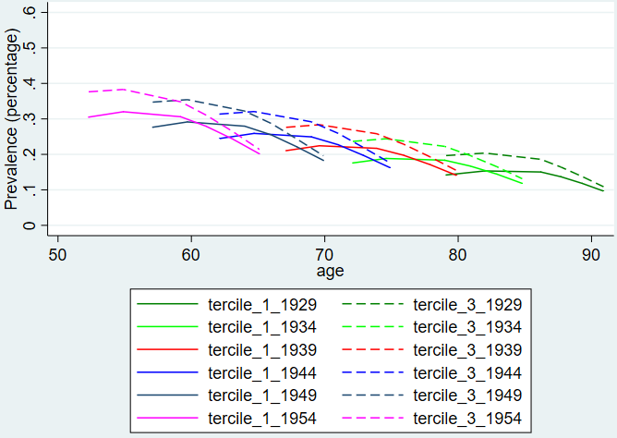

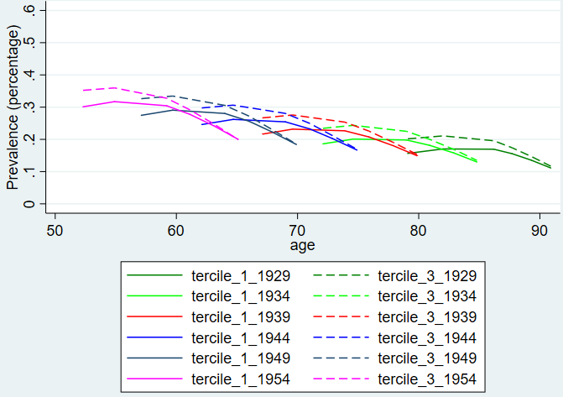

Evolution of caregiving, by income, **Nordic Europe** (upper: unadjusted model; lower: model adjusted by education, living with partner in same household and self-rated health)

Richer individuals are more likely to provide care in younger cohorts across, while this is less evident among poorer individuals (lines for different cohorts intersect). At lower age groups there are hardly any differences between quintiles – these are anyway the least visible in this cluster after the adjustment for covariates.

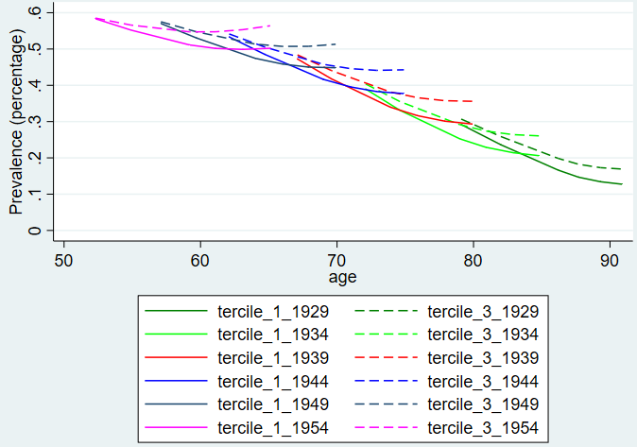

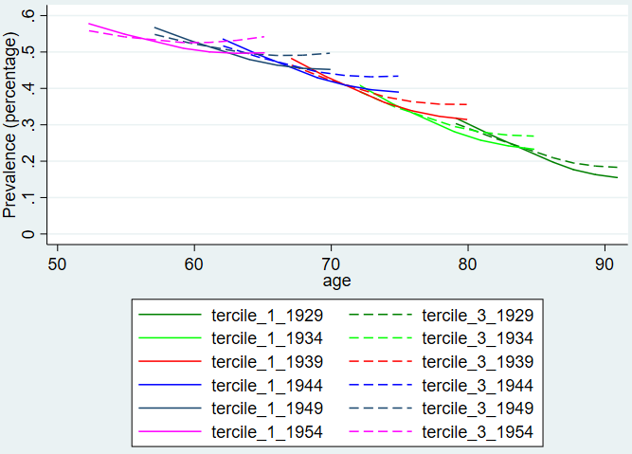

**Cohort analysis – FREQUENCY/INTENSITY SEX**

Evolution of caregiving by sex, overall sample without Eastern Europe using the following definition of high frequency/intensity care: **providing care to someone OUTSIDE the household at least once a week** (unadjusted model)

Frequency of care (outside hh) is lower among younger cohorts across sex (i.e. in comparison to older cohorts for same age groups). Sex differences diminish as age progresses and are likely not significant at higher age groups (unadjusted models). Inequalities seem to remain constant across cohorts.

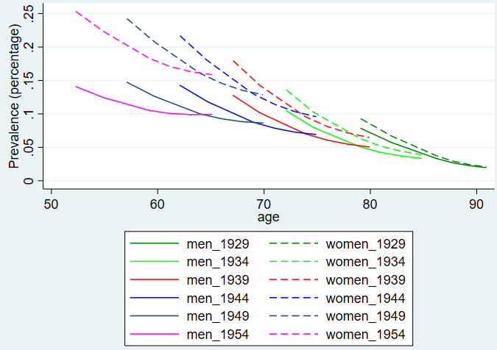

Evolution of caregiving by sex, overall sample without Eastern Europe using the following definition of high intensity care: **providing care to someone OUTSIDE the household daily or to two people at least once a week OR providing personal care INSIDE the household** (unadjusted model)

Younger cohorts of both men and women are less likely to provide high intensity care also in this measure (i.e. in comparison to older cohorts for same age groups). Among older age groups, sex differences are inverted and men are more likely to provide high intensity care (mostly driven by intragenerational or spousal care?).

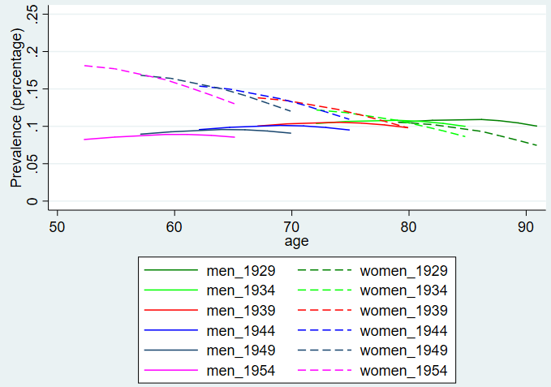

**Cohort analysis – INTENSITY INCOME**

Evolution of caregiving by income tercile, overall sample without Eastern Europe using the following definition of high intensity care: **providing care to someone OUTSIDE the household at least once a week** (unadjusted model)

Poor and rich individuals are less likely to provide high intensity care in younger age cohorts, but the changes run in parallel across terciles and cohorts so that differences remain stable. Richer individuals are always more likely to provide high intensity care, but differences likely not significant.

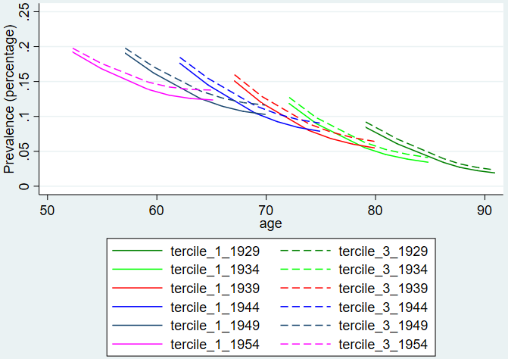

Evolution of caregiving by income tercile, overall sample without Eastern Europe using the following definition of high intensity care: **providing care to someone OUTSIDE the household daily or to two people at least once a week OR providing personal care INSIDE the household** (unadjusted model)

Rich and poor individuals alike are less likely to provide high intensity care in younger cohorts. Age profile for richer individuals is mostly flat across cohorts/age groups. Income differences are inverted at older age groups (rich more likely to provide high intensity care) likely driven by spousal care. Differences between income groups likely not significant.

