## Cohort trajectories of functional decline among older women and men in Europe 2004-2017.

Stefan Fors a b *

Stefania Illinca d e

Janet Jull f

Selma Kadi d

Susan Phillips g

Ricardo Rodrigues d

Afshin Vafaei g

Eszter Zolyomi d

Johan Rehnberg a c

*a Aging Research Center, Karolinska Institutet & Stockholm University, Stockholm, Sweden.*

*b Center for Epidemiology and Community Medicine, Region Stockholm, Stockholm, Sweden.*

*c Department of Public Health Sciences, Stockholm University, Stockholm, Sweden.*

*d European Center for Social Welfare Policy and Research, Vienna, Austria.*

*e Global Brain Health Institute, Trinity College, Dublin, Ireland.*

*f School of Rehabilitation Therapy, Queen’s University, Kingston, Canada.*

*g Department of Family Medicine, Queen’s University, Kingston, Canada.*

* Corresponding author:

Stefan Fors

Aging Research Center

Tomtebodavägen 18A

SE-171 65 Solna

SWEDEN

**Introduction**

Changes in the prevalence of late-life disabilities are likely to be shaped by cohort replacement within the older population. As older birth cohorts die out and new cohorts, who have experienced different living conditions and exposures throughout the life-course, come into old age the characteristics of the older population changes. To the extent that these cohorts enter old age with different levels of disabilities, or different patterns of risk factors for disabilities, it will affect the incidence and prevalence of disabilities in the older population.

As a greater share of each cohort survive to old ages, one hypothesis about? has been that this development (reference to increasing patterns of disability?) has been partly driven by increased survival among frail and disabled individuals (4,6). This hypothesis has sometimes been referred to as the ‘failures of success’ (4,7) or the ‘burden of triumph’ (8). If true, this scenario has consequences - both in terms of the quality of life of the individuals affected, and for the costs and needs of social services in the future, as disabilities are the main drivers of social service utilization in the older population.

The main aim of this study? is to track the disability trajectories of consecutive birth cohorts through old age in Europe and analyse whether levels and trajectories of disabilities differ across cohorts. We will also analyse whether these cohort-specific disability trajectories differ between women and men.

Recent studies of trends in disabilities in Europe suggests that there are substantial regional heterogeneities in the development of…?. There is evidence of improving independence in activities of daily living (ADL) among older adults in the Nordic countries (Ahrenfeldt et al 2018; Hossin et al. 2018; Christensen et al 2013), while there is less evidence of improvements in the other European regions (Ahrenfeldt et al 2018; Chatterji et al 2015).

Besides regional variance, there is strong evidence that the prevalence of disabilities varies by sex among older adults in Europe. Overall, women are more likely to have disabilities than men (Scheel-Hinke et al. 2019; Ahrenfeldt et al. 2018). Despite differences in prevalences, repeated cross-sectional analyses have not found any differences in the trends in disabilities by sex in Europe (Ahrenfeldt et al. 2018).

Yet these studies are all based on trends and inequalities in the prevalence of disabilities. To our knowledge, no previous studies have analysed trends in sex differences in disabilities across subsequent birth cohorts of older adults in Europe.

The research on cohort differences in late life disabilities can roughly be divided into two categories: static and dynamic analyses. Static analyses compare the prevalence of disabilities at a given age in cohorts of people born in different years. A Danish study compared the health and function of two cohorts, born 10 years apart, at age 93-95 (4). The results showed that the cohort born later, on average, had better cognition and less disabilities than the older cohort. Similarly, a regional Swedish study compared the disability rates, at age 75, of two cohorts born 30 years apart. The results showed that the later born cohort had lower rates of disability than the older cohort (9). These results are in line with the findings from a study of disabilities in Europe and the US, showing a general trend of decreasing disability rates among later born cohorts, but the cohort trend in England showed an unexpected increase in disability rates for the youngest cohorts (born 1956-1958) (3).

While static cohort analyses are useful for describing trends in disabilities, their cross-sectional nature makes it impossible to trace the emergence of the cohort differences. To what extent are they a result of differences in the levels of functional impairments accumulated earlier in life, carried through to old age, and to what extent are they caused by changing disability trajectories during old age? To answer these questions, we need dynamic analyses following cohorts over time.

In a seminal Danish study, individuals from a single birth cohort, born in 1905, were followed from age 92-93 to age 99-100 (10). The results showed that the rate of accumulation of disabilities in the cohort was surprisingly slow. But the slow decline of independency was contingent on selective mortality. Analyses that accounted for selective mortality by only tracking survivors showed a much faster rate of decline. Similar patterns have been observed for a cohort of older Americans (11).

Dynamic cohort studies, like the ones above, show that the disability trajectory of any given cohort is shaped by social and demographic forces. As the nature of these forces change, the cohort-specific health trajectories are also likely to change. Hence, comparative analyses of the health trajectories of consecutive cohorts provides novel insights into the dynamics behind the aggregate level health trends.

As an example, a Swedish study showed a strong, cross-sectional, age gradient in the prevalence of poor dental health. Older individuals had worse dental health than younger individuals. However, the observed association was largely driven by cohort differences rather than by age itself. Longitudinal analysis revealed that each successive cohort had better dental health than the previous already when entering old age. The bulk of the tooth loss in the older age groups had occurred at younger ages, after which the within-cohort levels of tooth loss only increased slightly with age (12).

A study of frailty in England revealed a more pessimistic pattern, where later born cohorts had higher prevalence of frailty than earlier cohorts already when entering old age, while the rate of decline during old age was similar across cohorts (13). Similar results from the US showed that later born cohorts of older adults have more frailty and self-reported illnesses than preceding cohorts (14–16).

In sum, the results from previous research suggest that there is a stark difference between the disability trajectories of individuals and cohorts. Individuals tend to have a more rapid decline in terms of old age disability, whereas the prevalence of disability rises slowly in ageing cohorts, as it is tempered by continuous selective mortality. Yet, these findings are based on studies of single, historical, cohorts in Denmark and the US, and should be interpreted with caution. The Danish study is based on a survey with a non-response rate of 37%, and the US sample exclude older adults living in institutions at baseline (10,17). These are conditions known to bias the results in studies of health in old age (18).

## Data and methods

The Survey of Health, Ageing and Retirement in Europe (SHARE) is a cross-national and longitudinal survey that collects data on health, social and economic factors among Europeans aged 50 and older (cite?). Data collection was conducted at seven occasions (survey waves) between 2004 and 2017 and performed by computer assisted face-to-face interviews. The samples are drawn at the household level and the response rate in the first survey (survey wave 1) varied between 51 percent in Spain to 67 percent in Denmark. Calibrated weights have been developed centrally by the SHARE team, the calibration method aims to match the size of the target population in each country and to account for the size of the populations across eight sex-age groups and across regional areas.

The analytical sample used in this our? study consists of five five-year cohorts born between 1920 and 1944 from all countries that participated in the first or second wave of the SHARE data collection, except for Israel and Ireland. We opted to exclude Israel since we limited our analysis to European countries, and Ireland as it did not participate in wave 4 to 7. In order to gain sufficient statistical power, the thirteen included countries were grouped into the following four region-based groups:

* *Northern Europe*: Sweden and Denmark.
* *Western Europe*: Austria, Germany, the Netherlands, France, Switzerland, and Belgium.
* *Southern Europe*: Spain, Italy, and Greece.
* *Eastern Europe*: Czech Republic, and Poland.

Thes groupings have been used in previous studies based on SHARE data (Ahrenfehldt, et al. 2018).

### *Variables*

To assess physical functioning we created indices of self-reported limitations in activities of daily living (ADL) and instrumental activities of daily living (IADL). The ADL index consisted of six tasks that assess whether the respondent had difficulties with: dressing; bathing or showering; eating or cutting up food; walking across a room; and using the toilet including getting up or down. The IADL index included seven items that assessed whether the respondent had difficulties with: using a map in a unknown place; preparing a hot meal; shopping for groceries; making a telephone call; taking medications; doing work around the house or garden; and managing money. The respondents were considered limited on the ADL or IADL scales if they had at least one limitation. These indices have previously been used to analyse health trends in SHARE (Ahrenfehldt, et al. 2018).

### *Analytic strategy*

In order to analyse trajectories of physical functioning within cohorts, we structured the data as repeated observations for individuals that participated in SHARE wave 1 (2004) or wave 2 (2007) and at least one subsequent panel wave. We fit generalized linear mixed model (GLMM) that estimate the level of ADL and IADL limitations at baseline, in wave 1 or wave 2, and then the change in ADL and IADL limitations indeces through subsequent waves up to wave 7 (2004–2017) for five-year cohorts from each region. A similar analytical strategy has previously been used in studies that examined cohort trajectories of frailty in the UK (Marshall et al., 2015; Rogers et al., 2017).

Formally, the model reads as follows:

Level 1 model

(I)ADLti = β0i + β1waveti + eti (1)

Level 2 model: intercept

β0i = γ00 + γ01 sex + γ02 cohort + γ03 wave + γ04 cohort sex + (2)  
γ05 wave sex + γ06 wave cohort + γ07 cohort2 + γ08 wave2 + u0i

Level 2 model: slope

β1i = γ10 + γ01 sex + γ12 cohort + γ13 wave + γ14 cohort sex + (3)  
γ15 wave sex + γ16 wave cohort + γ17 cohort2 + γ18 wave2 + u1i

The model above first specifies the level 1 model that estimates ADL and IADL for each individual (i) at each observed point in time (t). In this model, time is represented by the wave of the observation (from 1 to 7). We tested a quadratic wave term in the level 1 model to allow the trajectories to take non-linear shapes, however, the quadratic term was not statistically significant and did not alter the model substantially and were, as a consequence, not included in the final models. In the first equation (1), the intercept β0i estimates the mean ADL of person i in wave 1 or wave 2 while β1i the linear growth of ADL and IADL over time for individual i. In equations 2 and 3 the intercept and slope are defined for each individual in the sample. The inclusion of cohort and sex enables the modelling of the intercept and the slope separately for each cohort and sex. Moreover, an interaction term was included between sex and cohort, and between wave and cohort, these interaction terms allow us to model different trajectories across waves and between the sexes.

The model was estimates separately for ADL and IADL in the complete sample of all thirteen countries, and then in subsamples of four European regions specified above.

From these models, we estimated the probability of the outcome occurring for each cohort across waves and by sex. In the final step, each? wave was transformed into the average age of each cohort at each survey wave to facilitate a more intuitive interpretation of the growth in the outcome measure over time.

Calibrated cross-sectional weights from the first wave that the participants were included were used to account for imbalances in the sample. Sensitivity tests confirmed that applying weights does not affect the results from the analyses (see Supplementary figure 1-4 for the main results without weights).

## Results

Table 1 shows descriptive statistics for the complete pooled data from all regions, by cohort and wave. The number of observations in each cohort and wave ranged from 3 165 persons for the youngest cohort of women (born between 1945 and 1949) in wave two, to 69 persons in the oldest cohort of men (born between 1920 and 1924) in wave seven. For each cohort, the highest number of observations were seen in wave two. This occurred because we included respondents that entered the survey at either wave one or wave two.

Our results from table 1 show that ADL and IADL limitations increase with age within each cohort. In the first wave (2004) of the youngest cohort (aged between 55 and 59) 4.9 percent had ADL limitations, while at the last observation (wave 7) when the cohort was aged between 68 and 72, the proportion with ADL limitations had increased to 7.3 percent. The corresponding increase in IADL ranged from 10.6 percent in wave one to 14.2 in wave seven. When the oldest cohort (born between 1920 and 1924) was aged between 80 and 84 at wave one, 27.1 percent of the cohort had ADL limitations, whereas at the end of the follow-up period 61.8 percent of the cohort (now aged between 93 and 97) had ADL limitations. For the oldest cohort, there was also a corresponding increase in IADL limitations from 43.8 percent in wave 1 to 80.1 in wave 7.

Table 1. Descriptive statistics of the analytical sample.

|  |  |  |  |  |  |  |  |
| --- | --- | --- | --- | --- | --- | --- | --- |
| Cohort |  | Wave 1 | Wave 2 | Wave 4 | Wave 5 | Wave 6 | Wave 7 |
|  |  | 2004 | 2007 | 2011 | 2013 | 2015 | 2017 |
| 1940-1944 | Men (n) | 1757 | 2263 | 1588 | 1494 | 1463 | 1319 |
| Women (n) | 2031 | 2662 | 1846 | 1774 | 1769 | 1633 |
| Mean age (years) | 61.9 | 64.9 | 68.9 | 70.9 | 72.9 | 74.9 |
| ADL limitations (%) | 7.1 | 7.7 | 8.6 | 10.0 | 10.8 | 11.9 |
| IADL limitations (%) | 13.2 | 15.3 | 15.8 | 18.4 | 21.6 | 22.6 |
| 1935-1939 | Men (n) | 1634 | 2076 | 1383 | 1282 | 1267 | 1069 |
| Women (n) | 1788 | 2231 | 1520 | 1455 | 1451 | 1261 |
| Mean age (years) | 66.9 | 69.9 | 73.9 | 75.9 | 77.9 | 79.9 |
| ADL limitations (%) | 6.9 | 9.6 | 14.0 | 15.9 | 17.6 | 19.5 |
| IADL limitations (%) | 17.6 | 21.0 | 25.3 | 28.5 | 34.1 | 40.7 |
| 1930-1934 | Men (n) | 1269 | 1585 | 1038 | 953 | 859 | 693 |
| Women (n) | 1442 | 1759 | 1169 | 1117 | 1087 | 865 |
| Mean age (years) | 71.9 | 74.9 | 78.9 | 80.9 | 82.8 | 84.8 |
| ADL limitations (%) | 11.6 | 15.3 | 22.0 | 23.5 | 27.0 | 30.8 |
| IADL limitations (%) | 24.7 | 31.8 | 35.8 | 43.2 | 48.9 | 56.0 |
| 1925-1929 | Men (n) | 870 | 1013 | 591 | 475 | 390 | 265 |
| Women (n) | 1127 | 1331 | 863 | 746 | 666 | 464 |
| Mean age (years) | 76.9 | 79.9 | 83.8 | 85.7 | 87.7 | 89.7 |
| ADL limitations (%) | 16.7 | 21.8 | 30.1 | 36.1 | 43.8 | 46.1 |
| IADL limitations (%) | 31.5 | 38.6 | 48.0 | 56.8 | 66.7 | 71.8 |
| 1920-1924 | Men (n) | 464 | 520 | 256 | 189 | 133 | 69 |
| Women (n) | 682 | 760 | 383 | 302 | 218 | 136 |
| Mean age (years) | 81.7 | 84.7 | 88.6 | 90.5 | 92.4 | 94.3 |
| ADL limitations (%) | 27.1 | 33.8 | 48.6 | 54.0 | 56.0 | 61.8 |
| IADL limitations (%) | 43.8 | 53.0 | 70.5 | 70.5 | 77.5 | 80.1 |

Figure 1 shows the results of the cohort analyses for the pooled European sample, by sex and cohort. The underlying Generalized linear mixed models that generated the estimated probabilities are presented in Supplementary Tables 1 and 2, in addition, the estimated probabilities and confidence intervals are presented in Supplementary Tables x-x. The estimated probability of ADL limitations increased with age, and the patterns indicated an accelerated increase of limitations in higher ages. Moreover, for men, younger cohorts had a higher prevalence of ADL limitations than older cohorts in the beginning of the study period. This trend was especially striking in the three cohorts born before 1935. However, at the end of the measurement period the prevalence of ADL limitations at equivalent ages for men converged across the cohorts. For women, the cohort trends overlapped across cohorts, with no clear improvement or deterioration of limitations for any of the cohorts.

Women reported more ADL-limitations than men. Yet, the sex differences were smaller in the younger cohorts and larger for the older cohorts. Overall, the differences remained stable within cohorts during the entire measurement period.

The prevalence of IADL limitations also increased with age. However, no clear trends towards either improvement or deterioration across cohorts were observed. The youngest cohorts of both men and women (born between 1940 and 1944) had somewhat lower levels of IADL limitations at any given age than their respective older cohort (born between 1935 and 1939). The reversed pattern was again seen in the two oldest cohorts, where the oldest cohort (born between 1920 and 1924) had somewhat lower levels of IADL problems than the second oldest cohort (born between 1925 and 1929).

Women reported more IADL-limitations than men. These sex differences were constant across the cohorts, however, as with ADL limitations, no clear age effect was observed within the cohorts.

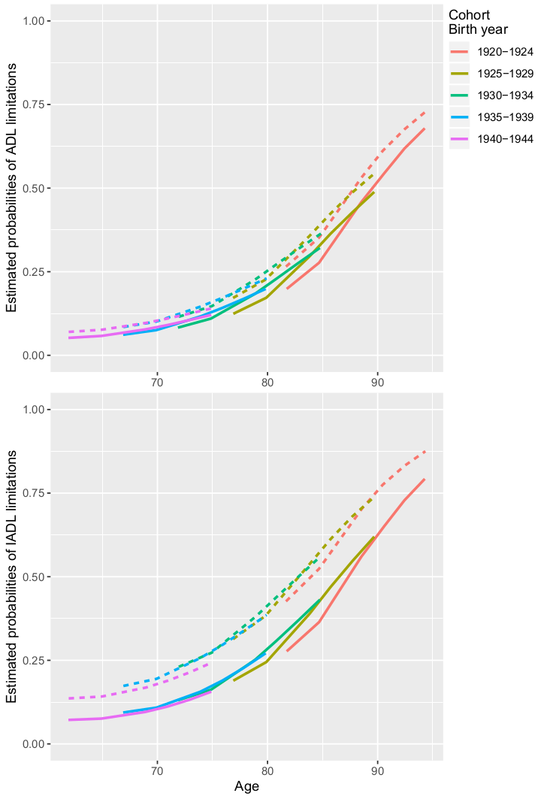

Figure 1. Estimated Probabilities of ADL and IADL limitations in 13 European countries, 2004 – 2017. Estimated from multilevel growth curve models, see Supplementary table 1. Dotted lines denote the estimates for women and solid lines the estimates for men.

Figures 2 and 3 show the corresponding results by region. The exact estimates are presented in Supplementary table 3.

The overall trends in ADL limitations were similar in all four regions, albeit with some differences in the levels of limitations. In Eastern Europe the initial levels of ADL limitations in the youngest cohorts were higher than in the other three regions. However, in the oldest cohorts the highest prevalence of ADL limitations was observed in Southern and Western Europe.

The prevalence of ADL limitations increased with age in each cohort. However, the age trends across cohorts differed depending on sex and region. Among men in Eastern, Northern and Western Europe, and for women in Northern and Western Europe, older cohorts tend to have a lower prevalence of ADL limitations than younger cohorts at the same ages. The reversed pattern was observed for women in Eastern Europe, where older cohorts showed a higher prevalence of ADL limitations than younger cohorts. In Southern Europe, the age-pattern of ADL limitations overlapped almost completely across cohorts.

Moreover, we observe variations in the sex differences in the patterning of ADL limitations across the regions. In Northern and Western Europe, sex differences in ADL limitations were small or non-existent in all age groups. In Eastern and Southern Europe, on the other hand, there were marked sex differences in ADL limitations, where women reported more limitations than men. In Eastern Europe, the sex differences were greater in the older cohorts than in younger cohorts. In Southern Europe, there were no discernible cohort effects in the sex differences. In Eastern, Northern and Western Europe the sex differences tended to decrease with age within the cohorts whereas the opposite pattern was observed in Southern Europe (figure 2).

Overall, the trends in IADL limitations were similar to the trends in ADL limitations. Here too we saw a higher prevalence of limitations among the younger cohorts in Eastern Europe compared to the younger cohorts in the other regions. For the older cohorts (1920-1924 and 1925-1929), regional differences were small, and only Northern Europe showed a somewhat lower prevalence of IADL limitations compared to the other regions.

IADL limitations increased more rapidly with age than ADL limitations, with levels starting at around 10 to 20 percent of respondents with IADL limitations in the youngest cohorts ranging up to 75-85 percent in the older cohorts. Moreover, only men in Eastern and Western Europe showed trends of higher rates of limitations in younger cohorts. Among women in Eastern Europe, the reverse pattern was observed. Here, each subsequent younger cohort showed a substantially lower prevalence of limitations compared to the older cohorts.

In all age groups and in all regions, women had higher prevalence of IADL limitations than men. The sex differences in IADL limitations were more marked than in ADL limitations, and again, Eastern and Southern Europe showed the highest levels difference between men and women. The differences were also substantial in Northern and Western Europe, albeit at lower levels compared to the other two regions (figure 3).

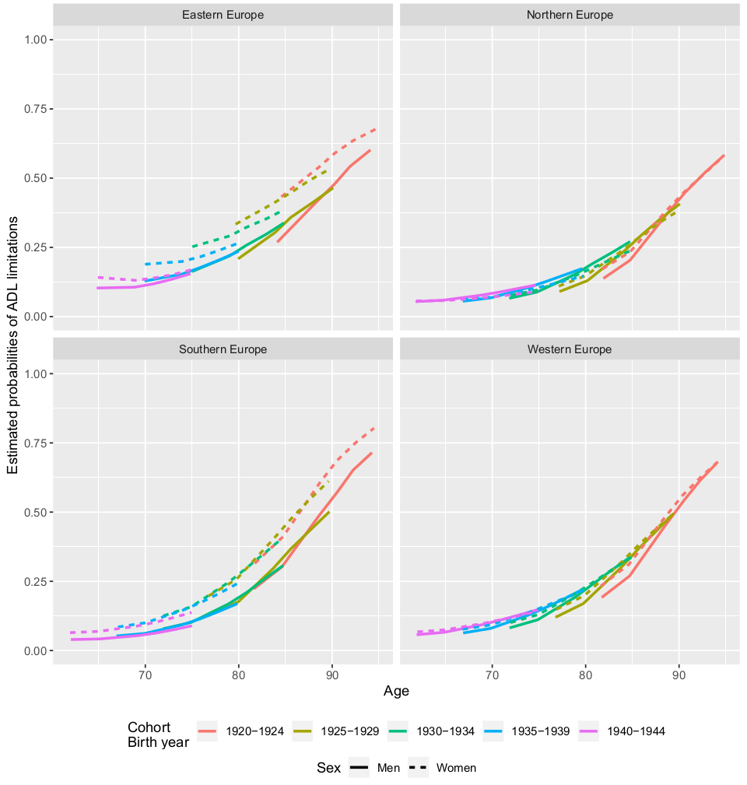

Figure 2. Estimated Probabilities of ADL limitations in European regions, 2004 – 2017. Estimated from multilevel growth curve models, see Supplementary table 3.

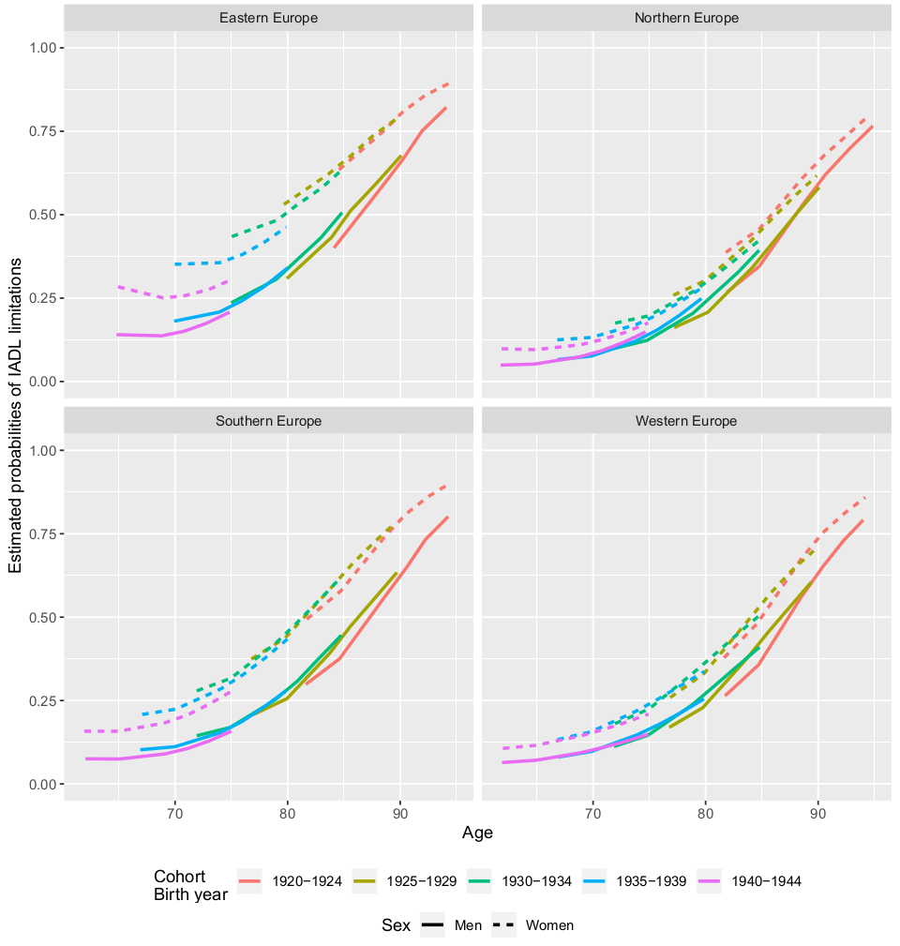

Figure 3. Estimated probabilities of IADL limitations in European regions, 2004 – 2017. Estimated from multilevel growth curve models, see Supplementary table 3.

## Discussion

In this study we followed the disability trajectories of women and men from five subsequent birth cohorts, from four European regions, over a period of 13 years. The results showed different tendencies across cohorts, regions, and sex. There were sex differences in ADL limitations in all regions for most cohorts, and even stronger sex differences in IADL limitations. Women reported more limitations than men. However, these sex differences varied across regions. They were larger in Eastern and Southern Europe, and smaller in Northern and Western Europe. Overall, sex differences in prevalence of functional limitations tended to decrease with age within birth cohorts.

Among men in Eastern, Northern and Western Europe later born cohorts tended to have a higher risk of disabilities than previous birth cohorts at the same ages. A similar pattern was observed for women in Northern and Western Europe. In contrast, the risk of disabilities was lower in later born cohorts than in previous birth cohorts among women in Eastern Europe.

Yet, these results should be interpreted with caution. This is a descriptive study, and as such interpretation of the results rely on the representativity of the samples. In our study design, there are two major threats to this assumption. The first threat is the selection of countries in the respective regions. Not all countries in Europe participates in SHARE, which means that we rely on data from those who do and lack data from those who don’t. This poses limitations on inferences drawn from the results. For example, in this study Eastern Europe is represented by only two countries: Czech Republic and Poland. To the extent the patterns differ for other countries in the region, our results cannot be generalized to the whole of Eastern Europe.

The second threat to the representativity of the sample is the non-response and attrition rates of the SHARE survey. The response rate for Wave 1 of SHARE, which serves as the baseline for this study, ranged between 51 and 67 percent for the countries included in the analyses. As the non-respondents are likely to be a selected group in terms of health and health related characteristics, this may bias our results. Moreover, due to the longitudinal design in this study we included only respondents that had participated in two or more survey waves, this criterion possibly further exacerbated the non-response bias. In order to minimize the impact of non-response on the estimates, we used calibrated cross-sectional weights provided by SHARE to compensate for selective non-response.

Perhaps the most disconcerting finding of the study was the increasing probabilities of disabilities observed across subsequent birth cohorts, especially among men in Eastern, Northern and Western Europe, but also among women in Northern and Western Europe. It is possible that this is a consequence of increased survival among individuals with health problems in later born cohorts (‘sick survivors’). This development is seemingly at odds with previous studies, based on repeated cross-sections, that have documented decreasing prevalences of disabilities in the Nordic countries (Christensen et al. 2013; Ahrenfeldt et al. 2018; Fors & Thorslund 2015). This discrepancy underscores the difference between studying health trends through repeated cross-sections and through cohort succession. Yet, the results suggest that the positive development observed in previous studies is unlikely to be explained by younger cohorts entering old age with better function. Rather the explanation is more likely to depend on the development of disabilities within cohorts (where we see a steeper decline with age among older cohorts than among younger cohorts) or on the age structure of the entire older population.

In contrast, the strongest cohort differences were observed among younger cohorts of women in Eastern Europe, where each subsequent cohort reported less disabilities than the previous. These differences were concentrated to the younger cohorts, who were most likely to have their life trajectories altered by the fall of the Soviet Union. This is a positive development for several reasons. Not only does it imply a decreasing burden of late-life disabilities in Eastern Europe in the future, it also implies a decreasing sex gap in the likelihood of disabilities in the older population.

Overall, the results from this study suggests that disability trajectories in older cohorts of men and women were similar across Europe, with the exception of younger cohorts of women in Eastern Europe. The trajectories varied more depending on sex, age, and region than depending on cohort. This implies that future studies on trends in old-age disabilities should primarily focus on mapping out and explaining sex and geographical inequalities in health. Moreover, the results underscore the importance of developing interventions and innovations that facilitate independent living also in old age.

Nevertheless, the increasing prevalence of disabilities among later born cohorts observed in Eastern, Northern and Western Europe warrants attention. Future studies should seek to assess to what extent this development can be attributed to different trends, such as increasing survival of older adults with chronic conditions and increasing prevalence of obesity.

## Supplementary data

Supplementary table 1. Generalized linear mixed model, binomial distribution. Outcome: ADL. Complete population (figure 1).

Supplementary table 2. Generalized linear mixed model, binomial distribution. Outcome: IADL. Complete population (figure 2).

Supplementary table 3. Generalized linear mixed model, binomial distribution. Outcome: ADL. Stratified by region (Figure 3 and Figure 4).

|  |  |  |  |  |  |  |  |  |  |  |  |  |  |  |  |  |  |
| --- | --- | --- | --- | --- | --- | --- | --- | --- | --- | --- | --- | --- | --- | --- | --- | --- | --- |
|  | ADL | |  | |  | |  | |  | | IADL |  | |  | |  | |
|  | Coef. | | P-value | | LCI | | UCI | |  | | Coef. | P-value | | LCI | | UCI | |
| Northern Europe |  | |  | |  | |  | |  | |  |  | |  | |  | |
| Sex (1=women) | 0.332 | | 0.000 | | 0.319 | | 0.345 | |  | | 1.106 | 0.000 | | 1.094 | | 1.118 | |
| Cohort | 0.202 | | 0.000 | | 0.196 | | 0.208 | |  | | 0.584 | 0.000 | | 0.578 | | 0.590 | |
| Wave | 0.358 | | 0.000 | | 0.352 | | 0.365 | |  | | 0.182 | 0.000 | | 0.176 | | 0.188 | |
| Wave*cohort | 0.169 | | 0.000 | | 0.168 | | 0.170 | |  | | 0.160 | 0.000 | | 0.159 | | 0.161 | |
| Sex*wave | -0.098 | | 0.000 | | -0.101 | | -0.095 | |  | | -0.105 | 0.000 | | -0.107 | | -0.102 | |
| Sex*cohort | 0.085 | | 0.000 | | 0.078 | | 0.091 | |  | | -0.025 | 0.000 | | -0.031 | | -0.019 | |
| Wave*wave | -0.006 | | 0.000 | | -0.007 | | -0.005 | |  | | 0.032 | 0.000 | | 0.031 | | 0.033 | |
| Cohort*cohort | 0.111 | | 0.000 | | 0.108 | | 0.114 | |  | | 0.106 | 0.000 | | 0.103 | | 0.108 | |
| Intercept | -4.621 | | 0.000 | | -4.639 | | -4.604 | |  | | -3.874 | 0.000 | | -3.889 | | -3.858 | |
|  |  | |  | |  | |  | |  | |  |  | |  | |  | |
| Wave | 0.152 | | 0.154 | |  | |  | |  | | 0.141 | 0.143 | |  | |  | |
| Intercept | 4.735 | | 4.772 | |  | |  | |  | | 4.826 | 4.858 | |  | |  | |
|  |  | |  | |  | |  | |  | |  |  | |  | |  | |
| Western Europe |  | |  | |  | |  | |  | |  |  | |  | |  | |
| Sex (1=women) | 0.398 | | 0.000 | | 0.394 | | 0.402 | |  | | 0.827 | 0.000 | | 0.824 | | 0.831 | |
| Cohort | 0.367 | | 0.000 | | 0.365 | | 0.369 | |  | | 0.456 | 0.000 | | 0.455 | | 0.458 | |
| Wave | 0.435 | | 0.000 | | 0.433 | | 0.437 | |  | | 0.374 | 0.000 | | 0.372 | | 0.375 | |
| Wave*cohort | 0.151 | | 0.000 | | 0.150 | | 0.151 | |  | | 0.160 | 0.000 | | 0.160 | | 0.160 | |
| Sex*wave | -0.058 | | 0.000 | | -0.059 | | -0.057 | |  | | 0.003 | 0.000 | | 0.002 | | 0.003 | |
| Sex*cohort | 0.042 | | 0.000 | | 0.041 | | 0.044 | |  | | 0.029 | 0.000 | | 0.027 | | 0.030 | |
| Wave*wave | -0.003 | | 0.000 | | -0.003 | | -0.002 | |  | | 0.007 | 0.000 | | 0.007 | | 0.007 | |
| Cohort*cohort | 0.119 | | 0.000 | | 0.118 | | 0.120 | |  | | 0.094 | 0.000 | | 0.093 | | 0.095 | |
| Intercept | -4.494 | | 0.000 | | -4.499 | | -4.489 | |  | | -3.712 | 0.000 | | -3.716 | | -3.708 | |
|  |  | |  | |  | |  | |  | |  |  | |  | |  | |
| Wave | 0.122 | | 0.123 | |  | |  | |  | | 0.085 | 0.085 | |  | |  | |
| Intercept | 5.268 | | 5.279 | |  | |  | |  | | 4.349 | 4.357 | |  | |  | |
|  |  |  | |  | |  | |  | |  | | |  |  |  | |
| Southern Europe |  |  | |  | |  | |  | |  | | |  |  |  | |
| Sex (1=women) | 0.682 | 0.000 | | 0.677 | | 0.686 | |  | | 1.112 | | | 0.000 | 1.108 | 1.115 | |
| Cohort | 0.518 | 0.000 | | 0.515 | | 0.520 | |  | | 0.412 | | | 0.000 | 0.410 | 0.414 | |
| Wave | 0.284 | 0.000 | | 0.282 | | 0.286 | |  | | 0.120 | | | 0.000 | 0.119 | 0.122 | |
| Wave*cohort | 0.166 | 0.000 | | 0.165 | | 0.166 | |  | | 0.139 | | | 0.000 | 0.138 | 0.139 | |
| Sex*wave | 0.038 | 0.000 | | 0.037 | | 0.039 | |  | | 0.027 | | | 0.000 | 0.026 | 0.027 | |
| Sex*cohort | 0.022 | 0.000 | | 0.020 | | 0.025 | |  | | 0.034 | | | 0.000 | 0.033 | 0.036 | |
| Wave*wave | 0.007 | 0.000 | | 0.007 | | 0.007 | |  | | 0.029 | | | 0.000 | 0.029 | 0.029 | |
| Cohort*cohort | 0.099 | 0.000 | | 0.099 | | 0.100 | |  | | 0.043 | | | 0.000 | 0.042 | 0.044 | |
| Intercept | -4.104 | 0.000 | | -4.109 | | -4.099 | |  | | -2.665 | | | 0.000 | -2.669 | -2.662 | |
|  |  |  | |  | |  | |  | |  | | |  |  |  | |
| Wave | 0.103 | 0.104 | |  | |  | |  | | 0.068 | | | 0.068 |  |  | |
| Intercept | 4.056 | 4.065 | |  | |  | |  | | 2.560 | | | 2.566 |  |  | |
|  |  |  | |  | |  | |  | |  | | |  |  |  | |
| Eastern Europe |  |  | |  | |  | |  | |  | | |  |  |  | |
| Sex (1=women) | 0.775 | 0.000 | | 0.766 | | 0.785 | |  | | 1.327 | | | 0.000 | 1.319 | 1.336 | |
| Cohort | 0.043 | 0.000 | | 0.038 | | 0.048 | |  | | 0.152 | | | 0.000 | 0.147 | 0.156 | |
| Wave | -0.128 | 0.000 | | -0.135 | | -0.122 | |  | | -0.081 | | | 0.000 | -0.086 | -0.076 | |
| Wave*cohort | 0.155 | 0.000 | | 0.154 | | 0.156 | |  | | 0.153 | | | 0.000 | 0.152 | 0.154 | |
| Sex*wave | -0.045 | 0.000 | | -0.048 | | -0.043 | |  | | -0.057 | | | 0.000 | -0.059 | -0.055 | |
| Sex*cohort | 0.129 | 0.000 | | 0.125 | | 0.134 | |  | | 0.040 | | | 0.000 | 0.036 | 0.044 | |
| Wave*wave | 0.028 | 0.000 | | 0.028 | | 0.029 | |  | | 0.045 | | | 0.000 | 0.044 | 0.045 | |
| Cohort*cohort | 0.021 | 0.000 | | 0.019 | | 0.023 | |  | | 0.027 | | | 0.000 | 0.026 | 0.029 | |
| Intercept | -1.946 | 0.000 | | -1.960 | | -1.931 | |  | | -1.590 | | | 0.000 | -1.602 | -1.578 | |
|  |  |  | |  | |  | |  | |  | | |  |  |  | |
| Wave | 0.175 | 0.176 | |  | |  | |  | | 0.067 | | | 0.068 |  |  | |
| Intercept | 0.877 | 0.895 | |  | |  | |  | | 1.621 | | | 1.634 |  |  | |

Supplementary table x. Estimated probabilities of **ADL** limitations by age and sex. **All regions**, data for figure 1 in the manuscript.

|  |  |  |  |  |  |  |  |  |  |  |  |  |  |  |  |  |
| --- | --- | --- | --- | --- | --- | --- | --- | --- | --- | --- | --- | --- | --- | --- | --- | --- |
| Age | Sex | PP | LCI | UCI | PP | LCI | UCI | PP | LCI | UCI | PP | LCI | UCI | PP | LCI | UCI |
| 62 | M | 0.052 | 0.052 | 0.052 |  |  |  |  |  |  |  |  |  |  |  |  |
| 62 | W | 0.070 | 0.070 | 0.070 |  |  |  |  |  |  |  |  |  |  |  |  |
| 63 | M |  |  |  |  |  |  |  |  |  |  |  |  |  |  |  |
| 63 | W |  |  |  |  |  |  |  |  |  |  |  |  |  |  |  |
| 64 | M |  |  |  |  |  |  |  |  |  |  |  |  |  |  |  |
| 64 | W |  |  |  |  |  |  |  |  |  |  |  |  |  |  |  |
| 65 | M | 0.058 | 0.058 | 0.058 |  |  |  |  |  |  |  |  |  |  |  |  |
| 65 | W | 0.076 | 0.076 | 0.077 |  |  |  |  |  |  |  |  |  |  |  |  |
| 66 | M |  |  |  |  |  |  |  |  |  |  |  |  |  |  |  |
| 66 | W |  |  |  |  |  |  |  |  |  |  |  |  |  |  |  |
| 67 | M |  |  |  | 0.062 | 0.061 | 0.062 |  |  |  |  |  |  |  |  |  |
| 67 | W |  |  |  | 0.085 | 0.085 | 0.085 |  |  |  |  |  |  |  |  |  |
| 68 | M |  |  |  |  |  |  |  |  |  |  |  |  |  |  |  |
| 68 | W |  |  |  |  |  |  |  |  |  |  |  |  |  |  |  |
| 69 | M | 0.077 | 0.077 | 0.078 |  |  |  |  |  |  |  |  |  |  |  |  |
| 69 | W | 0.097 | 0.097 | 0.097 |  |  |  |  |  |  |  |  |  |  |  |  |
| 70 | M |  |  |  | 0.075 | 0.075 | 0.076 |  |  |  |  |  |  |  |  |  |
| 70 | W |  |  |  | 0.101 | 0.101 | 0.101 |  |  |  |  |  |  |  |  |  |
| 71 | M | 0.091 | 0.090 | 0.091 |  |  |  |  |  |  |  |  |  |  |  |  |
| 71 | W | 0.110 | 0.110 | 0.110 |  |  |  |  |  |  |  |  |  |  |  |  |
| 72 | M |  |  |  |  |  |  | 0.083 | 0.083 | 0.083 |  |  |  |  |  |  |
| 72 | W |  |  |  |  |  |  | 0.115 | 0.115 | 0.115 |  |  |  |  |  |  |
| 73 | M | 0.105 | 0.105 | 0.105 |  |  |  |  |  |  |  |  |  |  |  |  |
| 73 | W | 0.125 | 0.125 | 0.125 |  |  |  |  |  |  |  |  |  |  |  |  |
| 74 | M |  |  |  | 0.116 | 0.116 | 0.116 |  |  |  |  |  |  |  |  |  |
| 74 | W |  |  |  | 0.146 | 0.145 | 0.146 |  |  |  |  |  |  |  |  |  |
| 75 | M | 0.121 | 0.121 | 0.121 |  |  |  | 0.110 | 0.110 | 0.110 |  |  |  |  |  |  |
| 75 | W | 0.140 | 0.140 | 0.141 |  |  |  | 0.147 | 0.147 | 0.147 |  |  |  |  |  |  |
| 76 | M |  |  |  | 0.142 | 0.141 | 0.142 |  |  |  |  |  |  |  |  |  |
| 76 | W |  |  |  | 0.172 | 0.172 | 0.172 |  |  |  |  |  |  |  |  |  |
| 77 | M |  |  |  |  |  |  |  |  |  | 0.124 | 0.124 | 0.124 |  |  |  |
| 77 | W |  |  |  |  |  |  |  |  |  | 0.172 | 0.171 | 0.172 |  |  |  |
| 78 | M |  |  |  | 0.169 | 0.169 | 0.169 |  |  |  |  |  |  |  |  |  |
| 78 | W |  |  |  | 0.201 | 0.200 | 0.201 |  |  |  |  |  |  |  |  |  |
| 79 | M |  |  |  |  |  |  | 0.184 | 0.184 | 0.184 |  |  |  |  |  |  |
| 79 | W |  |  |  |  |  |  | 0.228 | 0.228 | 0.228 |  |  |  |  |  |  |
| 80 | M |  |  |  | 0.199 | 0.198 | 0.199 |  |  |  | 0.172 | 0.172 | 0.172 |  |  |  |
| 80 | W |  |  |  | 0.230 | 0.230 | 0.230 |  |  |  | 0.226 | 0.226 | 0.227 |  |  |  |
| 81 | M |  |  |  |  |  |  | 0.229 | 0.229 | 0.229 |  |  |  |  |  |  |
| 81 | W |  |  |  |  |  |  | 0.274 | 0.274 | 0.275 |  |  |  |  |  |  |
| 82 | M |  |  |  |  |  |  |  |  |  |  |  |  | 0.199 | 0.198 | 0.199 |
| 82 | W |  |  |  |  |  |  |  |  |  |  |  |  | 0.265 | 0.265 | 0.266 |
| 83 | M |  |  |  |  |  |  | 0.276 | 0.275 | 0.276 |  |  |  |  |  |  |
| 83 | W |  |  |  |  |  |  | 0.321 | 0.320 | 0.321 |  |  |  |  |  |  |
| 84 | M |  |  |  |  |  |  |  |  |  | 0.296 | 0.296 | 0.296 |  |  |  |
| 84 | W |  |  |  |  |  |  |  |  |  | 0.358 | 0.357 | 0.358 |  |  |  |
| 85 | M |  |  |  |  |  |  | 0.321 | 0.321 | 0.321 |  |  |  | 0.277 | 0.277 | 0.277 |
| 85 | W |  |  |  |  |  |  | 0.364 | 0.364 | 0.364 |  |  |  | 0.352 | 0.351 | 0.352 |
| 86 | M |  |  |  |  |  |  |  |  |  | 0.363 | 0.363 | 0.364 |  |  |  |
| 86 | W |  |  |  |  |  |  |  |  |  | 0.424 | 0.424 | 0.424 |  |  |  |
| 87 | M |  |  |  |  |  |  |  |  |  |  |  |  |  |  |  |
| 87 | W |  |  |  |  |  |  |  |  |  |  |  |  |  |  |  |
| 88 | M |  |  |  |  |  |  |  |  |  | 0.428 | 0.428 | 0.428 |  |  |  |
| 88 | W |  |  |  |  |  |  |  |  |  | 0.486 | 0.486 | 0.486 |  |  |  |
| 89 | M |  |  |  |  |  |  |  |  |  |  |  |  | 0.459 | 0.458 | 0.459 |
| 89 | W |  |  |  |  |  |  |  |  |  |  |  |  | 0.533 | 0.533 | 0.534 |
| 90 | M |  |  |  |  |  |  |  |  |  | 0.489 | 0.488 | 0.489 |  |  |  |
| 90 | W |  |  |  |  |  |  |  |  |  | 0.542 | 0.542 | 0.543 | 0.612 | 0.611 | 0.612 |
| 91 | M |  |  |  |  |  |  |  |  |  |  |  |  | 0.544 | 0.544 | 0.545 |
| 91 | W |  |  |  |  |  |  |  |  |  |  |  |  |  |  |  |
| 92 | M |  |  |  |  |  |  |  |  |  |  |  |  | 0.618 | 0.618 | 0.619 |
| 92 | W |  |  |  |  |  |  |  |  |  |  |  |  | 0.676 | 0.676 | 0.677 |
| 93 | M |  |  |  |  |  |  |  |  |  |  |  |  |  |  |  |
| 93 | W |  |  |  |  |  |  |  |  |  |  |  |  |  |  |  |
| 94 | M |  |  |  |  |  |  |  |  |  |  |  |  | 0.679 | 0.678 | 0.679 |
| 94 | W |  |  |  |  |  |  |  |  |  |  |  |  | 0.728 | 0.728 | 0.729 |

Supplementary table x. Estimated probabilities of **IADL** limitations by age and sex. **All regions**, data for figure 1 in the manuscript.

|  |  |  |  |  |  |  |  |  |  |  |  |  |  |  |  |  |
| --- | --- | --- | --- | --- | --- | --- | --- | --- | --- | --- | --- | --- | --- | --- | --- | --- |
| Age | Sex | PP | LCI | UCI | PP | LCI | UCI | PP | LCI | UCI | PP | LCI | UCI | PP | LCI | UCI |
| 62 | M | 0.072 | 0.072 | 0.072 |  |  |  |  |  |  |  |  |  |  |  |  |
| 62 | W | 0.136 | 0.136 | 0.136 |  |  |  |  |  |  |  |  |  |  |  |  |
| 63 | M |  |  |  |  |  |  |  |  |  |  |  |  |  |  |  |
| 63 | W |  |  |  |  |  |  |  |  |  |  |  |  |  |  |  |
| 64 | M |  |  |  |  |  |  |  |  |  |  |  |  |  |  |  |
| 64 | W |  |  |  |  |  |  |  |  |  |  |  |  |  |  |  |
| 65 | M | 0.076 | 0.076 | 0.076 |  |  |  |  |  |  |  |  |  |  |  |  |
| 65 | W | 0.142 | 0.142 | 0.142 |  |  |  |  |  |  |  |  |  |  |  |  |
| 66 | M |  |  |  |  |  |  |  |  |  |  |  |  |  |  |  |
| 66 | W |  |  |  |  |  |  |  |  |  |  |  |  |  |  |  |
| 67 | M |  |  |  | 0.094 | 0.094 | 0.094 |  |  |  |  |  |  |  |  |  |
| 67 | W |  |  |  | 0.173 | 0.173 | 0.174 |  |  |  |  |  |  |  |  |  |
| 68 | M |  |  |  |  |  |  |  |  |  |  |  |  |  |  |  |
| 68 | W |  |  |  |  |  |  |  |  |  |  |  |  |  |  |  |
| 69 | M | 0.096 | 0.095 | 0.096 |  |  |  |  |  |  |  |  |  |  |  |  |
| 69 | W | 0.169 | 0.168 | 0.169 |  |  |  |  |  |  |  |  |  |  |  |  |
| 70 | M |  |  |  | 0.108 | 0.108 | 0.109 |  |  |  |  |  |  |  |  |  |
| 70 | W |  |  |  | 0.195 | 0.194 | 0.195 |  |  |  |  |  |  |  |  |  |
| 71 | M | 0.112 | 0.112 | 0.112 |  |  |  |  |  |  |  |  |  |  |  |  |
| 71 | W | 0.189 | 0.189 | 0.189 |  |  |  |  |  |  |  |  |  |  |  |  |
| 72 | M |  |  |  |  |  |  | 0.131 | 0.131 | 0.131 |  |  |  |  |  |  |
| 72 | W |  |  |  |  |  |  | 0.231 | 0.230 | 0.231 |  |  |  |  |  |  |
| 73 | M | 0.132 | 0.132 | 0.132 |  |  |  |  |  |  |  |  |  |  |  |  |
| 73 | W | 0.214 | 0.214 | 0.214 |  |  |  |  |  |  |  |  |  |  |  |  |
| 74 | M |  |  |  | 0.156 | 0.156 | 0.156 |  |  |  |  |  |  |  |  |  |
| 74 | W |  |  |  | 0.257 | 0.257 | 0.257 |  |  |  |  |  |  |  |  |  |
| 75 | M | 0.156 | 0.156 | 0.156 |  |  |  | 0.162 | 0.162 | 0.162 |  |  |  |  |  |  |
| 75 | W | 0.243 | 0.243 | 0.243 |  |  |  | 0.273 | 0.273 | 0.273 |  |  |  |  |  |  |
| 76 | M |  |  |  | 0.189 | 0.189 | 0.189 |  |  |  |  |  |  |  |  |  |
| 76 | W |  |  |  | 0.296 | 0.296 | 0.297 |  |  |  |  |  |  |  |  |  |
| 77 | M |  |  |  |  |  |  |  |  |  | 0.189 | 0.189 | 0.189 |  |  |  |
| 77 | W |  |  |  |  |  |  |  |  |  | 0.313 | 0.313 | 0.314 |  |  |  |
| 78 | M |  |  |  | 0.228 | 0.228 | 0.228 |  |  |  |  |  |  |  |  |  |
| 78 | W |  |  |  | 0.340 | 0.340 | 0.340 |  |  |  |  |  |  |  |  |  |
| 79 | M |  |  |  |  |  |  | 0.252 | 0.251 | 0.252 |  |  |  |  |  |  |
| 79 | W |  |  |  |  |  |  | 0.382 | 0.381 | 0.382 |  |  |  |  |  |  |
| 80 | M |  |  |  | 0.271 | 0.271 | 0.271 |  |  |  | 0.245 | 0.245 | 0.245 |  |  |  |
| 80 | W |  |  |  | 0.385 | 0.385 | 0.386 |  |  |  | 0.383 | 0.383 | 0.383 |  |  |  |
| 81 | M |  |  |  |  |  |  | 0.308 | 0.308 | 0.308 |  |  |  |  |  |  |
| 81 | W |  |  |  |  |  |  | 0.442 | 0.442 | 0.442 |  |  |  |  |  |  |
| 82 | M |  |  |  |  |  |  |  |  |  |  |  |  | 0.277 | 0.277 | 0.277 |
| 82 | W |  |  |  |  |  |  |  |  |  |  |  |  | 0.426 | 0.426 | 0.427 |
| 83 | M |  |  |  |  |  |  | 0.369 | 0.369 | 0.369 |  |  |  |  |  |  |
| 83 | W |  |  |  |  |  |  | 0.503 | 0.503 | 0.503 |  |  |  |  |  |  |
| 84 | M |  |  |  |  |  |  |  |  |  | 0.389 | 0.389 | 0.389 |  |  |  |
| 84 | W |  |  |  |  |  |  |  |  |  | 0.538 | 0.538 | 0.538 |  |  |  |
| 85 | M |  |  |  |  |  |  | 0.431 | 0.431 | 0.431 |  |  |  | 0.364 | 0.364 | 0.365 |
| 85 | W |  |  |  |  |  |  | 0.562 | 0.562 | 0.562 |  |  |  | 0.524 | 0.523 | 0.524 |
| 86 | M |  |  |  |  |  |  |  |  |  | 0.469 | 0.469 | 0.469 |  |  |  |
| 86 | W |  |  |  |  |  |  |  |  |  | 0.613 | 0.612 | 0.613 |  |  |  |
| 87 | M |  |  |  |  |  |  |  |  |  |  |  |  |  |  |  |
| 87 | W |  |  |  |  |  |  |  |  |  |  |  |  |  |  |  |
| 88 | M |  |  |  |  |  |  |  |  |  | 0.547 | 0.547 | 0.548 |  |  |  |
| 88 | W |  |  |  |  |  |  |  |  |  | 0.679 | 0.679 | 0.680 |  |  |  |
| 89 | M |  |  |  |  |  |  |  |  |  |  |  |  | 0.560 | 0.560 | 0.561 |
| 89 | W |  |  |  |  |  |  |  |  |  |  |  |  | 0.704 | 0.703 | 0.704 |
| 90 | M |  |  |  |  |  |  |  |  |  | 0.620 | 0.619 | 0.620 |  |  |  |
| 90 | W |  |  |  |  |  |  |  |  |  | 0.737 | 0.737 | 0.738 | 0.775 | 0.775 | 0.775 |
| 91 | M |  |  |  |  |  |  |  |  |  |  |  |  | 0.651 | 0.650 | 0.651 |
| 91 | W |  |  |  |  |  |  |  |  |  |  |  |  |  |  |  |
| 92 | M |  |  |  |  |  |  |  |  |  |  |  |  | 0.729 | 0.728 | 0.729 |
| 92 | W |  |  |  |  |  |  |  |  |  |  |  |  | 0.832 | 0.832 | 0.832 |
| 93 | M |  |  |  |  |  |  |  |  |  |  |  |  |  |  |  |
| 93 | W |  |  |  |  |  |  |  |  |  |  |  |  |  |  |  |
| 94 | M |  |  |  |  |  |  |  |  |  |  |  |  | 0.793 | 0.792 | 0.793 |
| 94 | W |  |  |  |  |  |  |  |  |  |  |  |  | 0.875 | 0.875 | 0.875 |

Supplementary table x. Estimated probabilities of **ADL** limitations by age and sex. **Eastern Europe**, data for figure 2 in the manuscript.

|  |  |  |  |  |  |  |  |  |  |  |  |  |  |  |  |  |
| --- | --- | --- | --- | --- | --- | --- | --- | --- | --- | --- | --- | --- | --- | --- | --- | --- |
| Age | Sex | PP | LCI | UCI | PP | LCI | UCI | PP | LCI | UCI | PP | LCI | UCI | PP | LCI | UCI |
| 62 | M |  |  |  |  |  |  |  |  |  |  |  |  |  |  |  |
| 62 | W |  |  |  |  |  |  |  |  |  |  |  |  |  |  |  |
| 63 | M |  |  |  |  |  |  |  |  |  |  |  |  |  |  |  |
| 63 | W |  |  |  |  |  |  |  |  |  |  |  |  |  |  |  |
| 64 | M |  |  |  |  |  |  |  |  |  |  |  |  |  |  |  |
| 64 | W |  |  |  |  |  |  |  |  |  |  |  |  |  |  |  |
| 65 | M | 0.103 | 0.103 | 0.104 |  |  |  |  |  |  |  |  |  |  |  |  |
| 65 | W | 0.142 | 0.141 | 0.142 |  |  |  |  |  |  |  |  |  |  |  |  |
| 66 | M |  |  |  |  |  |  |  |  |  |  |  |  |  |  |  |
| 66 | W |  |  |  |  |  |  |  |  |  |  |  |  |  |  |  |
| 67 | M |  |  |  |  |  |  |  |  |  |  |  |  |  |  |  |
| 67 | W |  |  |  |  |  |  |  |  |  |  |  |  |  |  |  |
| 68 | M |  |  |  |  |  |  |  |  |  |  |  |  |  |  |  |
| 68 | W |  |  |  |  |  |  |  |  |  |  |  |  |  |  |  |
| 69 | M | 0.106 | 0.105 | 0.106 |  |  |  |  |  |  |  |  |  |  |  |  |
| 69 | W | 0.131 | 0.130 | 0.131 |  |  |  |  |  |  |  |  |  |  |  |  |
| 70 | M |  |  |  | 0.128 | 0.128 | 0.129 |  |  |  |  |  |  |  |  |  |
| 70 | W |  |  |  | 0.189 | 0.188 | 0.189 |  |  |  |  |  |  |  |  |  |
| 71 | M | 0.118 | 0.117 | 0.118 |  |  |  |  |  |  |  |  |  |  |  |  |
| 71 | W | 0.138 | 0.138 | 0.139 |  |  |  |  |  |  |  |  |  |  |  |  |
| 72 | M |  |  |  |  |  |  |  |  |  |  |  |  |  |  |  |
| 72 | W |  |  |  |  |  |  |  |  |  |  |  |  |  |  |  |
| 73 | M | 0.134 | 0.134 | 0.135 |  |  |  |  |  |  |  |  |  |  |  |  |
| 73 | W | 0.151 | 0.151 | 0.152 |  |  |  |  |  |  |  |  |  |  |  |  |
| 74 | M |  |  |  | 0.153 | 0.153 | 0.154 |  |  |  |  |  |  |  |  |  |
| 74 | W |  |  |  | 0.199 | 0.199 | 0.200 |  |  |  |  |  |  |  |  |  |
| 75 | M | 0.155 | 0.154 | 0.156 |  |  |  | 0.163 | 0.162 | 0.163 |  |  |  |  |  |  |
| 75 | W | 0.169 | 0.168 | 0.169 |  |  |  | 0.252 | 0.252 | 0.253 |  |  |  |  |  |  |
| 76 | M |  |  |  | 0.177 | 0.176 | 0.177 |  |  |  |  |  |  |  |  |  |
| 76 | W |  |  |  | 0.217 | 0.216 | 0.217 |  |  |  |  |  |  |  |  |  |
| 77 | M |  |  |  |  |  |  |  |  |  |  |  |  |  |  |  |
| 77 | W |  |  |  |  |  |  |  |  |  |  |  |  |  |  |  |
| 78 | M |  |  |  | 0.205 | 0.204 | 0.206 |  |  |  |  |  |  |  |  |  |
| 78 | W |  |  |  | 0.239 | 0.239 | 0.240 |  |  |  |  |  |  |  |  |  |
| 79 | M |  |  |  |  |  |  | 0.219 | 0.218 | 0.219 |  |  |  |  |  |  |
| 79 | W |  |  |  |  |  |  | 0.292 | 0.291 | 0.292 |  |  |  |  |  |  |
| 80 | M |  |  |  | 0.236 | 0.235 | 0.237 |  |  |  | 0.208 | 0.207 | 0.210 |  |  |  |
| 80 | W |  |  |  | 0.264 | 0.264 | 0.265 |  |  |  | 0.334 | 0.333 | 0.335 |  |  |  |
| 81 | M |  |  |  |  |  |  | 0.257 | 0.256 | 0.258 |  |  |  |  |  |  |
| 81 | W |  |  |  |  |  |  | 0.321 | 0.321 | 0.322 |  |  |  |  |  |  |
| 82 | M |  |  |  |  |  |  |  |  |  |  |  |  |  |  |  |
| 82 | W |  |  |  |  |  |  |  |  |  |  |  |  |  |  |  |
| 83 | M |  |  |  |  |  |  | 0.298 | 0.297 | 0.299 |  |  |  |  |  |  |
| 83 | W |  |  |  |  |  |  | 0.354 | 0.353 | 0.354 |  |  |  |  |  |  |
| 84 | M |  |  |  |  |  |  |  |  |  | 0.304 | 0.303 | 0.305 | 0.269 | 0.267 | 0.271 |
| 84 | W |  |  |  |  |  |  |  |  |  | 0.408 | 0.407 | 0.409 |  |  |  |
| 85 | M |  |  |  |  |  |  | 0.338 | 0.337 | 0.339 |  |  |  |  |  |  |
| 85 | W |  |  |  |  |  |  | 0.386 | 0.385 | 0.387 |  |  |  | 0.433 | 0.431 | 0.434 |
| 86 | M |  |  |  |  |  |  |  |  |  | 0.359 | 0.358 | 0.360 |  |  |  |
| 86 | W |  |  |  |  |  |  |  |  |  | 0.450 | 0.449 | 0.451 |  |  |  |
| 87 | M |  |  |  |  |  |  |  |  |  |  |  |  |  |  |  |
| 87 | W |  |  |  |  |  |  |  |  |  |  |  |  |  |  |  |
| 88 | M |  |  |  |  |  |  |  |  |  | 0.412 | 0.411 | 0.414 | 0.409 | 0.407 | 0.411 |
| 88 | W |  |  |  |  |  |  |  |  |  | 0.491 | 0.491 | 0.492 |  |  |  |
| 89 | M |  |  |  |  |  |  |  |  |  |  |  |  |  |  |  |
| 89 | W |  |  |  |  |  |  |  |  |  |  |  |  | 0.540 | 0.539 | 0.542 |
| 90 | M |  |  |  |  |  |  |  |  |  | 0.465 | 0.463 | 0.466 | 0.478 | 0.476 | 0.480 |
| 90 | W |  |  |  |  |  |  |  |  |  | 0.533 | 0.532 | 0.534 | 0.590 | 0.589 | 0.591 |
| 91 | M |  |  |  |  |  |  |  |  |  |  |  |  |  |  |  |
| 91 | W |  |  |  |  |  |  |  |  |  |  |  |  |  |  |  |
| 92 | M |  |  |  |  |  |  |  |  |  |  |  |  | 0.543 | 0.541 | 0.545 |
| 92 | W |  |  |  |  |  |  |  |  |  |  |  |  | 0.636 | 0.634 | 0.637 |
| 93 | M |  |  |  |  |  |  |  |  |  |  |  |  |  |  |  |
| 93 | W |  |  |  |  |  |  |  |  |  |  |  |  |  |  |  |
| 94 | M |  |  |  |  |  |  |  |  |  |  |  |  | 0.602 | 0.600 | 0.604 |
| 94 | W |  |  |  |  |  |  |  |  |  |  |  |  |  |  |  |
| 95 | M |  |  |  |  |  |  |  |  |  |  |  |  |  |  |  |
| 95 | W |  |  |  |  |  |  |  |  |  |  |  |  | 0.677 | 0.675 | 0.678 |

Supplementary table x. Estimated probabilities of **ADL** limitations by age and sex. **Northern Europe**, data for figure 2 in the manuscript.

|  |  |  |  |  |  |  |  |  |  |  |  |  |  |  |  |  |
| --- | --- | --- | --- | --- | --- | --- | --- | --- | --- | --- | --- | --- | --- | --- | --- | --- |
| Age | Sex | PP | LCI | UCI | PP | LCI | UCI | PP | LCI | UCI | PP | LCI | UCI | PP | LCI | UCI |
| 62 | M | 0.054 | 0.054 | 0.055 |  |  |  |  |  |  |  |  |  |  |  |  |
| 62 | W | 0.057 | 0.056 | 0.057 |  |  |  |  |  |  |  |  |  |  |  |  |
| 63 | M |  |  |  |  |  |  |  |  |  |  |  |  |  |  |  |
| 63 | W |  |  |  |  |  |  |  |  |  |  |  |  |  |  |  |
| 64 | M |  |  |  |  |  |  |  |  |  |  |  |  |  |  |  |
| 64 | W |  |  |  |  |  |  |  |  |  |  |  |  |  |  |  |
| 65 | M | 0.059 | 0.059 | 0.060 |  |  |  |  |  |  |  |  |  |  |  |  |
| 65 | W | 0.058 | 0.057 | 0.058 |  |  |  |  |  |  |  |  |  |  |  |  |
| 66 | M |  |  |  |  |  |  |  |  |  |  |  |  |  |  |  |
| 66 | W |  |  |  |  |  |  |  |  |  |  |  |  |  |  |  |
| 67 | M |  |  |  | 0.056 | 0.055 | 0.056 |  |  |  |  |  |  |  |  |  |
| 67 | W |  |  |  | 0.061 | 0.061 | 0.062 |  |  |  |  |  |  |  |  |  |
| 68 | M |  |  |  |  |  |  |  |  |  |  |  |  |  |  |  |
| 68 | W |  |  |  |  |  |  |  |  |  |  |  |  |  |  |  |
| 69 | M | 0.077 | 0.076 | 0.077 |  |  |  |  |  |  |  |  |  |  |  |  |
| 69 | W | 0.067 | 0.067 | 0.068 |  |  |  |  |  |  |  |  |  |  |  |  |
| 70 | M |  |  |  | 0.068 | 0.067 | 0.068 |  |  |  |  |  |  |  |  |  |
| 70 | W |  |  |  | 0.070 | 0.070 | 0.070 |  |  |  |  |  |  |  |  |  |
| 71 | M | 0.089 | 0.088 | 0.089 |  |  |  |  |  |  |  |  |  |  |  |  |
| 71 | W | 0.074 | 0.074 | 0.075 |  |  |  |  |  |  |  |  |  |  |  |  |
| 72 | M |  |  |  |  |  |  | 0.066 | 0.066 | 0.067 |  |  |  |  |  |  |
| 72 | W |  |  |  |  |  |  | 0.077 | 0.077 | 0.078 |  |  |  |  |  |  |
| 73 | M | 0.101 | 0.101 | 0.102 |  |  |  |  |  |  |  |  |  |  |  |  |
| 73 | W | 0.083 | 0.082 | 0.083 |  |  |  |  |  |  |  |  |  |  |  |  |
| 74 | M |  |  |  | 0.104 | 0.103 | 0.104 |  |  |  |  |  |  |  |  |  |
| 74 | W |  |  |  | 0.096 | 0.096 | 0.097 |  |  |  |  |  |  |  |  |  |
| 75 | M | 0.114 | 0.113 | 0.115 |  |  |  | 0.089 | 0.088 | 0.089 |  |  |  |  |  |  |
| 75 | W | 0.091 | 0.090 | 0.092 |  |  |  | 0.096 | 0.096 | 0.097 |  |  |  |  |  |  |
| 76 | M |  |  |  | 0.126 | 0.126 | 0.127 |  |  |  |  |  |  |  |  |  |
| 76 | W |  |  |  | 0.112 | 0.112 | 0.113 |  |  |  |  |  |  |  |  |  |
| 77 | M |  |  |  |  |  |  |  |  |  | 0.090 | 0.090 | 0.091 |  |  |  |
| 77 | W |  |  |  |  |  |  |  |  |  | 0.110 | 0.109 | 0.111 |  |  |  |
| 78 | M |  |  |  | 0.149 | 0.149 | 0.150 |  |  |  |  |  |  |  |  |  |
| 78 | W |  |  |  | 0.129 | 0.129 | 0.130 |  |  |  |  |  |  |  |  |  |
| 79 | M |  |  |  |  |  |  | 0.153 | 0.152 | 0.154 |  |  |  |  |  |  |
| 79 | W |  |  |  |  |  |  | 0.149 | 0.148 | 0.149 |  |  |  |  |  |  |
| 80 | M |  |  |  | 0.174 | 0.173 | 0.174 |  |  |  | 0.130 | 0.129 | 0.131 |  |  |  |
| 80 | W |  |  |  | 0.146 | 0.146 | 0.147 |  |  |  | 0.147 | 0.146 | 0.147 |  |  |  |
| 81 | M |  |  |  |  |  |  | 0.191 | 0.191 | 0.192 |  |  |  |  |  |  |
| 81 | W |  |  |  |  |  |  | 0.179 | 0.178 | 0.180 |  |  |  |  |  |  |
| 82 | M |  |  |  |  |  |  |  |  |  |  |  |  | 0.138 | 0.136 | 0.139 |
| 82 | W |  |  |  |  |  |  |  |  |  |  |  |  | 0.172 | 0.171 | 0.173 |
| 83 | M |  |  |  |  |  |  | 0.232 | 0.231 | 0.233 |  |  |  |  |  |  |
| 83 | W |  |  |  |  |  |  | 0.211 | 0.210 | 0.212 |  |  |  |  |  |  |
| 84 | M |  |  |  |  |  |  |  |  |  | 0.237 | 0.236 | 0.238 |  |  |  |
| 84 | W |  |  |  |  |  |  |  |  |  | 0.239 | 0.239 | 0.240 |  |  |  |
| 85 | M |  |  |  |  |  |  | 0.271 | 0.270 | 0.272 |  |  |  | 0.204 | 0.202 | 0.205 |
| 85 | W |  |  |  |  |  |  | 0.242 | 0.241 | 0.243 |  |  |  | 0.235 | 0.233 | 0.236 |
| 86 | M |  |  |  |  |  |  |  |  |  | 0.297 | 0.296 | 0.299 |  |  |  |
| 86 | W |  |  |  |  |  |  |  |  |  | 0.290 | 0.289 | 0.291 |  |  |  |
| 87 | M |  |  |  |  |  |  |  |  |  |  |  |  |  |  |  |
| 87 | W |  |  |  |  |  |  |  |  |  |  |  |  |  |  |  |
| 88 | M |  |  |  |  |  |  |  |  |  | 0.355 | 0.353 | 0.356 |  |  |  |
| 88 | W |  |  |  |  |  |  |  |  |  | 0.338 | 0.337 | 0.339 |  |  |  |
| 89 | M |  |  |  |  |  |  |  |  |  |  |  |  | 0.367 | 0.365 | 0.369 |
| 89 | W |  |  |  |  |  |  |  |  |  |  |  |  | 0.380 | 0.379 | 0.382 |
| 90 | M |  |  |  |  |  |  |  |  |  | 0.407 | 0.406 | 0.409 |  |  |  |
| 90 | W |  |  |  |  |  |  |  |  |  | 0.381 | 0.380 | 0.382 |  |  |  |
| 91 | M |  |  |  |  |  |  |  |  |  |  |  |  | 0.448 | 0.446 | 0.450 |
| 91 | W |  |  |  |  |  |  |  |  |  |  |  |  | 0.450 | 0.448 | 0.451 |
| 92 | M |  |  |  |  |  |  |  |  |  |  |  |  |  |  |  |
| 92 | W |  |  |  |  |  |  |  |  |  |  |  |  |  |  |  |
| 93 | M |  |  |  |  |  |  |  |  |  |  |  |  | 0.522 | 0.520 | 0.524 |
| 93 | W |  |  |  |  |  |  |  |  |  |  |  |  | 0.512 | 0.510 | 0.514 |
| 94 | M |  |  |  |  |  |  |  |  |  |  |  |  |  |  |  |
| 94 | W |  |  |  |  |  |  |  |  |  |  |  |  | 0.565 | 0.563 | 0.567 |
| 95 | M |  |  |  |  |  |  |  |  |  |  |  |  | 0.584 | 0.582 | 0.586 |

Supplementary table x. Estimated probabilities of **ADL** limitations by age and sex**. Southern Europe**, data for figure 2 in the manuscript.

|  |  |  |  |  |  |  |  |  |  |  |  |  |  |  |  |  |
| --- | --- | --- | --- | --- | --- | --- | --- | --- | --- | --- | --- | --- | --- | --- | --- | --- |
| Age | Sex | PP | LCI | UCI | PP | LCI | UCI | PP | LCI | UCI | PP | LCI | UCI | PP | LCI | UCI |
| 62 | M | 0.040 | 0.040 | 0.040 |  |  |  |  |  |  |  |  |  |  |  |  |
| 62 | W | 0.065 | 0.064 | 0.065 |  |  |  |  |  |  |  |  |  |  |  |  |
| 63 | M |  |  |  |  |  |  |  |  |  |  |  |  |  |  |  |
| 63 | W |  |  |  |  |  |  |  |  |  |  |  |  |  |  |  |
| 64 | M |  |  |  |  |  |  |  |  |  |  |  |  |  |  |  |
| 64 | W |  |  |  |  |  |  |  |  |  |  |  |  |  |  |  |
| 65 | M | 0.042 | 0.042 | 0.042 |  |  |  |  |  |  |  |  |  |  |  |  |
| 65 | W | 0.069 | 0.069 | 0.069 |  |  |  |  |  |  |  |  |  |  |  |  |
| 66 | M |  |  |  |  |  |  |  |  |  |  |  |  |  |  |  |
| 66 | W |  |  |  |  |  |  |  |  |  |  |  |  |  |  |  |
| 67 | M |  |  |  | 0.053 | 0.052 | 0.053 |  |  |  |  |  |  |  |  |  |
| 67 | W |  |  |  | 0.085 | 0.085 | 0.085 |  |  |  |  |  |  |  |  |  |
| 68 | M |  |  |  |  |  |  |  |  |  |  |  |  |  |  |  |
| 68 | W |  |  |  |  |  |  |  |  |  |  |  |  |  |  |  |
| 69 | M | 0.054 | 0.053 | 0.054 |  |  |  |  |  |  |  |  |  |  |  |  |
| 69 | W | 0.088 | 0.088 | 0.088 |  |  |  |  |  |  |  |  |  |  |  |  |
| 70 | M |  |  |  | 0.062 | 0.062 | 0.062 |  |  |  |  |  |  |  |  |  |
| 70 | W |  |  |  | 0.100 | 0.100 | 0.101 |  |  |  |  |  |  |  |  |  |
| 71 | M | 0.063 | 0.063 | 0.063 |  |  |  |  |  |  |  |  |  |  |  |  |
| 71 | W | 0.102 | 0.102 | 0.102 |  |  |  |  |  |  |  |  |  |  |  |  |
| 72 | M |  |  |  |  |  |  | 0.079 | 0.079 | 0.079 |  |  |  |  |  |  |
| 72 | W |  |  |  |  |  |  | 0.125 | 0.125 | 0.125 |  |  |  |  |  |  |
| 73 | M | 0.075 | 0.075 | 0.075 |  |  |  |  |  |  |  |  |  |  |  |  |
| 73 | W | 0.119 | 0.119 | 0.119 |  |  |  |  |  |  |  |  |  |  |  |  |
| 74 | M |  |  |  | 0.093 | 0.093 | 0.093 |  |  |  |  |  |  |  |  |  |
| 74 | W |  |  |  | 0.146 | 0.146 | 0.146 |  |  |  |  |  |  |  |  |  |
| 75 | M | 0.089 | 0.089 | 0.090 |  |  |  | 0.101 | 0.101 | 0.102 |  |  |  |  |  |  |
| 75 | W | 0.137 | 0.137 | 0.138 |  |  |  | 0.158 | 0.158 | 0.159 |  |  |  |  |  |  |
| 76 | M |  |  |  | 0.115 | 0.115 | 0.115 |  |  |  |  |  |  |  |  |  |
| 76 | W |  |  |  | 0.176 | 0.176 | 0.176 |  |  |  |  |  |  |  |  |  |
| 77 | M |  |  |  |  |  |  |  |  |  | 0.130 | 0.130 | 0.130 |  |  |  |
| 77 | W |  |  |  |  |  |  |  |  |  | 0.197 | 0.197 | 0.198 |  |  |  |
| 78 | M |  |  |  | 0.141 | 0.141 | 0.141 |  |  |  |  |  |  |  |  |  |
| 78 | W |  |  |  | 0.209 | 0.209 | 0.210 |  |  |  |  |  |  |  |  |  |
| 79 | M |  |  |  |  |  |  | 0.168 | 0.168 | 0.168 |  |  |  |  |  |  |
| 79 | W |  |  |  |  |  |  | 0.247 | 0.247 | 0.248 |  |  |  |  |  |  |
| 80 | M |  |  |  | 0.169 | 0.169 | 0.170 |  |  |  | 0.176 | 0.175 | 0.176 |  |  |  |
| 80 | W |  |  |  | 0.245 | 0.245 | 0.245 |  |  |  | 0.258 | 0.257 | 0.258 |  |  |  |
| 81 | M |  |  |  |  |  |  | 0.211 | 0.211 | 0.211 |  |  |  |  |  |  |
| 81 | W |  |  |  |  |  |  | 0.300 | 0.300 | 0.300 |  |  |  |  |  |  |
| 82 | M |  |  |  |  |  |  |  |  |  |  |  |  | 0.223 | 0.222 | 0.223 |
| 82 | W |  |  |  |  |  |  |  |  |  |  |  |  | 0.315 | 0.314 | 0.315 |
| 83 | M |  |  |  |  |  |  | 0.258 | 0.258 | 0.259 |  |  |  |  |  |  |
| 83 | W |  |  |  |  |  |  | 0.354 | 0.354 | 0.354 |  |  |  |  |  |  |
| 84 | M |  |  |  |  |  |  |  |  |  | 0.297 | 0.297 | 0.298 |  |  |  |
| 84 | W |  |  |  |  |  |  |  |  |  | 0.404 | 0.404 | 0.404 |  |  |  |
| 85 | M |  |  |  |  |  |  | 0.307 | 0.307 | 0.308 |  |  |  | 0.302 | 0.302 | 0.303 |
| 85 | W |  |  |  |  |  |  | 0.407 | 0.406 | 0.407 |  |  |  | 0.411 | 0.411 | 0.412 |
| 86 | M |  |  |  |  |  |  |  |  |  | 0.367 | 0.366 | 0.367 |  |  |  |
| 86 | W |  |  |  |  |  |  |  |  |  | 0.479 | 0.478 | 0.479 |  |  |  |
| 87 | M |  |  |  |  |  |  |  |  |  |  |  |  |  |  |  |
| 87 | W |  |  |  |  |  |  |  |  |  |  |  |  |  |  |  |
| 88 | M |  |  |  |  |  |  |  |  |  | 0.436 | 0.435 | 0.436 |  |  |  |
| 88 | W |  |  |  |  |  |  |  |  |  | 0.549 | 0.549 | 0.550 |  |  |  |
| 89 | M |  |  |  |  |  |  |  |  |  |  |  |  | 0.487 | 0.487 | 0.488 |
| 89 | W |  |  |  |  |  |  |  |  |  |  |  |  | 0.605 | 0.604 | 0.605 |
| 90 | M |  |  |  |  |  |  |  |  |  | 0.502 | 0.501 | 0.502 |  |  |  |
| 90 | W |  |  |  |  |  |  |  |  |  | 0.612 | 0.611 | 0.612 | 0.685 | 0.685 | 0.686 |
| 91 | M |  |  |  |  |  |  |  |  |  |  |  |  | 0.575 | 0.574 | 0.576 |
| 91 | W |  |  |  |  |  |  |  |  |  |  |  |  |  |  |  |
| 92 | M |  |  |  |  |  |  |  |  |  |  |  |  | 0.652 | 0.651 | 0.652 |
| 92 | W |  |  |  |  |  |  |  |  |  |  |  |  |  |  |  |
| 93 | M |  |  |  |  |  |  |  |  |  |  |  |  |  |  |  |
| 93 | W |  |  |  |  |  |  |  |  |  |  |  |  | 0.751 | 0.750 | 0.751 |
| 94 | M |  |  |  |  |  |  |  |  |  |  |  |  | 0.715 | 0.714 | 0.716 |
| 94 | W |  |  |  |  |  |  |  |  |  |  |  |  | 0.803 | 0.803 | 0.804 |

Supplementary table x. Estimated probabilities of **ADL** limitations by age and sex. **Western Europe**, data for figure 2 in the manuscript.

|  |  |  |  |  |  |  |  |  |  |  |  |  |  |  |  |  |
| --- | --- | --- | --- | --- | --- | --- | --- | --- | --- | --- | --- | --- | --- | --- | --- | --- |
| Age | Sex | PP | LCI | UCI | PP | LCI | UCI | PP | LCI | UCI | PP | LCI | UCI | PP | LCI | UCI |
| 62 | M | 0.057 | 0.057 | 0.057 |  |  |  |  |  |  |  |  |  |  |  |  |
| 62 | W | 0.067 | 0.067 | 0.068 |  |  |  |  |  |  |  |  |  |  |  |  |
| 63 | M |  |  |  |  |  |  |  |  |  |  |  |  |  |  |  |
| 63 | W |  |  |  |  |  |  |  |  |  |  |  |  |  |  |  |
| 64 | M |  |  |  |  |  |  |  |  |  |  |  |  |  |  |  |
| 64 | W |  |  |  |  |  |  |  |  |  |  |  |  |  |  |  |
| 65 | M | 0.066 | 0.066 | 0.066 |  |  |  |  |  |  |  |  |  |  |  |  |
| 65 | W | 0.075 | 0.075 | 0.075 |  |  |  |  |  |  |  |  |  |  |  |  |
| 66 | M |  |  |  |  |  |  |  |  |  |  |  |  |  |  |  |
| 66 | W |  |  |  |  |  |  |  |  |  |  |  |  |  |  |  |
| 67 | M |  |  |  | 0.063 | 0.063 | 0.064 |  |  |  |  |  |  |  |  |  |
| 67 | W |  |  |  | 0.077 | 0.077 | 0.077 |  |  |  |  |  |  |  |  |  |
| 68 | M |  |  |  |  |  |  |  |  |  |  |  |  |  |  |  |
| 68 | W |  |  |  |  |  |  |  |  |  |  |  |  |  |  |  |
| 69 | M | 0.093 | 0.093 | 0.093 |  |  |  |  |  |  |  |  |  |  |  |  |
| 69 | W | 0.097 | 0.097 | 0.098 |  |  |  |  |  |  |  |  |  |  |  |  |
| 70 | M |  |  |  | 0.080 | 0.080 | 0.080 |  |  |  |  |  |  |  |  |  |
| 70 | W |  |  |  | 0.093 | 0.093 | 0.093 |  |  |  |  |  |  |  |  |  |
| 71 | M | 0.110 | 0.110 | 0.111 |  |  |  |  |  |  |  |  |  |  |  |  |
| 71 | W | 0.112 | 0.111 | 0.112 |  |  |  |  |  |  |  |  |  |  |  |  |
| 72 | M |  |  |  |  |  |  | 0.082 | 0.082 | 0.082 |  |  |  |  |  |  |
| 72 | W |  |  |  |  |  |  | 0.101 | 0.101 | 0.101 |  |  |  |  |  |  |
| 73 | M | 0.129 | 0.129 | 0.129 |  |  |  |  |  |  |  |  |  |  |  |  |
| 73 | W | 0.127 | 0.127 | 0.127 |  |  |  |  |  |  |  |  |  |  |  |  |
| 74 | M |  |  |  | 0.128 | 0.128 | 0.129 |  |  |  |  |  |  |  |  |  |
| 74 | W |  |  |  | 0.137 | 0.136 | 0.137 |  |  |  |  |  |  |  |  |  |
| 75 | M | 0.148 | 0.148 | 0.149 |  |  |  | 0.111 | 0.111 | 0.111 |  |  |  |  |  |  |
| 75 | W | 0.143 | 0.143 | 0.143 |  |  |  | 0.130 | 0.130 | 0.130 |  |  |  |  |  |  |
| 76 | M |  |  |  | 0.158 | 0.158 | 0.158 |  |  |  |  |  |  |  |  |  |
| 76 | W |  |  |  | 0.163 | 0.163 | 0.163 |  |  |  |  |  |  |  |  |  |
| 77 | M |  |  |  |  |  |  |  |  |  | 0.120 | 0.120 | 0.120 |  |  |  |
| 77 | W |  |  |  |  |  |  |  |  |  | 0.149 | 0.149 | 0.149 |  |  |  |
| 78 | M |  |  |  | 0.190 | 0.190 | 0.190 |  |  |  |  |  |  |  |  |  |
| 78 | W |  |  |  | 0.191 | 0.191 | 0.191 |  |  |  |  |  |  |  |  |  |
| 79 | M |  |  |  |  |  |  | 0.192 | 0.192 | 0.192 |  |  |  |  |  |  |
| 79 | W |  |  |  |  |  |  | 0.206 | 0.206 | 0.206 |  |  |  |  |  |  |
| 80 | M |  |  |  | 0.224 | 0.224 | 0.224 |  |  |  | 0.170 | 0.169 | 0.170 |  |  |  |
| 80 | W |  |  |  | 0.220 | 0.220 | 0.220 |  |  |  | 0.198 | 0.198 | 0.199 |  |  |  |
| 81 | M |  |  |  |  |  |  | 0.240 | 0.240 | 0.240 |  |  |  |  |  |  |
| 81 | W |  |  |  |  |  |  | 0.250 | 0.250 | 0.250 |  |  |  |  |  |  |
| 82 | M |  |  |  |  |  |  |  |  |  |  |  |  | 0.192 | 0.191 | 0.192 |
| 82 | W |  |  |  |  |  |  |  |  |  |  |  |  | 0.233 | 0.233 | 0.233 |
| 83 | M |  |  |  |  |  |  | 0.290 | 0.290 | 0.291 |  |  |  |  |  |  |
| 83 | W |  |  |  |  |  |  | 0.295 | 0.295 | 0.295 |  |  |  |  |  |  |
| 84 | M |  |  |  |  |  |  |  |  |  | 0.297 | 0.297 | 0.297 |  |  |  |
| 84 | W |  |  |  |  |  |  |  |  |  | 0.320 | 0.319 | 0.320 |  |  |  |
| 85 | M |  |  |  |  |  |  | 0.338 | 0.338 | 0.338 |  |  |  | 0.269 | 0.269 | 0.270 |
| 85 | W |  |  |  |  |  |  | 0.337 | 0.337 | 0.338 |  |  |  | 0.311 | 0.311 | 0.311 |
| 86 | M |  |  |  |  |  |  |  |  |  | 0.366 | 0.366 | 0.367 |  |  |  |
| 86 | W |  |  |  |  |  |  |  |  |  | 0.383 | 0.383 | 0.384 |  |  |  |
| 87 | M |  |  |  |  |  |  |  |  |  |  |  |  |  |  |  |
| 87 | W |  |  |  |  |  |  |  |  |  |  |  |  |  |  |  |
| 88 | M |  |  |  |  |  |  |  |  |  | 0.433 | 0.432 | 0.433 |  |  |  |
| 88 | W |  |  |  |  |  |  |  |  |  | 0.443 | 0.443 | 0.444 |  |  |  |
| 89 | M |  |  |  |  |  |  |  |  |  | 0.495 | 0.495 | 0.496 | 0.452 | 0.452 | 0.453 |
| 89 | W |  |  |  |  |  |  |  |  |  |  |  |  | 0.483 | 0.483 | 0.484 |
| 90 | M |  |  |  |  |  |  |  |  |  |  |  |  | 0.539 | 0.538 | 0.540 |
| 90 | W |  |  |  |  |  |  |  |  |  | 0.499 | 0.499 | 0.500 | 0.562 | 0.561 | 0.562 |
| 91 | M |  |  |  |  |  |  |  |  |  |  |  |  |  |  |  |
| 91 | W |  |  |  |  |  |  |  |  |  |  |  |  |  |  |  |
| 92 | M |  |  |  |  |  |  |  |  |  |  |  |  | 0.615 | 0.614 | 0.615 |
| 92 | W |  |  |  |  |  |  |  |  |  |  |  |  | 0.629 | 0.628 | 0.629 |
| 93 | M |  |  |  |  |  |  |  |  |  |  |  |  |  |  |  |
| 93 | W |  |  |  |  |  |  |  |  |  |  |  |  |  |  |  |
| 94 | M |  |  |  |  |  |  |  |  |  |  |  |  | 0.676 | 0.675 | 0.676 |
| 94 | W |  |  |  |  |  |  |  |  |  |  |  |  | 0.683 | 0.682 | 0.684 |

Supplementary table x. Estimated probabilities of **IADL** limitations by age and sex. **Eastern Europe**, data for figure 3 in the manuscript.

|  |  |  |  |  |  |  |  |  |  |  |  |  |  |  |  |  |
| --- | --- | --- | --- | --- | --- | --- | --- | --- | --- | --- | --- | --- | --- | --- | --- | --- |
| Age | Sex | PP | LCI | UCI | PP | LCI | UCI | PP | LCI | UCI | PP | LCI | UCI | PP | LCI | UCI |
| 62 | M |  |  |  |  |  |  |  |  |  |  |  |  |  |  |  |
| 62 | W |  |  |  |  |  |  |  |  |  |  |  |  |  |  |  |
| 63 | M |  |  |  |  |  |  |  |  |  |  |  |  |  |  |  |
| 63 | W |  |  |  |  |  |  |  |  |  |  |  |  |  |  |  |
| 64 | M |  |  |  |  |  |  |  |  |  |  |  |  |  |  |  |
| 64 | W |  |  |  |  |  |  |  |  |  |  |  |  |  |  |  |
| 65 | M | 0.140 | 0.140 | 0.141 |  |  |  |  |  |  |  |  |  |  |  |  |
| 65 | W | 0.284 | 0.283 | 0.285 |  |  |  |  |  |  |  |  |  |  |  |  |
| 66 | M |  |  |  |  |  |  |  |  |  |  |  |  |  |  |  |
| 66 | W |  |  |  |  |  |  |  |  |  |  |  |  |  |  |  |
| 67 | M |  |  |  |  |  |  |  |  |  |  |  |  |  |  |  |
| 67 | W |  |  |  |  |  |  |  |  |  |  |  |  |  |  |  |
| 68 | M |  |  |  |  |  |  |  |  |  |  |  |  |  |  |  |
| 68 | W |  |  |  |  |  |  |  |  |  |  |  |  |  |  |  |
| 69 | M | 0.137 | 0.136 | 0.138 |  |  |  |  |  |  |  |  |  |  |  |  |
| 69 | W | 0.251 | 0.250 | 0.251 |  |  |  |  |  |  |  |  |  |  |  |  |
| 70 | M |  |  |  | 0.181 | 0.180 | 0.181 |  |  |  |  |  |  |  |  |  |
| 70 | W |  |  |  | 0.351 | 0.351 | 0.352 |  |  |  |  |  |  |  |  |  |
| 71 | M | 0.151 | 0.150 | 0.151 |  |  |  |  |  |  |  |  |  |  |  |  |
| 71 | W | 0.257 | 0.256 | 0.257 |  |  |  |  |  |  |  |  |  |  |  |  |
| 72 | M |  |  |  |  |  |  |  |  |  |  |  |  |  |  |  |
| 72 | W |  |  |  |  |  |  |  |  |  |  |  |  |  |  |  |
| 73 | M | 0.174 | 0.174 | 0.175 |  |  |  |  |  |  |  |  |  |  |  |  |
| 73 | W | 0.275 | 0.274 | 0.276 |  |  |  |  |  |  |  |  |  |  |  |  |
| 74 | M |  |  |  | 0.208 | 0.207 | 0.209 |  |  |  |  |  |  |  |  |  |
| 74 | W |  |  |  | 0.356 | 0.355 | 0.357 |  |  |  |  |  |  |  |  |  |
| 75 | M | 0.208 | 0.207 | 0.209 |  |  |  | 0.236 | 0.235 | 0.237 |  |  |  |  |  |  |
| 75 | W | 0.304 | 0.303 | 0.305 |  |  |  | 0.434 | 0.434 | 0.435 |  |  |  |  |  |  |
| 76 | M |  |  |  | 0.241 | 0.240 | 0.241 |  |  |  |  |  |  |  |  |  |
| 76 | W |  |  |  | 0.380 | 0.380 | 0.381 |  |  |  |  |  |  |  |  |  |
| 77 | M |  |  |  |  |  |  |  |  |  |  |  |  |  |  |  |
| 77 | W |  |  |  |  |  |  |  |  |  |  |  |  |  |  |  |
| 78 | M |  |  |  | 0.285 | 0.284 | 0.286 |  |  |  |  |  |  |  |  |  |
| 78 | W |  |  |  | 0.417 | 0.416 | 0.417 |  |  |  |  |  |  |  |  |  |
| 79 | M |  |  |  |  |  |  | 0.307 | 0.306 | 0.307 |  |  |  |  |  |  |
| 79 | W |  |  |  |  |  |  | 0.484 | 0.483 | 0.485 |  |  |  |  |  |  |
| 80 | M |  |  |  | 0.341 | 0.340 | 0.342 |  |  |  | 0.309 | 0.308 | 0.310 |  |  |  |
| 80 | W |  |  |  | 0.463 | 0.462 | 0.463 |  |  |  | 0.531 | 0.530 | 0.532 |  |  |  |
| 81 | M |  |  |  |  |  |  | 0.363 | 0.362 | 0.364 |  |  |  |  |  |  |
| 81 | W |  |  |  |  |  |  | 0.527 | 0.527 | 0.528 |  |  |  |  |  |  |
| 82 | M |  |  |  |  |  |  |  |  |  |  |  |  |  |  |  |
| 82 | W |  |  |  |  |  |  |  |  |  |  |  |  |  |  |  |
| 83 | M |  |  |  |  |  |  | 0.431 | 0.430 | 0.432 |  |  |  |  |  |  |
| 83 | W |  |  |  |  |  |  | 0.579 | 0.578 | 0.580 |  |  |  |  |  |  |
| 84 | M |  |  |  |  |  |  |  |  |  | 0.432 | 0.431 | 0.433 | 0.400 | 0.398 | 0.403 |
| 84 | W |  |  |  |  |  |  |  |  |  | 0.622 | 0.622 | 0.623 |  |  |  |
| 85 | M |  |  |  |  |  |  | 0.506 | 0.505 | 0.507 |  |  |  |  |  |  |
| 85 | W |  |  |  |  |  |  | 0.636 | 0.635 | 0.636 |  |  |  | 0.635 | 0.633 | 0.636 |
| 86 | M |  |  |  |  |  |  |  |  |  | 0.512 | 0.510 | 0.513 |  |  |  |
| 86 | W |  |  |  |  |  |  |  |  |  | 0.678 | 0.678 | 0.679 |  |  |  |
| 87 | M |  |  |  |  |  |  |  |  |  |  |  |  |  |  |  |
| 87 | W |  |  |  |  |  |  |  |  |  |  |  |  |  |  |  |
| 88 | M |  |  |  |  |  |  |  |  |  | 0.595 | 0.594 | 0.597 | 0.574 | 0.572 | 0.576 |
| 88 | W |  |  |  |  |  |  |  |  |  | 0.735 | 0.734 | 0.736 |  |  |  |
| 89 | M |  |  |  |  |  |  |  |  |  |  |  |  |  |  |  |
| 89 | W |  |  |  |  |  |  |  |  |  |  |  |  | 0.753 | 0.752 | 0.754 |
| 90 | M |  |  |  |  |  |  |  |  |  | 0.677 | 0.676 | 0.679 | 0.666 | 0.664 | 0.668 |
| 90 | W |  |  |  |  |  |  |  |  |  | 0.789 | 0.788 | 0.790 | 0.809 | 0.808 | 0.810 |
| 91 | M |  |  |  |  |  |  |  |  |  |  |  |  |  |  |  |
| 91 | W |  |  |  |  |  |  |  |  |  |  |  |  |  |  |  |
| 92 | M |  |  |  |  |  |  |  |  |  |  |  |  | 0.750 | 0.749 | 0.752 |
| 92 | W |  |  |  |  |  |  |  |  |  |  |  |  | 0.858 | 0.858 | 0.859 |
| 93 | M |  |  |  |  |  |  |  |  |  |  |  |  |  |  |  |
| 93 | W |  |  |  |  |  |  |  |  |  |  |  |  |  |  |  |
| 94 | M |  |  |  |  |  |  |  |  |  |  |  |  | 0.822 | 0.820 | 0.823 |
| 94 | W |  |  |  |  |  |  |  |  |  |  |  |  |  |  |  |
| 95 | M |  |  |  |  |  |  |  |  |  |  |  |  |  |  |  |
| 95 | W |  |  |  |  |  |  |  |  |  |  |  |  | 0.899 | 0.898 | 0.899 |

Supplementary table x. Estimated probabilities of **IADL** limitations by age and sex. **Northern Europe**, data for figure 3 in the manuscript.

|  |  |  |  |  |  |  |  |  |  |  |  |  |  |  |  |  |
| --- | --- | --- | --- | --- | --- | --- | --- | --- | --- | --- | --- | --- | --- | --- | --- | --- |
| Age | Sex | PP | LCI | UCI | PP | LCI | UCI | PP | LCI | UCI | PP | LCI | UCI | PP | LCI | UCI |
| 62 | M | 0.049 | 0.049 | 0.050 |  |  |  |  |  |  |  |  |  |  |  |  |
| 62 | W | 0.098 | 0.097 | 0.099 |  |  |  |  |  |  |  |  |  |  |  |  |
| 63 | M |  |  |  |  |  |  |  |  |  |  |  |  |  |  |  |
| 63 | W |  |  |  |  |  |  |  |  |  |  |  |  |  |  |  |
| 64 | M |  |  |  |  |  |  |  |  |  |  |  |  |  |  |  |
| 64 | W |  |  |  |  |  |  |  |  |  |  |  |  |  |  |  |
| 65 | M | 0.052 | 0.052 | 0.053 |  |  |  |  |  |  |  |  |  |  |  |  |
| 65 | W | 0.095 | 0.095 | 0.096 |  |  |  |  |  |  |  |  |  |  |  |  |
| 66 | M |  |  |  |  |  |  |  |  |  |  |  |  |  |  |  |
| 66 | W |  |  |  |  |  |  |  |  |  |  |  |  |  |  |  |
| 67 | M |  |  |  | 0.066 | 0.065 | 0.066 |  |  |  |  |  |  |  |  |  |
| 67 | W |  |  |  | 0.125 | 0.124 | 0.125 |  |  |  |  |  |  |  |  |  |
| 68 | M |  |  |  |  |  |  |  |  |  |  |  |  |  |  |  |
| 68 | W |  |  |  |  |  |  |  |  |  |  |  |  |  |  |  |
| 69 | M | 0.073 | 0.073 | 0.074 |  |  |  |  |  |  |  |  |  |  |  |  |
| 69 | W | 0.110 | 0.110 | 0.111 |  |  |  |  |  |  |  |  |  |  |  |  |
| 70 | M |  |  |  | 0.076 | 0.076 | 0.077 |  |  |  |  |  |  |  |  |  |
| 70 | W |  |  |  | 0.132 | 0.131 | 0.133 |  |  |  |  |  |  |  |  |  |
| 71 | M | 0.092 | 0.092 | 0.093 |  |  |  |  |  |  |  |  |  |  |  |  |
| 71 | W | 0.127 | 0.126 | 0.127 |  |  |  |  |  |  |  |  |  |  |  |  |
| 72 | M |  |  |  |  |  |  | 0.099 | 0.098 | 0.099 |  |  |  |  |  |  |
| 72 | W |  |  |  |  |  |  | 0.175 | 0.174 | 0.176 |  |  |  |  |  |  |
| 73 | M | 0.117 | 0.117 | 0.118 |  |  |  |  |  |  |  |  |  |  |  |  |
| 73 | W | 0.148 | 0.147 | 0.149 |  |  |  |  |  |  |  |  |  |  |  |  |
| 74 | M |  |  |  | 0.120 | 0.120 | 0.121 |  |  |  |  |  |  |  |  |  |
| 74 | W |  |  |  | 0.171 | 0.170 | 0.171 |  |  |  |  |  |  |  |  |  |
| 75 | M | 0.149 | 0.148 | 0.149 |  |  |  | 0.123 | 0.123 | 0.124 |  |  |  |  |  |  |
| 75 | W | 0.176 | 0.175 | 0.177 |  |  |  | 0.197 | 0.196 | 0.197 |  |  |  |  |  |  |
| 76 | M |  |  |  | 0.155 | 0.154 | 0.155 |  |  |  |  |  |  |  |  |  |
| 76 | W |  |  |  | 0.201 | 0.201 | 0.202 |  |  |  |  |  |  |  |  |  |
| 77 | M |  |  |  |  |  |  |  |  |  | 0.162 | 0.161 | 0.162 |  |  |  |
| 77 | W |  |  |  |  |  |  |  |  |  | 0.259 | 0.258 | 0.259 |  |  |  |
| 78 | M |  |  |  | 0.198 | 0.197 | 0.198 |  |  |  |  |  |  |  |  |  |
| 78 | W |  |  |  | 0.240 | 0.239 | 0.240 |  |  |  |  |  |  |  |  |  |
| 79 | M |  |  |  |  |  |  | 0.204 | 0.204 | 0.205 |  |  |  |  |  |  |
| 79 | W |  |  |  |  |  |  | 0.271 | 0.270 | 0.272 |  |  |  |  |  |  |
| 80 | M |  |  |  | 0.249 | 0.248 | 0.250 |  |  |  | 0.208 | 0.207 | 0.208 |  |  |  |
| 80 | W |  |  |  | 0.283 | 0.282 | 0.284 |  |  |  | 0.302 | 0.301 | 0.303 |  |  |  |
| 81 | M |  |  |  |  |  |  | 0.262 | 0.261 | 0.263 |  |  |  |  |  |  |
| 81 | W |  |  |  |  |  |  | 0.320 | 0.320 | 0.321 |  |  |  |  |  |  |
| 82 | M |  |  |  |  |  |  |  |  |  |  |  |  | 0.268 | 0.266 | 0.270 |
| 82 | W |  |  |  |  |  |  |  |  |  |  |  |  | 0.387 | 0.385 | 0.389 |
| 83 | M |  |  |  |  |  |  | 0.326 | 0.325 | 0.327 |  |  |  |  |  |  |
| 83 | W |  |  |  |  |  |  | 0.374 | 0.373 | 0.375 |  |  |  |  |  |  |
| 84 | M |  |  |  |  |  |  |  |  |  | 0.341 | 0.340 | 0.342 |  |  |  |
| 84 | W |  |  |  |  |  |  |  |  |  | 0.420 | 0.419 | 0.421 |  |  |  |
| 85 | M |  |  |  |  |  |  | 0.394 | 0.392 | 0.395 |  |  |  | 0.345 | 0.343 | 0.347 |
| 85 | W |  |  |  |  |  |  | 0.431 | 0.430 | 0.432 |  |  |  | 0.458 | 0.456 | 0.459 |
| 86 | M |  |  |  |  |  |  |  |  |  | 0.421 | 0.419 | 0.422 |  |  |  |
| 86 | W |  |  |  |  |  |  |  |  |  | 0.486 | 0.485 | 0.487 |  |  |  |
| 87 | M |  |  |  |  |  |  |  |  |  |  |  |  |  |  |  |
| 87 | W |  |  |  |  |  |  |  |  |  |  |  |  |  |  |  |
| 88 | M |  |  |  |  |  |  |  |  |  | 0.503 | 0.501 | 0.504 |  |  |  |
| 88 | W |  |  |  |  |  |  |  |  |  | 0.554 | 0.553 | 0.555 |  |  |  |
| 89 | M |  |  |  |  |  |  |  |  |  |  |  |  | 0.530 | 0.528 | 0.532 |
| 89 | W |  |  |  |  |  |  |  |  |  |  |  |  | 0.609 | 0.607 | 0.610 |
| 90 | M |  |  |  |  |  |  |  |  |  | 0.582 | 0.581 | 0.584 |  |  |  |
| 90 | W |  |  |  |  |  |  |  |  |  | 0.617 | 0.615 | 0.618 |  |  |  |
| 91 | M |  |  |  |  |  |  |  |  |  |  |  |  | 0.620 | 0.618 | 0.622 |
| 91 | W |  |  |  |  |  |  |  |  |  |  |  |  | 0.678 | 0.676 | 0.679 |
| 92 | M |  |  |  |  |  |  |  |  |  |  |  |  |  |  |  |
| 92 | W |  |  |  |  |  |  |  |  |  |  |  |  |  |  |  |
| 93 | M |  |  |  |  |  |  |  |  |  |  |  |  | 0.699 | 0.697 | 0.700 |
| 93 | W |  |  |  |  |  |  |  |  |  |  |  |  | 0.738 | 0.737 | 0.740 |
| 94 | M |  |  |  |  |  |  |  |  |  |  |  |  |  |  |  |
| 94 | W |  |  |  |  |  |  |  |  |  |  |  |  | 0.791 | 0.790 | 0.793 |
| 95 | M |  |  |  |  |  |  |  |  |  |  |  |  | 0.766 | 0.764 | 0.768 |

Supplementary table x. Estimated probabilities of **IADL** limitations by age and sex. **Southern Europe**, data for figure 3 in the manuscript.

|  |  |  |  |  |  |  |  |  |  |  |  |  |  |  |  |  |
| --- | --- | --- | --- | --- | --- | --- | --- | --- | --- | --- | --- | --- | --- | --- | --- | --- |
| Age | Sex | PP | LCI | UCI | PP | LCI | UCI | PP | LCI | UCI | PP | LCI | UCI | PP | LCI | UCI |
| 62 | M | 0.075 | 0.075 | 0.076 |  |  |  |  |  |  |  |  |  |  |  |  |
| 62 | W | 0.158 | 0.158 | 0.158 |  |  |  |  |  |  |  |  |  |  |  |  |
| 63 | M |  |  |  |  |  |  |  |  |  |  |  |  |  |  |  |
| 63 | W |  |  |  |  |  |  |  |  |  |  |  |  |  |  |  |
| 64 | M |  |  |  |  |  |  |  |  |  |  |  |  |  |  |  |
| 64 | W |  |  |  |  |  |  |  |  |  |  |  |  |  |  |  |
| 65 | M | 0.075 | 0.075 | 0.075 |  |  |  |  |  |  |  |  |  |  |  |  |
| 65 | W | 0.158 | 0.158 | 0.158 |  |  |  |  |  |  |  |  |  |  |  |  |
| 66 | M |  |  |  |  |  |  |  |  |  |  |  |  |  |  |  |
| 66 | W |  |  |  |  |  |  |  |  |  |  |  |  |  |  |  |
| 67 | M |  |  |  | 0.102 | 0.102 | 0.103 |  |  |  |  |  |  |  |  |  |
| 67 | W |  |  |  | 0.208 | 0.208 | 0.209 |  |  |  |  |  |  |  |  |  |
| 68 | M |  |  |  |  |  |  |  |  |  |  |  |  |  |  |  |
| 68 | W |  |  |  |  |  |  |  |  |  |  |  |  |  |  |  |
| 69 | M | 0.090 | 0.090 | 0.090 |  |  |  |  |  |  |  |  |  |  |  |  |
| 69 | W | 0.183 | 0.183 | 0.183 |  |  |  |  |  |  |  |  |  |  |  |  |
| 70 | M |  |  |  | 0.112 | 0.111 | 0.112 |  |  |  |  |  |  |  |  |  |
| 70 | W |  |  |  | 0.224 | 0.224 | 0.224 |  |  |  |  |  |  |  |  |  |
| 71 | M | 0.106 | 0.106 | 0.107 |  |  |  |  |  |  |  |  |  |  |  |  |
| 71 | W | 0.207 | 0.207 | 0.207 |  |  |  |  |  |  |  |  |  |  |  |  |
| 72 | M |  |  |  |  |  |  | 0.145 | 0.144 | 0.145 |  |  |  |  |  |  |
| 72 | W |  |  |  |  |  |  | 0.279 | 0.279 | 0.279 |  |  |  |  |  |  |
| 73 | M | 0.129 | 0.129 | 0.129 |  |  |  |  |  |  |  |  |  |  |  |  |
| 73 | W | 0.238 | 0.238 | 0.239 |  |  |  |  |  |  |  |  |  |  |  |  |
| 74 | M |  |  |  | 0.153 | 0.153 | 0.153 |  |  |  |  |  |  |  |  |  |
| 74 | W |  |  |  | 0.285 | 0.285 | 0.285 |  |  |  |  |  |  |  |  |  |
| 75 | M | 0.158 | 0.158 | 0.159 |  |  |  | 0.169 | 0.169 | 0.170 |  |  |  |  |  |  |
| 75 | W | 0.277 | 0.276 | 0.277 |  |  |  | 0.316 | 0.316 | 0.317 |  |  |  |  |  |  |
| 76 | M |  |  |  | 0.187 | 0.186 | 0.187 |  |  |  |  |  |  |  |  |  |
| 76 | W |  |  |  | 0.329 | 0.328 | 0.329 |  |  |  |  |  |  |  |  |  |
| 77 | M |  |  |  |  |  |  |  |  |  | 0.208 | 0.208 | 0.208 |  |  |  |
| 77 | W |  |  |  |  |  |  |  |  |  | 0.374 | 0.374 | 0.375 |  |  |  |
| 78 | M |  |  |  | 0.229 | 0.229 | 0.229 |  |  |  |  |  |  |  |  |  |
| 78 | W |  |  |  | 0.380 | 0.379 | 0.380 |  |  |  |  |  |  |  |  |  |
| 79 | M |  |  |  |  |  |  | 0.252 | 0.252 | 0.252 |  |  |  |  |  |  |
| 79 | W |  |  |  |  |  |  | 0.422 | 0.422 | 0.423 |  |  |  |  |  |  |
| 80 | M |  |  |  | 0.280 | 0.279 | 0.280 |  |  |  | 0.256 | 0.255 | 0.256 |  |  |  |
| 80 | W |  |  |  | 0.436 | 0.435 | 0.436 |  |  |  | 0.437 | 0.437 | 0.438 |  |  |  |
| 81 | M |  |  |  |  |  |  | 0.309 | 0.309 | 0.309 |  |  |  |  |  |  |
| 81 | W |  |  |  |  |  |  | 0.486 | 0.486 | 0.486 |  |  |  |  |  |  |
| 82 | M |  |  |  |  |  |  |  |  |  |  |  |  | 0.299 | 0.298 | 0.299 |
| 82 | W |  |  |  |  |  |  |  |  |  |  |  |  | 0.494 | 0.493 | 0.494 |
| 83 | M |  |  |  |  |  |  | 0.375 | 0.374 | 0.375 |  |  |  |  |  |  |
| 83 | W |  |  |  |  |  |  | 0.552 | 0.552 | 0.552 |  |  |  |  |  |  |
| 84 | M |  |  |  |  |  |  |  |  |  | 0.391 | 0.390 | 0.391 |  |  |  |
| 84 | W |  |  |  |  |  |  |  |  |  | 0.584 | 0.583 | 0.584 |  |  |  |
| 85 | M |  |  |  |  |  |  | 0.446 | 0.445 | 0.446 |  |  |  | 0.375 | 0.375 | 0.376 |
| 85 | W |  |  |  |  |  |  | 0.618 | 0.617 | 0.618 |  |  |  | 0.579 | 0.578 | 0.579 |
| 86 | M |  |  |  |  |  |  |  |  |  | 0.471 | 0.471 | 0.472 |  |  |  |
| 86 | W |  |  |  |  |  |  |  |  |  | 0.657 | 0.657 | 0.657 |  |  |  |
| 87 | M |  |  |  |  |  |  |  |  |  |  |  |  |  |  |  |
| 87 | W |  |  |  |  |  |  |  |  |  |  |  |  |  |  |  |
| 88 | M |  |  |  |  |  |  |  |  |  | 0.554 | 0.554 | 0.555 |  |  |  |
| 88 | W |  |  |  |  |  |  |  |  |  | 0.725 | 0.724 | 0.725 |  |  |  |
| 89 | M |  |  |  |  |  |  |  |  |  |  |  |  | 0.560 | 0.559 | 0.560 |
| 89 | W |  |  |  |  |  |  |  |  |  |  |  |  | 0.742 | 0.742 | 0.743 |
| 90 | M |  |  |  |  |  |  |  |  |  | 0.634 | 0.633 | 0.634 |  |  |  |
| 90 | W |  |  |  |  |  |  |  |  |  | 0.784 | 0.784 | 0.785 | 0.809 | 0.808 | 0.809 |
| 91 | M |  |  |  |  |  |  |  |  |  |  |  |  | 0.651 | 0.650 | 0.652 |
| 91 | W |  |  |  |  |  |  |  |  |  |  |  |  |  |  |  |
| 92 | M |  |  |  |  |  |  |  |  |  |  |  |  | 0.733 | 0.732 | 0.733 |
| 92 | W |  |  |  |  |  |  |  |  |  |  |  |  |  |  |  |
| 93 | M |  |  |  |  |  |  |  |  |  |  |  |  |  |  |  |
| 93 | W |  |  |  |  |  |  |  |  |  |  |  |  | 0.862 | 0.862 | 0.862 |
| 94 | M |  |  |  |  |  |  |  |  |  |  |  |  | 0.801 | 0.801 | 0.802 |
| 94 | W |  |  |  |  |  |  |  |  |  |  |  |  | 0.903 | 0.902 | 0.903 |

Supplementary table x. Estimated probabilities of **IADL** limitations by age and sex. **Western Europe**, data for figure 3 in the manuscript.

|  |  |  |  |  |  |  |  |  |  |  |  |  |  |  |  |  |
| --- | --- | --- | --- | --- | --- | --- | --- | --- | --- | --- | --- | --- | --- | --- | --- | --- |
| Age | Sex | PP | LCI | UCI | PP | LCI | UCI | PP | LCI | UCI | PP | LCI | UCI | PP | LCI | UCI |
| 62 | M | 0.064 | 0.064 | 0.064 |  |  |  |  |  |  |  |  |  |  |  |  |
| 62 | W | 0.107 | 0.106 | 0.107 |  |  |  |  |  |  |  |  |  |  |  |  |
| 63 | M |  |  |  |  |  |  |  |  |  |  |  |  |  |  |  |
| 63 | W |  |  |  |  |  |  |  |  |  |  |  |  |  |  |  |
| 64 | M |  |  |  |  |  |  |  |  |  |  |  |  |  |  |  |
| 64 | W |  |  |  |  |  |  |  |  |  |  |  |  |  |  |  |
| 65 | M | 0.071 | 0.071 | 0.071 |  |  |  |  |  |  |  |  |  |  |  |  |
| 65 | W | 0.116 | 0.116 | 0.116 |  |  |  |  |  |  |  |  |  |  |  |  |
| 66 | M |  |  |  |  |  |  |  |  |  |  |  |  |  |  |  |
| 66 | W |  |  |  |  |  |  |  |  |  |  |  |  |  |  |  |
| 67 | M |  |  |  | 0.080 | 0.080 | 0.081 |  |  |  |  |  |  |  |  |  |
| 67 | W |  |  |  | 0.133 | 0.133 | 0.133 |  |  |  |  |  |  |  |  |  |
| 68 | M |  |  |  |  |  |  |  |  |  |  |  |  |  |  |  |
| 68 | W |  |  |  |  |  |  |  |  |  |  |  |  |  |  |  |
| 69 | M | 0.093 | 0.093 | 0.094 |  |  |  |  |  |  |  |  |  |  |  |  |
| 69 | W | 0.145 | 0.144 | 0.145 |  |  |  |  |  |  |  |  |  |  |  |  |
| 70 | M |  |  |  | 0.097 | 0.097 | 0.098 |  |  |  |  |  |  |  |  |  |
| 70 | W |  |  |  | 0.156 | 0.156 | 0.156 |  |  |  |  |  |  |  |  |  |
| 71 | M | 0.109 | 0.109 | 0.110 |  |  |  |  |  |  |  |  |  |  |  |  |
| 71 | W | 0.164 | 0.163 | 0.164 |  |  |  |  |  |  |  |  |  |  |  |  |
| 72 | M |  |  |  |  |  |  | 0.112 | 0.112 | 0.112 |  |  |  |  |  |  |
| 72 | W |  |  |  |  |  |  | 0.181 | 0.181 | 0.181 |  |  |  |  |  |  |
| 73 | M | 0.128 | 0.128 | 0.128 |  |  |  |  |  |  |  |  |  |  |  |  |
| 73 | W | 0.185 | 0.185 | 0.186 |  |  |  |  |  |  |  |  |  |  |  |  |
| 74 | M |  |  |  | 0.147 | 0.147 | 0.147 |  |  |  |  |  |  |  |  |  |
| 74 | W |  |  |  | 0.218 | 0.218 | 0.218 |  |  |  |  |  |  |  |  |  |
| 75 | M | 0.149 | 0.149 | 0.149 |  |  |  | 0.146 | 0.146 | 0.146 |  |  |  |  |  |  |
| 75 | W | 0.209 | 0.209 | 0.210 |  |  |  | 0.225 | 0.224 | 0.225 |  |  |  |  |  |  |
| 76 | M |  |  |  | 0.179 | 0.179 | 0.179 |  |  |  |  |  |  |  |  |  |
| 76 | W |  |  |  | 0.256 | 0.256 | 0.256 |  |  |  |  |  |  |  |  |  |
| 77 | M |  |  |  |  |  |  |  |  |  | 0.170 | 0.169 | 0.170 |  |  |  |
| 77 | W |  |  |  |  |  |  |  |  |  | 0.259 | 0.259 | 0.260 |  |  |  |
| 78 | M |  |  |  | 0.215 | 0.215 | 0.216 |  |  |  |  |  |  |  |  |  |
| 78 | W |  |  |  | 0.296 | 0.296 | 0.296 |  |  |  |  |  |  |  |  |  |
| 79 | M |  |  |  |  |  |  | 0.238 | 0.238 | 0.238 |  |  |  |  |  |  |
| 79 | W |  |  |  |  |  |  | 0.333 | 0.333 | 0.333 |  |  |  |  |  |  |
| 80 | M |  |  |  | 0.255 | 0.255 | 0.255 |  |  |  | 0.229 | 0.228 | 0.229 |  |  |  |
| 80 | W |  |  |  | 0.337 | 0.337 | 0.337 |  |  |  | 0.331 | 0.331 | 0.331 |  |  |  |
| 81 | M |  |  |  |  |  |  | 0.293 | 0.293 | 0.294 |  |  |  |  |  |  |
| 81 | W |  |  |  |  |  |  | 0.393 | 0.393 | 0.393 |  |  |  |  |  |  |
| 82 | M |  |  |  |  |  |  |  |  |  |  |  |  | 0.264 | 0.263 | 0.264 |
| 82 | W |  |  |  |  |  |  |  |  |  |  |  |  | 0.378 | 0.377 | 0.378 |
| 83 | M |  |  |  |  |  |  | 0.352 | 0.352 | 0.352 |  |  |  |  |  |  |
| 83 | W |  |  |  |  |  |  | 0.452 | 0.452 | 0.453 |  |  |  |  |  |  |
| 84 | M |  |  |  |  |  |  |  |  |  | 0.378 | 0.377 | 0.378 |  |  |  |
| 84 | W |  |  |  |  |  |  |  |  |  | 0.493 | 0.492 | 0.493 |  |  |  |
| 85 | M |  |  |  |  |  |  | 0.410 | 0.410 | 0.410 |  |  |  | 0.357 | 0.356 | 0.357 |
| 85 | W |  |  |  |  |  |  | 0.509 | 0.509 | 0.510 |  |  |  | 0.483 | 0.482 | 0.483 |
| 86 | M |  |  |  |  |  |  |  |  |  | 0.458 | 0.457 | 0.458 |  |  |  |
| 86 | W |  |  |  |  |  |  |  |  |  | 0.570 | 0.570 | 0.571 |  |  |  |
| 87 | M |  |  |  |  |  |  |  |  |  |  |  |  |  |  |  |
| 87 | W |  |  |  |  |  |  |  |  |  |  |  |  |  |  |  |
| 88 | M |  |  |  |  |  |  |  |  |  | 0.535 | 0.535 | 0.535 |  |  |  |
| 88 | W |  |  |  |  |  |  |  |  |  | 0.640 | 0.639 | 0.640 |  |  |  |
| 89 | M |  |  |  |  |  |  |  |  |  | 0.605 | 0.605 | 0.606 | 0.562 | 0.561 | 0.562 |
| 89 | W |  |  |  |  |  |  |  |  |  |  |  |  | 0.677 | 0.676 | 0.677 |
| 90 | M |  |  |  |  |  |  |  |  |  |  |  |  | 0.653 | 0.653 | 0.654 |
| 90 | W |  |  |  |  |  |  |  |  |  | 0.699 | 0.698 | 0.699 | 0.753 | 0.752 | 0.753 |
| 91 | M |  |  |  |  |  |  |  |  |  |  |  |  |  |  |  |
| 91 | W |  |  |  |  |  |  |  |  |  |  |  |  |  |  |  |
| 92 | M |  |  |  |  |  |  |  |  |  |  |  |  | 0.729 | 0.729 | 0.730 |
| 92 | W |  |  |  |  |  |  |  |  |  |  |  |  | 0.813 | 0.813 | 0.814 |
| 93 | M |  |  |  |  |  |  |  |  |  |  |  |  |  |  |  |
| 93 | W |  |  |  |  |  |  |  |  |  |  |  |  |  |  |  |
| 94 | M |  |  |  |  |  |  |  |  |  |  |  |  | 0.791 | 0.791 | 0.792 |
| 94 | W |  |  |  |  |  |  |  |  |  |  |  |  | 0.859 | 0.859 | 0.859 |

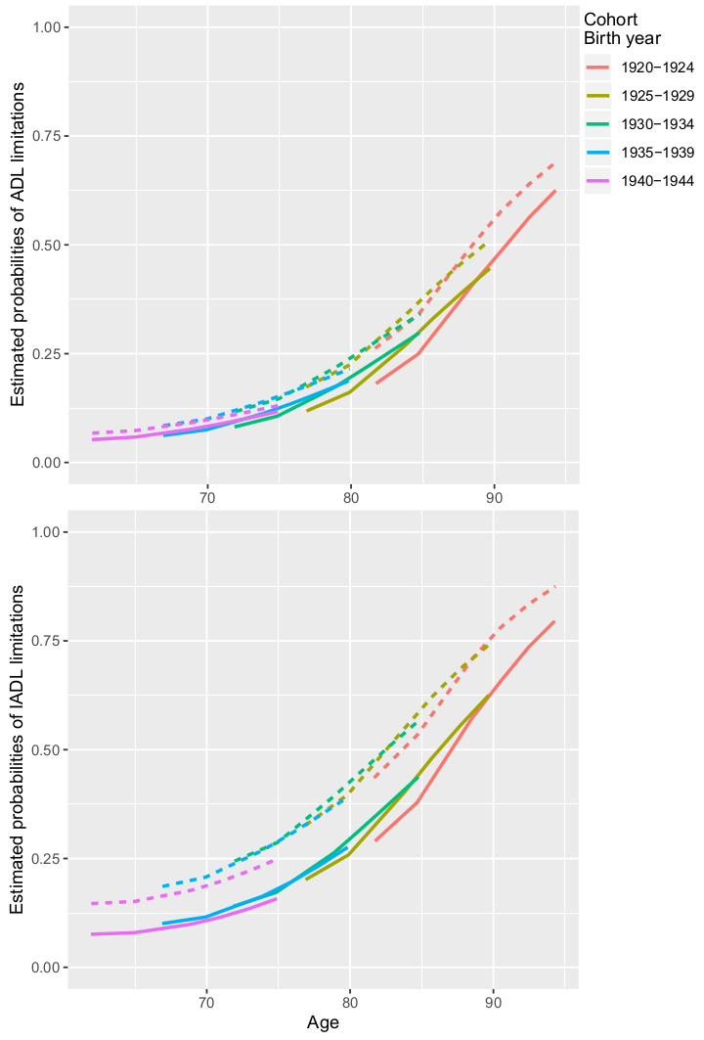

Figure S1. Estimated Probabilities of ADL and IADL limitations in xx European countries, 2004 – 2017. Estimated from multilevel growth curve models. Unweighted sample

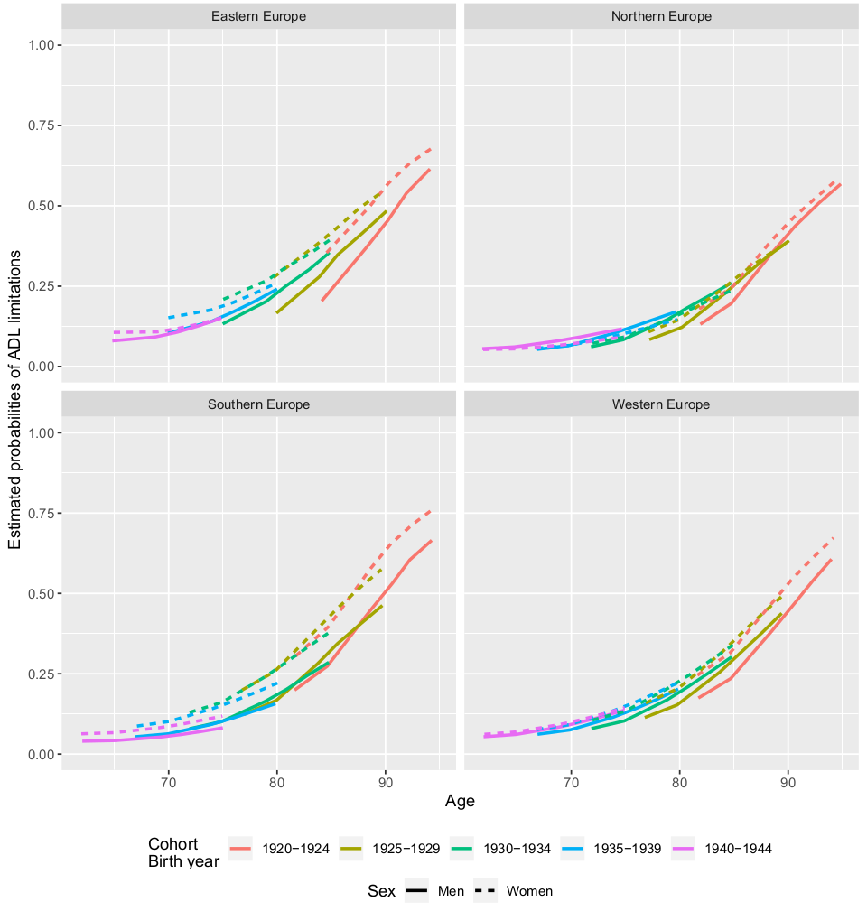

Figure S2. Estimated Probabilities of ADL limitations in European regions, 2004 – 2017. Estimated from multilevel growth curve models. Unweighted sample.

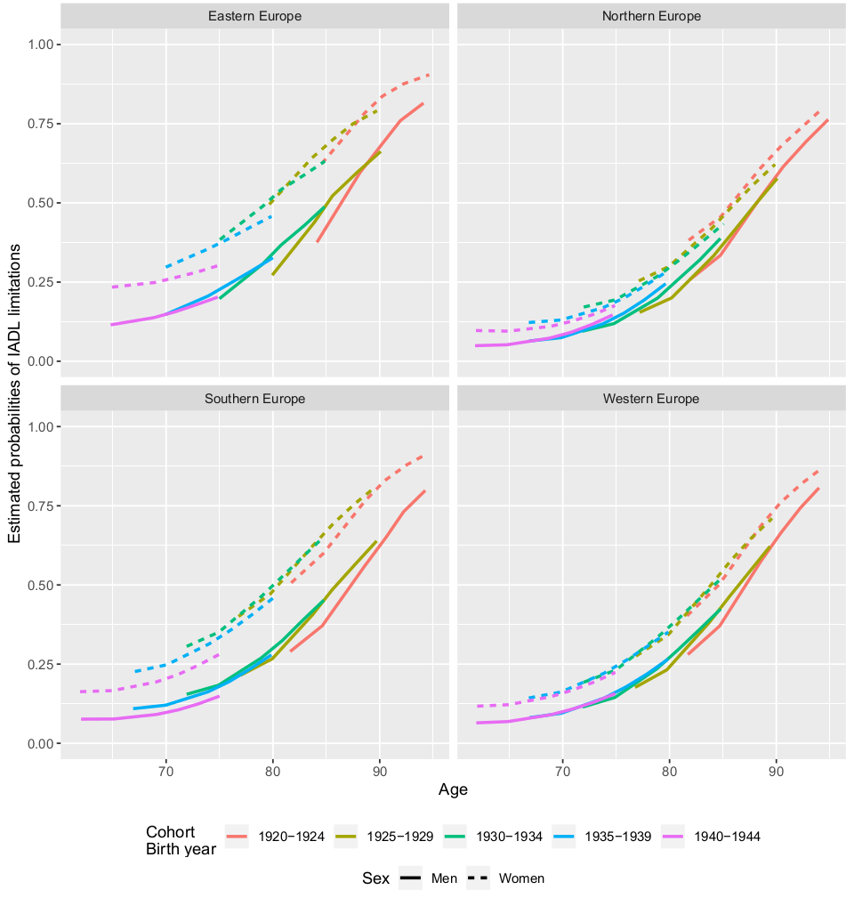

Figure S3. Estimated Probabilities of IADL limitations in European regions, 2004 – 2017. Estimated from multilevel growth curve models. Unweighted sample.