## Sex, ageing and disabilities: cohort trajectories of functional decline among older adults in Europe 2004-2017.

Stefan Fors a b *

Author list [TBD]

Johan Rehnberg a c

*a Aging Research Center, Karolinska Institutet & Stockholm University, Stockholm, Sweden.*

*b Center for Epidemiology and Community Medicine, Region Stockholm, Stockholm, Sweden.*

*c Department of Public Health Sciences, Stockholm University, Stockholm, Sweden.*

* Corresponding author:

Stefan Fors

Aging Research Center

Tomtebodavägen 18A

SE-171 65 Solna

SWEDEN

## Introduction

The likelihood of having a long and healthy life differs by sex. The ‘gender paradox in health’ suggests that women tend to have worse health than men, yet lower mortality – or as the adage goes: ‘women are sicker, but men die quicker’ [ref]. The mechanisms behind these sex differences in health are only partly known to date, but there is strong evidence suggesting that the aetiology comprise both biological and social components (Mauvais-Jarvis et al. 2020). Scheel-Hinke et al. (2020) conducted a study that explicitly addressed sex differences in late-life disabilities. They found consistent sex differences in the prevalence of disabilities in the older age groups. They also found that, in absolute terms, the sex differences increased with age.

The overarching aim of this study is to track the development of disabilities in later life in cohorts of older women and men in different regions of Europe between 2004 and 2017.

Several research teams have studied trends in the prevalence of late-life disabilities among women and men in Europe using repeated cross-sectional designs. Chatterji et al. (2015) found that the prevalence of ADL and IADL limitations in Europe were largely stable during the period 2004-2006. In a more recent study, Ahrenfeldt et al. (2018) also found largely stable prevalences of ADL limitations in Europe during the period 2004-5 to 2013. Yet, they observed some regional heterogeneity in the development. The prevalence of IADL-limitations decreased in Northern and Southern Europe, and the oldest age groups (70+) in Northern Europe also showed declines in ADL-limitations during the period. This decline in the prevalence of old-age disabilities in Northern Europe has also been observed in several national studies [ref].

Temporal trends in the prevalence of late-life disabilities are largely driven by cohort replacement within the older population. As older cohorts die out and new cohorts, who have experienced different living conditions and exposures throughout the life-course, come into old age the characteristics of the older population changes. To the extent that these cohorts enter old age with different levels of disabilities, or different patterns of risk factors for disabilities, it will affect the incidence and prevalence of disabilities in the older population.

## [add passage on changing gender relations across cohorts – and potential impact on late-life disabilities]

## Data and methods

The Survey of Health, Ageing and Retirement in Europe (SHARE) is a cross-national and longitudinal survey that collects data on health, social and economic factors among Europeans aged 50 and older. The data collection is conducted by face-to-face interviews. The samples are drawn at the household level and the response rate in Wave 1 varied between 51 percent in Spain and 67 percent in Denmark. Calibrated weights have been developed centrally by the SHARE team, to match the size of the target population in each country and to account for the size of the populations across eight sex-age groups and across NUTS1 regional areas.

The analytical sample used in this study consists of five five-year cohorts born between 1920 and 1944 from all countries that participated in the first or second wave of the SHARE data collection, except for Israel and Ireland. We opted to exclude Israel since we limited our analysis to European countries, and Ireland as it did not participate in wave 4 to 7. In order to gain sufficient statistical power, the thirteen included countries were grouped into the following four region-based groups. *Northern Europe*: Sweden and Denmark. *Western Europe*: Austria, Germany, the Netherlands, France, Switzerland, and Belgium. *Southern Europe*: Spain, Italy, and Greece. *Eastern Europe*: Czech Republic, and Poland. This grouping has been used in previous studies based on SHARE data [ref].

### Variables

Physical functioning was measured by indices of ADL and IADL items. The ADL index consisted of six tasks that assessed whether the respondent had difficulties with: dressing; bathing or showering; eating or cutting up food; walking across a room; and using the toilet including getting up or down. The IADL index included seven items that assessed whether the respondent had difficulties with: using a map in a unknown place; preparing a hot meal; shopping for groceries; making a telephone call; taking medications; doing work around the house or garden; and managing money. The respondents were considered limited on either scale if they had at least one limitation. These indices has previously been used to analyse health trends in SHARE [ref].

### Statistical method

The data is structured as repeated observations for individuals that participated in SHARE wave 1 (2004) or wave 2 (2007) and at least one subsequent wave. We fit generalized linear mixed model (GLMM) that estimate the level of ADL and IADL at baseline, in wave 1 or wave 2, and then the change in ADL and IADL through subsequent waves up to wave 7 (2004–2017) for five-year cohorts from each region. A similar analytical strategy has previously been used in studies that examined cohort trajectories of frailty in the UK (Marshall et al., 2015; Rogers et al., 2017).

Formally, the model reads as follows:

Level 1 model

(I)ADLti = β0i + β1waveti + eti (1)

Level 2 model: intercept

β0i = γ00 + γ01 cohort + γ01 sex + γ02 cohort sex + (2)  
γ03 wave sex + γ04 wave cohort + γ05 cohort2 + u0i

Level 2 model: slope

β1i = γ00 + γ11 cohort + γ11 sex + γ12 cohort sex + (3)  
γ13 wave sex + γ14 wave cohort + γ15 cohort2 + u0i

The model above first specifies the level 1 model that estimates ADL and IADL for each individual (i) at each observed point in time (t). In this model, time is assessed by the wave of the observation (from 1 to 7). We tested a quadratic wave term to allow the trajectories to take on non-linear shapes, however, the quadratic term was not statistically significant and did not alter the model substantially and were, as a consequence, not included in the final models. In the first equation (1), the intercept β0i gives the mean ADL of person i in wave 1 or wave 2 while β1i and β2i give the linear and quadratic growth of ADL and IADL over time for individual i. In equation 2 and 3 the intercept and slope is defined for each individual in the sample. The inclusion of cohort and sex enables the modelling of the intercept and the slope separately for each cohort and sex. Moreover, an interaction term was included between sex and cohort, and between wave and cohort to allow for different trajectories across waves and between the sexes.

Calibrated cross-sectional weights from the first wave that the participants were included were used to account for imbalances in the sample. Sensitivity tests were performed to assess whether applying weights affected the results from the analyses. These tests showed that applying weights did not affect the main results of the analyses (see Supplementary figure 1-4 for the main results without weights)

From these models, average marginal effects were estimated for each cohort across waves and by sex. In the final step, wave was transformed into the average age of each cohort at each survey wave to facilitate intuitive interpretation.

## Results

Table 1 shows descriptive statistics for the complete pooled data from all regions, by cohort and wave. The number of observations in each cohort and wave ranged from 3165 persons for the youngest cohort of women (born between 1945 and 1949) in wave two, to 69 persons in the oldest cohort of men (born between 1920 and 1924) in wave seven. For each cohort, the highest number of observations were seen in wave two, this occurred because we included respondents that entered the survey at either wave one or wave two. This allowed for additional respondents to be included in wave two due to refreshment sampling.

ADL and IADL limitations increased with age within each cohort. In the first wave (2004) of the youngest cohort (aged between 55 and 59) 4.9 percent had ADL limitations, while at the last observation (wave 7) when the cohort was aged between 68 and 72, the proportion with ADL limitations had increased to 7.3 percent. The corresponding increase in IADL ranged from 10.6 percent in wave one to 14.2 in wave seven. The oldest cohort (born between 1920 and 1924) was aged between 80 and 84 at wave one when 27.1 percent had ADL limitations, at the end of the follow-up period 61.8 percent of this cohort (now aged between 93 and 97) had ADL limitations. The corresponding increase in IADL limitations increased from 43.8 percent in wave 1 to 80.1 in wave 7.

Table 1. Descriptive statistics of the analytical sample.

|  |  |  |  |  |  |  |  |
| --- | --- | --- | --- | --- | --- | --- | --- |
| Cohort |  | Wave 1 | Wave 2 | Wave 4 | Wave 5 | Wave 6 | Wave 7 |
|  |  | 2004 | 2007 | 2011 | 2013 | 2015 | 2017 |
| 1944-1940 | Men (n) | 1757 | 2263 | 1588 | 1494 | 1463 | 1319 |
| Women (n) | 2031 | 2662 | 1846 | 1774 | 1769 | 1633 |
| Mean age (years) | 61.9 | 64.9 | 68.9 | 70.9 | 72.9 | 74.9 |
| ADL limitations (%) | 7.1 | 7.7 | 8.6 | 10.0 | 10.8 | 11.9 |
| IADL limitations (%) | 13.2 | 15.3 | 15.8 | 18.4 | 21.6 | 22.6 |
| 1939-1935 | Men (n) | 1634 | 2076 | 1383 | 1282 | 1267 | 1069 |
| Women (n) | 1788 | 2231 | 1520 | 1455 | 1451 | 1261 |
| Mean age (years) | 66.9 | 69.9 | 73.9 | 75.9 | 77.9 | 79.9 |
| ADL limitations (%) | 6.9 | 9.6 | 14.0 | 15.9 | 17.6 | 19.5 |
| IADL limitations (%) | 17.6 | 21.0 | 25.3 | 28.5 | 34.1 | 40.7 |
| 1934-1930 | Men (n) | 1269 | 1585 | 1038 | 953 | 859 | 693 |
| Women (n) | 1442 | 1759 | 1169 | 1117 | 1087 | 865 |
| Mean age (years) | 71.9 | 74.9 | 78.9 | 80.9 | 82.8 | 84.8 |
| ADL limitations (%) | 11.6 | 15.3 | 22.0 | 23.5 | 27.0 | 30.8 |
| IADL limitations (%) | 24.7 | 31.8 | 35.8 | 43.2 | 48.9 | 56.0 |
| 1929-1925 | Men (n) | 870 | 1013 | 591 | 475 | 390 | 265 |
| Women (n) | 1127 | 1331 | 863 | 746 | 666 | 464 |
| Mean age (years) | 76.9 | 79.9 | 83.8 | 85.7 | 87.7 | 89.7 |
| ADL limitations (%) | 16.7 | 21.8 | 30.1 | 36.1 | 43.8 | 46.1 |
| IADL limitations (%) | 31.5 | 38.6 | 48.0 | 56.8 | 66.7 | 71.8 |
| 1924-1920 | Men (n) | 464 | 520 | 256 | 189 | 133 | 69 |
| Women (n) | 682 | 760 | 383 | 302 | 218 | 136 |
| Mean age (years) | 81.7 | 84.7 | 88.6 | 90.5 | 92.4 | 94.3 |
| ADL limitations (%) | 27.1 | 33.8 | 48.6 | 54.0 | 56.0 | 61.8 |
| IADL limitations (%) | 43.8 | 53.0 | 70.5 | 70.5 | 77.5 | 80.1 |

Figure 1 and 2 shows the results of the cohort analyses for the all regions pooled together, by sex and cohort. The precise estimates are presented in Supplementary Tables 1 and 2. ADL limitations increased with age, and the patterns indicates an accelerated increase of limitations in higher ages. Moreover, for men, younger cohort had a higher prevalence of ADL limitations than older cohorts in the beginning of the study period. This trend was especially noticeable in the three cohorts born before 1935. However, at the end of the measurement period the prevalence of ADL limitations at equivalent ages for men converged across the cohorts. For women, the cohort trends overlapped across cohorts, with no clear improvement or deterioration of limitations for any of the cohorts.

Women reported more ADL-limitations than men. Yet, the sex differences were small in the younger cohorts and larger for the older cohorts. However, the differences remained relatively stable within cohorts during the entire measurement period.

The prevalence of IADL limitations also increased with age. However, no clear trends towards either improvement or deterioration across cohorts were observed. The youngest cohorts of both men and women (born between 1940 and 1944) had somewhat lower levels of IADL limitations at any given age than their respective older cohort (born between 1935 and 1939). The reversed pattern was again seen in the two oldest cohorts, where the oldest cohort (born between 1920 and 1924) had somewhat lower levels of IADL problems than the second oldest cohort (born between 1925 and 1929).

Women reported more IADL-limtations than men. These sex differences were constant across the cohorts, however, as with ADL limitations, no clear age effect was observed within the cohorts.

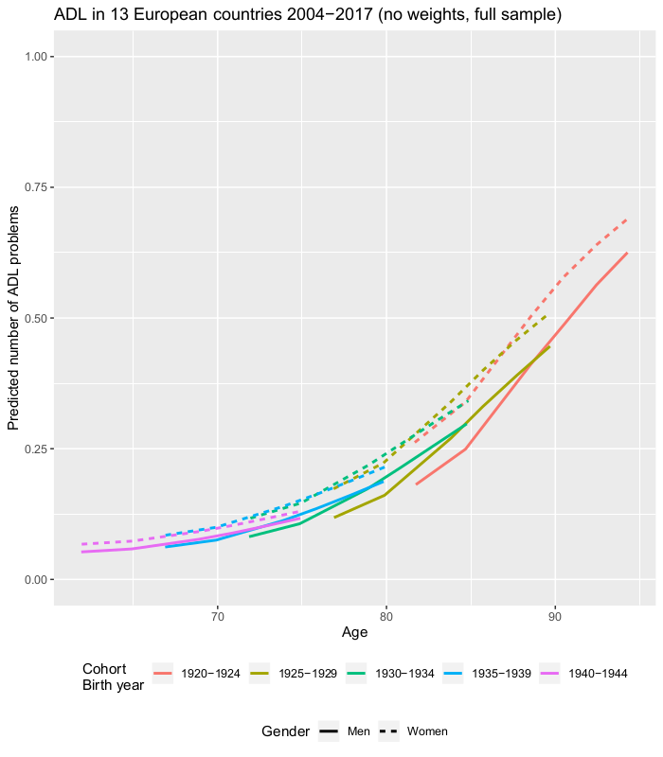

Figure 1. ADL limitations in xx European countries, 2004 – 2017. Predicted from multilevel growth curve models, see Supplementary table 1.

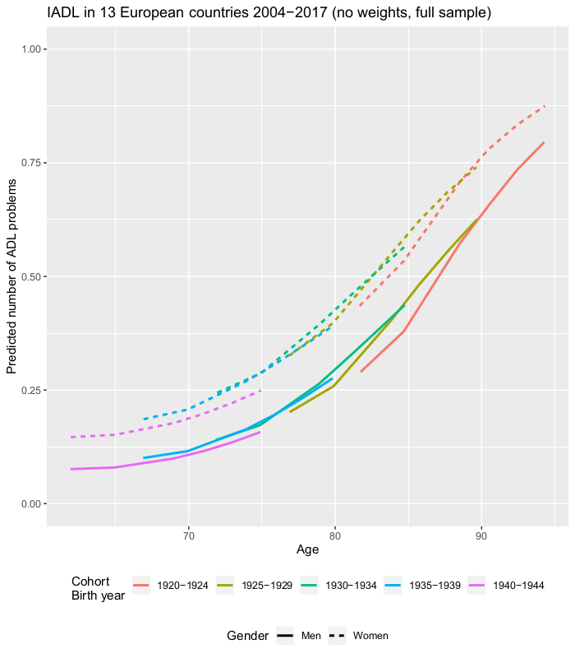

Figure 2. IADL limitations in xx European countries, 2004 – 2017. Predicted from multilevel growth curve models, see Supplementary table 2.

Figure 2 and 4 shows the corresponding results by region. The exact estimates are presented in Supplementary table 3.

The overall trends in ADL limitations were similar in all four regions, albeit with some differences in the levels of limitations. In Eastern Europe the initial levels of ADL limitations in the youngest cohorts were somewhat higher than in the other three regions. However, in the oldest cohorts the highest prevalence of ADL limitations was observed in Southern and Western Europe.

The prevalence of ADL limitations increased with age in each cohort. However, the age trends across cohorts were somewhat disparate between sex and regions. For men in Eastern Europe, men and to some degree women in Northern and Western Europe, older cohorts showed a lower prevalence of ADL limitations at any given age, especially at the first few observations in each cohort. The reversed pattern was observed for women in Eastern Europe, where older cohorts showed a higher prevalence of ADL limitations than younger cohorts. In Southern Europe, the age-pattern of ADL limitations overlapped almost completely across cohorts.

Moreover, we observe marked variations in sex differences in the patterning of ADL limitations across the regions. In Northern and Western Europe, sex differences in ADL limitations were small or non-existent in all age groups. In Eastern and Southern Europe, on the other hand, there were marked sex differences in ADL limitations, where women reported more limitations than men. In Eastern Europe, the sex differences were greater in the older cohorts than in younger cohorts. In Southern Europe, there were no discernible cohort effects in the sex differences.

Overall, the trends in IADL limitations were similar to the trends in ADL limitations. Here too we saw higher prevalence of limitations among the younger cohorts in Eastern Europe compared to the younger cohorts in the other regions. In the older cohorts, regional differences were small, only Northern Europe showed a somewhat lower prevalence of IADL limitations compared to the other regions in the older age groups.

IADL limitations increased more rapidly with age than ADL limitations, with levels starting at around 10 to 20 percent of respondents with IADL limitations in the youngest cohorts ranging up to 75-85 percent in the older cohorts. Moreover, only men in Eastern and Western Europe showed trends of higher rates of limitations in younger cohorts. Among women in Eastern Europe, the reverse pattern was observed. Here, each subsequent younger cohort showed a substantially lower prevalence of limitations compared to the older cohorts.

In all ages and in all regions, women had higher prevalence of IADL limitations than men. The sex differences in IADL limitations were more marked than in ADL limitations, and again, Eastern and Southern Europe showed the highest levels difference between men and women. The differences were also substantial in Northern and Western Europe, albeit at lower levels compared to the other two regions.

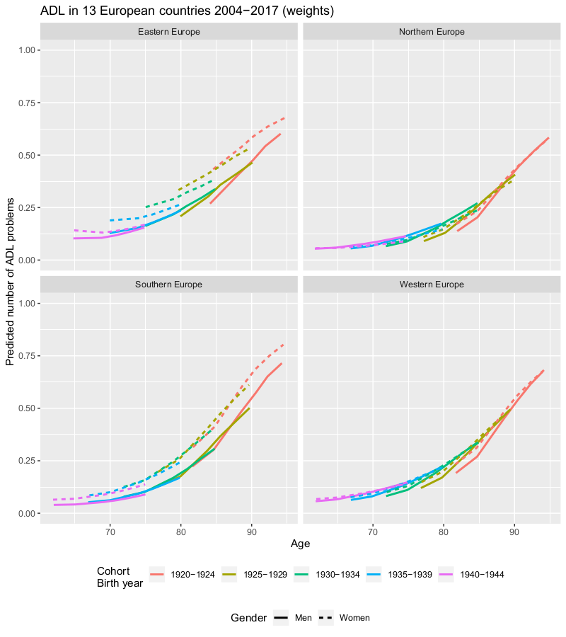

Figure 3. ADL limitations in xx European countries, 2004 – 2017. Predicted from multilevel growth curve models, see Supplementary table 3.

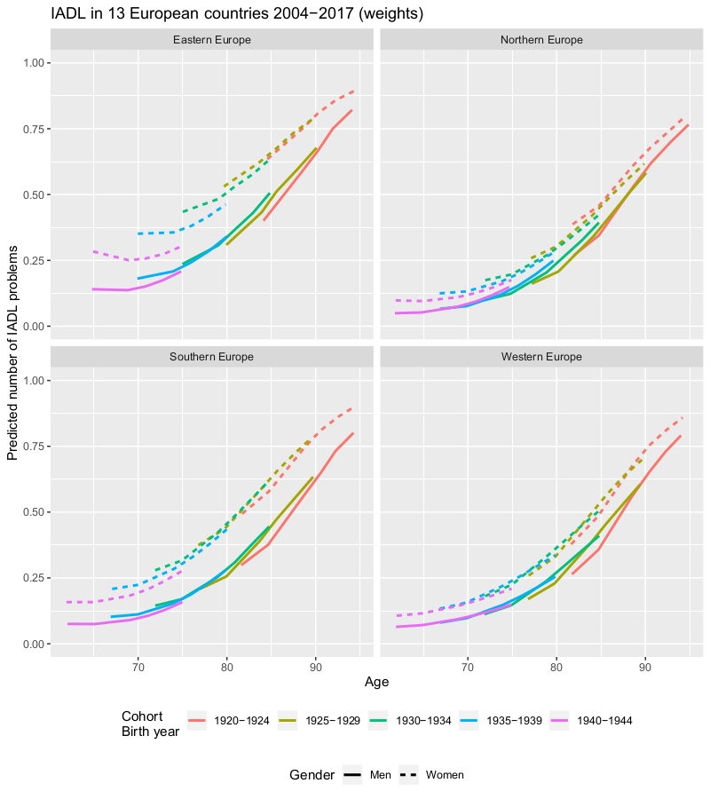

Figure 4. IADL limitations in xx European countries, 2004 – 2017. Predicted from multilevel growth curve models, see Supplementary table 3.

## Discussion

* Summary of the results
* Limitations and strengths
  + - Descriptive (no causal interpretations)
    - Non-response & attrition
    - Representative sampling
    - Longitudinal
    - Regional comparisons
* Discussion of results
  + - Improvements in Eastern Europe
    - Little change in rest of Europe
    - Lower prevalence in Northern Europe
    - Fairly stable sex differences
* Conclusion
  + - Stable cohort trajectories of functional decline
    - Stable sex differences
    - Improvements in Eastern Europe and better health in Northern Europe

Period effects rather than cohort effects?

## Supplementary data

Supplementary table 1. Generalized linear mixed model, binomial distribution. Outcome: ADL. Complete population (figure 1).

Supplementary table 2. Generalized linear mixed model, binomial distribution. Outcome: IADL. Complete population (figure 2).

Supplementary table 3. Generalized linear mixed model, binomial distribution. Outcome: ADL. Stratified by region (Figure 3 and Figure 4).

|  |  |  |  |  |  |  |  |  |  |  |  |  |  |  |  |  |  |  |
| --- | --- | --- | --- | --- | --- | --- | --- | --- | --- | --- | --- | --- | --- | --- | --- | --- | --- | --- |
|  | | ADL | |  |  | |  | |  | | IADL | |  | |  | |  | |
|  | | Coef. | | P-value | LCI | | UCI | |  | | Coef. | | P-value | | LCI | | UCI | |
| Northern Europe | |  | |  |  | |  | |  | |  | |  | |  | |  | |
| Sex (1=women) | | 0.332 | | 0.000 | 0.319 | | 0.345 | |  | | 1.106 | | 0.000 | | 1.094 | | 1.118 | |
| Cohort | | 0.202 | | 0.000 | 0.196 | | 0.208 | |  | | 0.584 | | 0.000 | | 0.578 | | 0.590 | |
| Wave | | 0.358 | | 0.000 | 0.352 | | 0.365 | |  | | 0.182 | | 0.000 | | 0.176 | | 0.188 | |
| Wave*cohort | | 0.169 | | 0.000 | 0.168 | | 0.170 | |  | | 0.160 | | 0.000 | | 0.159 | | 0.161 | |
| Gender*wave | | -0.098 | | 0.000 | -0.101 | | -0.095 | |  | | -0.105 | | 0.000 | | -0.107 | | -0.102 | |
| Gender*cohort | | 0.085 | | 0.000 | 0.078 | | 0.091 | |  | | -0.025 | | 0.000 | | -0.031 | | -0.019 | |
| Wave*wave | | -0.006 | | 0.000 | -0.007 | | -0.005 | |  | | 0.032 | | 0.000 | | 0.031 | | 0.033 | |
| Cohort*cohort | | 0.111 | | 0.000 | 0.108 | | 0.114 | |  | | 0.106 | | 0.000 | | 0.103 | | 0.108 | |
| Intercept | | -4.621 | | 0.000 | -4.639 | | -4.604 | |  | | -3.874 | | 0.000 | | -3.889 | | -3.858 | |
|  | |  | |  |  | |  | |  | |  | |  | |  | |  | |
| Wave | | 0.152 | | 0.154 |  | |  | |  | | 0.141 | | 0.143 | |  | |  | |
| Intercept | | 4.735 | | 4.772 |  | |  | |  | | 4.826 | | 4.858 | |  | |  | |
|  | |  | |  |  | |  | |  | |  | |  | |  | |  | |
| Western Europe | |  | |  |  | |  | |  | |  | |  | |  | |  | |
| Sex (1=women) | | 0.398 | | 0.000 | 0.394 | | 0.402 | |  | | 0.827 | | 0.000 | | 0.824 | | 0.831 | |
| Cohort | | 0.367 | | 0.000 | 0.365 | | 0.369 | |  | | 0.456 | | 0.000 | | 0.455 | | 0.458 | |
| Wave | | 0.435 | | 0.000 | 0.433 | | 0.437 | |  | | 0.374 | | 0.000 | | 0.372 | | 0.375 | |
| Wave*cohort | | 0.151 | | 0.000 | 0.150 | | 0.151 | |  | | 0.160 | | 0.000 | | 0.160 | | 0.160 | |
| Gender*wave | | -0.058 | | 0.000 | -0.059 | | -0.057 | |  | | 0.003 | | 0.000 | | 0.002 | | 0.003 | |
| Gender*cohort | | 0.042 | | 0.000 | 0.041 | | 0.044 | |  | | 0.029 | | 0.000 | | 0.027 | | 0.030 | |
| Wave*wave | | -0.003 | | 0.000 | -0.003 | | -0.002 | |  | | 0.007 | | 0.000 | | 0.007 | | 0.007 | |
| Cohort*cohort | | 0.119 | | 0.000 | 0.118 | | 0.120 | |  | | 0.094 | | 0.000 | | 0.093 | | 0.095 | |
| Intercept | | -4.494 | | 0.000 | -4.499 | | -4.489 | |  | | -3.712 | | 0.000 | | -3.716 | | -3.708 | |
|  | |  | |  |  | |  | |  | |  | |  | |  | |  | |
| Wave | | 0.122 | | 0.123 |  | |  | |  | | 0.085 | | 0.085 | |  | |  | |
| Intercept | | 5.268 | | 5.279 |  | |  | |  | | 4.349 | | 4.357 | |  | |  | |
|  |  | |  | | |  | |  | |  | |  | |  | |  | |  | |
| Southern Europe |  | |  | | |  | |  | |  | |  | |  | |  | |  | |
| Sex (1=women) | 0.682 | | 0.000 | | | 0.677 | | 0.686 | |  | | 1.112 | | 0.000 | | 1.108 | | 1.115 | |
| Cohort | 0.518 | | 0.000 | | | 0.515 | | 0.520 | |  | | 0.412 | | 0.000 | | 0.410 | | 0.414 | |
| Wave | 0.284 | | 0.000 | | | 0.282 | | 0.286 | |  | | 0.120 | | 0.000 | | 0.119 | | 0.122 | |
| Wave*cohort | 0.166 | | 0.000 | | | 0.165 | | 0.166 | |  | | 0.139 | | 0.000 | | 0.138 | | 0.139 | |
| Gender*wave | 0.038 | | 0.000 | | | 0.037 | | 0.039 | |  | | 0.027 | | 0.000 | | 0.026 | | 0.027 | |
| Gender*cohort | 0.022 | | 0.000 | | | 0.020 | | 0.025 | |  | | 0.034 | | 0.000 | | 0.033 | | 0.036 | |
| Wave*wave | 0.007 | | 0.000 | | | 0.007 | | 0.007 | |  | | 0.029 | | 0.000 | | 0.029 | | 0.029 | |
| Cohort*cohort | 0.099 | | 0.000 | | | 0.099 | | 0.100 | |  | | 0.043 | | 0.000 | | 0.042 | | 0.044 | |
| Intercept | -4.104 | | 0.000 | | | -4.109 | | -4.099 | |  | | -2.665 | | 0.000 | | -2.669 | | -2.662 | |
|  |  | |  | | |  | |  | |  | |  | |  | |  | |  | |
| Wave | 0.103 | | 0.104 | | |  | |  | |  | | 0.068 | | 0.068 | |  | |  | |
| Intercept | 4.056 | | 4.065 | | |  | |  | |  | | 2.560 | | 2.566 | |  | |  | |
|  |  | |  | | |  | |  | |  | |  | |  | |  | |  | |
| Eastern Europe |  | |  | | |  | |  | |  | |  | |  | |  | |  | |
| Sex (1=women) | 0.775 | | 0.000 | | | 0.766 | | 0.785 | |  | | 1.327 | | 0.000 | | 1.319 | | 1.336 | |
| Cohort | 0.043 | | 0.000 | | | 0.038 | | 0.048 | |  | | 0.152 | | 0.000 | | 0.147 | | 0.156 | |
| Wave | -0.128 | | 0.000 | | | -0.135 | | -0.122 | |  | | -0.081 | | 0.000 | | -0.086 | | -0.076 | |
| Wave*cohort | 0.155 | | 0.000 | | | 0.154 | | 0.156 | |  | | 0.153 | | 0.000 | | 0.152 | | 0.154 | |
| Gender*wave | -0.045 | | 0.000 | | | -0.048 | | -0.043 | |  | | -0.057 | | 0.000 | | -0.059 | | -0.055 | |
| Gender*cohort | 0.129 | | 0.000 | | | 0.125 | | 0.134 | |  | | 0.040 | | 0.000 | | 0.036 | | 0.044 | |
| Wave*wave | 0.028 | | 0.000 | | | 0.028 | | 0.029 | |  | | 0.045 | | 0.000 | | 0.044 | | 0.045 | |
| Cohort*cohort | 0.021 | | 0.000 | | | 0.019 | | 0.023 | |  | | 0.027 | | 0.000 | | 0.026 | | 0.029 | |
| Intercept | -1.946 | | 0.000 | | | -1.960 | | -1.931 | |  | | -1.590 | | 0.000 | | -1.602 | | -1.578 | |
|  |  | |  | | |  | |  | |  | |  | |  | |  | |  | |
| Wave | 0.175 | | 0.176 | | |  | |  | |  | | 0.067 | | 0.068 | |  | |  | |
| Intercept | 0.877 | | 0.895 | | |  | |  | |  | | 1.621 | | 1.634 | |  | |  | |

Supplementary table 4. Generalized linear mixed model, binomial distribution. Outcome: IADL. Stratified by region (figure 4).

Supplementary table 5. Generalized linear mixed model, binomial distribution. Outcome: ADL. Stratified by region. With/without weights.

Supplementary table 6. Generalized linear mixed model, binomial distribution. Outcome: IADL. Stratified by region. With/without weights.

|  |  |  |  |  |  |  |  |
| --- | --- | --- | --- | --- | --- | --- | --- |
| Northern europe |  |  |  |  |  |  |  |
|  |  |  |  |  |  |  |  |
| Cohort |  | Wave 1 | Wave 2 | Wave 4 | Wave 5 | Wave 6 | Wave 7 |
| 1949-1945 | Men (n) | 334 | 423 | 324 | 347 | 330 | 297 |
| Women (n) | 430 | 507 | 408 | 430 | 401 | 356 |
|  | Mean age (years) | 57.1 | 60.1 | 64.1 | 66.1 | 68.1 | 70.1 |
|  | ADL limitations (%) | 4.2 | 6.1 | 5.1 | 7.0 | 8.0 | 7.9 |
|  | IADL limitations (%) | 12.1 | 10.1 | 8.1 | 12.6 | 10.5 | 12.6 |
| 1944-1940 | Men (n) | 321 | 387 | 304 | 309 | 277 | 228 |
| Women (n) | 354 | 469 | 348 | 343 | 333 | 289 |
|  | Mean age (years) | 61.8 | 64.8 | 68.8 | 70.8 | 72.8 | 74.8 |
|  | ADL limitations (%) | 5.6 | 5.8 | 6.0 | 7.6 | 8.1 | 9.7 |
|  | IADL limitations (%) | 10.5 | 9.6 | 10.6 | 11.4 | 15.6 | 15.9 |
| 1939-1935 | Men (n) | 260 | 333 | 260 | 253 | 219 | 180 |
| Women (n) | 268 | 309 | 252 | 235 | 219 | 186 |
|  | Mean age (years) | 66.8 | 69.8 | 73.8 | 75.8 | 77.7 | 79.7 |
|  | ADL limitations (%) | 4.1 | 4.9 | 10.3 | 6.8 | 12.3 | 11.8 |
|  | IADL limitations (%) | 11.9 | 9.1 | 17.5 | 18.7 | 25.6 | 26.9 |
| 1934-1930 | Men (n) | 205 | 234 | 177 | 159 | 137 | 108 |
| Women (n) | 217 | 242 | 204 | 198 | 183 | 136 |
|  | Mean age (years) | 71.9 | 74.9 | 78.9 | 80.9 | 82.9 | 84.9 |
|  | ADL limitations (%) | 7.8 | 12.4 | 12.7 | 17.2 | 15.3 | 16.2 |
|  | IADL limitations (%) | 17.1 | 21.5 | 27.9 | 26.3 | 29.5 | 36.8 |
| 1929-1925 | Men (n) | 159 | 182 | 123 | 93 | 71 | 47 |
| Women (n) | 181 | 226 | 159 | 141 | 115 | 81 |
|  | Mean age (years) | 77.2 | 80.0 | 84.0 | 85.9 | 87.9 | 90.0 |
|  | ADL limitations (%) | 12.7 | 13.7 | 20.1 | 24.8 | 28.7 | 33.3 |
|  | IADL limitations (%) | 27.6 | 29.6 | 36.5 | 44.7 | 53.0 | 56.8 |
| 1924-1920 | Men (n) | 80 | 92 | 50 | 41 | 27 | 14 |
| Women (n) | 101 | 118 | 67 | 59 | 40 | 26 |
|  | Mean age (years) | 81.8 | 84.8 | 88.6 | 90.6 | 92.7 | 94.5 |
|  | ADL limitations (%) | 17.8 | 24.6 | 32.8 | 40.7 | 37.5 | 50.0 |
|  | IADL limitations (%) | 32.7 | 48.3 | 62.7 | 52.5 | 57.5 | 73.1 |
|  |  |  |  |  |  |  |  |
| Western europe |  |  |  |  |  |  |  |
|  |  |  |  |  |  |  |  |
| Cohort |  | Wave 1 | Wave 2 | Wave 4 | Wave 5 | Wave 6 | Wave 7 |
| 1949-1945 | Men (n) | 986 | 1091 | 862 | 762 | 537 | 505 |
| Women (n) | 1187 | 1272 | 1051 | 937 | 633 | 587 |
|  | Mean age (years) | 56.9 | 59.9 | 63.9 | 65.9 | 67.8 | 69.8 |
|  | ADL limitations (%) | 5.1 | 5.7 | 6.3 | 6.6 | 9.0 | 8.3 |
|  | IADL limitations (%) | 10.6 | 10.6 | 11.5 | 12.5 | 14.5 | 16.0 |
| 1944-1940 | Men (n) | 851 | 940 | 746 | 641 | 451 | 400 |
| Women (n) | 972 | 1081 | 865 | 776 | 545 | 497 |
|  | Mean age (years) | 61.9 | 64.9 | 68.9 | 70.9 | 72.9 | 74.9 |
|  | ADL limitations (%) | 7.1 | 7.2 | 8.8 | 10.6 | 12.1 | 11.3 |
|  | IADL limitations (%) | 11.4 | 11.9 | 14.9 | 16.8 | 19.1 | 17.7 |
| 1939-1935 | Men (n) | 802 | 863 | 667 | 540 | 400 | 329 |
| Women (n) | 863 | 922 | 730 | 632 | 462 | 387 |
|  | Mean age (years) | 66.9 | 69.8 | 73.9 | 75.9 | 77.9 | 79.9 |
|  | ADL limitations (%) | 6.0 | 8.0 | 11.9 | 15.8 | 18.6 | 19.9 |
|  | IADL limitations (%) | 14.5 | 15.7 | 20.3 | 24.7 | 29.0 | 33.1 |
| 1934-1930 | Men (n) | 578 | 624 | 473 | 393 | 258 | 191 |
| Women (n) | 684 | 716 | 573 | 487 | 343 | 271 |
|  | Mean age (years) | 71.9 | 74.9 | 78.9 | 80.9 | 82.9 | 84.9 |
|  | ADL limitations (%) | 11.8 | 13.3 | 21.1 | 18.9 | 30.6 | 33.2 |
|  | IADL limitations (%) | 20.3 | 23.7 | 32.6 | 37.2 | 43.7 | 50.2 |
| 1929-1925 | Men (n) | 422 | 441 | 279 | 203 | 127 | 85 |
| Women (n) | 570 | 585 | 443 | 334 | 241 | 170 |
|  | Mean age (years) | 76.8 | 79.8 | 83.8 | 85.7 | 87.6 | 89.5 |
|  | ADL limitations (%) | 14.6 | 20.0 | 27.3 | 29.6 | 42.3 | 41.8 |
|  | IADL limitations (%) | 28.4 | 33.8 | 46.7 | 51.5 | 64.7 | 68.2 |
| 1924-1920 | Men (n) | 235 | 234 | 132 | 75 | 39 | 20 |
| Women (n) | 348 | 349 | 198 | 132 | 84 | 59 |
|  | Mean age (years) | 81.7 | 84.7 | 88.5 | 90.4 | 92.4 | 94.1 |
|  | ADL limitations (%) | 26.4 | 32.1 | 48.5 | 50.0 | 57.1 | 54.2 |
|  | IADL limitations (%) | 41.4 | 46.1 | 70.7 | 68.9 | 78.6 | 72.9 |
|  |  |  |  |  |  |  |  |
| Southern europe |  |  |  |  |  |  |  |
|  |  |  |  |  |  |  |  |
| Cohort |  | Wave 1 | Wave 2 | Wave 4 | Wave 5 | Wave 6 | Wave 7 |
| 1949-1945 | Men (n) | 523 | 649 | 304 | 330 | 541 | 483 |
| Women (n) | 602 | 731 | 424 | 425 | 613 | 587 |
|  | Mean age (years) | 56.9 | 59.9 | 63.9 | 65.9 | 67.9 | 69.9 |
|  | ADL limitations (%) | 4.3 | 4.0 | 5.7 | 8.5 | 5.9 | 5.8 |
|  | IADL limitations (%) | 9.5 | 12.4 | 11.3 | 14.1 | 13.1 | 14.1 |
| 1944-1940 | Men (n) | 473 | 577 | 328 | 316 | 470 | 434 |
| Women (n) | 564 | 665 | 377 | 357 | 535 | 510 |
|  | Mean age (years) | 62.0 | 65.0 | 69.1 | 71.1 | 73.0 | 75.0 |
|  | ADL limitations (%) | 7.1 | 6.5 | 9.0 | 11.2 | 8.2 | 10.2 |
|  | IADL limitations (%) | 15.2 | 15.8 | 15.1 | 22.7 | 23.4 | 25.3 |
| 1939-1935 | Men (n) | 435 | 540 | 301 | 284 | 405 | 349 |
| Women (n) | 512 | 595 | 334 | 328 | 454 | 409 |
|  | Mean age (years) | 67.0 | 70.0 | 74.0 | 76.0 | 78.0 | 79.9 |
|  | ADL limitations (%) | 8.6 | 9.2 | 17.4 | 19.2 | 17.6 | 22.2 |
|  | IADL limitations (%) | 22.1 | 25.7 | 35.0 | 34.5 | 36.8 | 51.1 |
| 1934-1930 | Men (n) | 392 | 478 | 270 | 246 | 300 | 251 |
| Women (n) | 440 | 501 | 246 | 244 | 344 | 273 |
|  | Mean age (years) | 71.9 | 74.9 | 78.9 | 80.9 | 82.8 | 84.7 |
|  | ADL limitations (%) | 12.0 | 15.4 | 28.9 | 29.1 | 25.6 | 31.5 |
|  | IADL limitations (%) | 32.5 | 36.9 | 41.5 | 52.9 | 53.5 | 62.6 |
| 1929-1925 | Men (n) | 235 | 256 | 131 | 106 | 126 | 83 |
| Women (n) | 311 | 336 | 167 | 160 | 188 | 131 |
|  | Mean age (years) | 76.9 | 79.8 | 83.7 | 85.6 | 87.7 | 89.7 |
|  | ADL limitations (%) | 21.9 | 25.9 | 42.5 | 58.8 | 50.0 | 54.2 |
|  | IADL limitations (%) | 38.9 | 45.8 | 52.7 | 70.0 | 72.3 | 78.6 |
| 1924-1920 | Men (n) | 114 | 125 | 49 | 36 | 29 | 18 |
| Women (n) | 196 | 208 | 83 | 68 | 61 | 31 |
|  | Mean age (years) | 81.7 | 84.7 | 88.6 | 90.5 | 92.4 | 94.4 |
|  | ADL limitations (%) | 29.1 | 36.5 | 61.4 | 60.3 | 60.7 | 74.2 |
|  | IADL limitations (%) | 51.0 | 61.5 | 72.3 | 76.5 | 82.0 | 90.3 |
|  |  |  |  |  |  |  |  |
| Eastern europe |  |  |  |  |  |  |  |
|  |  |  |  |  |  |  |  |
| Cohort |  | Wave 1 | Wave 2 | Wave 4 | Wave 5 | Wave 6 | Wave 7 |
| 1949-1945 | Men (n) |  | 272 | 254 | 105 | 217 | 195 |
| Women (n) |  | 374 | 359 | 140 | 300 | 279 |
|  | Mean age (years) |  | 60.0 | 64.0 | 66.1 | 68.0 | 70.0 |
|  | ADL limitations (%) |  | 9.9 | 8.1 | 6.4 | 9.7 | 8.6 |
|  | IADL limitations (%) |  | 15.2 | 13.9 | 19.3 | 15.7 | 11.8 |
| 1944-1940 | Men (n) |  | 221 | 210 | 100 | 159 | 147 |
| Women (n) |  | 269 | 256 | 141 | 224 | 209 |
|  | Mean age (years) |  | 64.9 | 68.9 | 70.8 | 72.9 | 74.9 |
|  | ADL limitations (%) |  | 10.4 | 10.9 | 6.4 | 11.6 | 14.4 |
|  | IADL limitations (%) |  | 22.7 | 26.6 | 16.3 | 25.0 | 28.7 |
| 1939-1935 | Men (n) |  | 159 | 155 | 53 | 120 | 98 |
| Women (n) |  | 216 | 204 | 96 | 166 | 139 |
|  | Mean age (years) |  | 69.9 | 73.9 | 75.9 | 77.9 | 79.9 |
|  | ADL limitations (%) |  | 18.1 | 20.6 | 15.6 | 21.1 | 21.6 |
|  | IADL limitations (%) |  | 30.6 | 36.8 | 30.2 | 47.0 | 38.1 |
| 1934-1930 | Men (n) |  | 124 | 118 | 51 | 84 | 67 |
| Women (n) |  | 156 | 146 | 61 | 111 | 87 |
|  | Mean age (years) |  | 75.0 | 79.0 | 80.8 | 83.0 | 84.9 |
|  | ADL limitations (%) |  | 17.9 | 26.7 | 37.7 | 28.8 | 36.8 |
|  | IADL limitations (%) |  | 41.0 | 50.0 | 65.6 | 60.4 | 67.8 |
| 1929-1925 | Men (n) |  | 60 | 58 | 12 | 27 | 20 |
| Women (n) |  | 100 | 94 | 33 | 60 | 39 |
|  | Mean age (years) |  | 79.8 | 83.7 | 85.6 | 87.7 | 89.9 |
|  | ADL limitations (%) |  | 25.0 | 38.3 | 27.3 | 50.0 | 51.3 |
|  | IADL limitations (%) |  | 43.0 | 64.9 | 57.6 | 66.7 | 82.1 |
| 1924-1920 | Men (n) |  | 26 | 25 | 4 | 14 | 10 |
| Women (n) |  | 41 | 35 | 15 | 16 | 11 |
|  | Mean age (years) |  | 84.4 | 88.4 | 90.3 | 92.1 | 94.4 |
|  | ADL limitations (%) |  | 34.1 | 48.6 | 66.7 | 62.5 | 81.8 |
|  | IADL limitations (%) |  | 61.0 | 80.0 | 80.0 | 93.8 | 90.9 |

Supplementary table x. Average marginal effects for ADL by country group, cohort, sex and wave. Predicted from multilevel growth curve models, see Supplementary table x.

|  |  |  |  |  |  |  |  |  |  |  |  |
| --- | --- | --- | --- | --- | --- | --- | --- | --- | --- | --- | --- |
| Country group | Cohort | Sex | Wave 1 |  |  | Wave 4 |  |  | Wave 7 |  |  |
|  |  |  | AME | LCI | UCI | AME | LCI | UCI | AME | LCI | UCI |
| Eastern Europe | 1944-1940 | Men | 0.120 | 0.119 | 0.121 | 0.106 | 0.105 | 0.106 | 0.155 | 0.154 | 0.156 |
|  | Women | 0.171 | 0.170 | 0.172 | 0.131 | 0.130 | 0.131 | 0.169 | 0.168 | 0.169 |
| 1939-1935 | Men | 0.133 | 0.132 | 0.134 | 0.153 | 0.153 | 0.154 | 0.236 | 0.235 | 0.237 |
|  | Women | 0.206 | 0.205 | 0.207 | 0.199 | 0.199 | 0.200 | 0.264 | 0.264 | 0.265 |
| 1934-1930 | Men | 0.152 | 0.151 | 0.153 | 0.219 | 0.218 | 0.219 | 0.338 | 0.337 | 0.339 |
|  | Women | 0.251 | 0.250 | 0.253 | 0.292 | 0.291 | 0.292 | 0.386 | 0.385 | 0.387 |
| 1929-1925 | Men | 0.178 | 0.177 | 0.179 | 0.304 | 0.303 | 0.305 | 0.465 | 0.463 | 0.466 |
|  | Women | 0.310 | 0.309 | 0.312 | 0.408 | 0.407 | 0.409 | 0.533 | 0.532 | 0.534 |
| 1924-1920 | Men | 0.214 | 0.212 | 0.216 | 0.409 | 0.407 | 0.411 | 0.602 | 0.600 | 0.604 |
|  | Women | 0.384 | 0.381 | 0.386 | 0.540 | 0.539 | 0.542 | 0.677 | 0.675 | 0.678 |
| Northern Europe | 1944-1940 | Men | 0.054 | 0.054 | 0.055 | 0.077 | 0.076 | 0.077 | 0.114 | 0.113 | 0.115 |
|  | Women | 0.057 | 0.056 | 0.057 | 0.067 | 0.067 | 0.068 | 0.091 | 0.090 | 0.092 |
| 1939-1935 | Men | 0.056 | 0.055 | 0.056 | 0.104 | 0.103 | 0.104 | 0.174 | 0.173 | 0.174 |
|  | Women | 0.061 | 0.061 | 0.062 | 0.096 | 0.096 | 0.097 | 0.146 | 0.146 | 0.147 |
| 1934-1930 | Men | 0.066 | 0.066 | 0.067 | 0.153 | 0.152 | 0.154 | 0.271 | 0.270 | 0.272 |
|  | Women | 0.077 | 0.077 | 0.078 | 0.149 | 0.148 | 0.149 | 0.242 | 0.241 | 0.243 |
| 1929-1925 | Men | 0.090 | 0.090 | 0.091 | 0.237 | 0.236 | 0.238 | 0.407 | 0.406 | 0.409 |
|  | Women | 0.110 | 0.109 | 0.111 | 0.239 | 0.239 | 0.240 | 0.381 | 0.380 | 0.382 |
| 1924-1920 | Men | 0.138 | 0.136 | 0.139 | 0.367 | 0.365 | 0.369 | 0.584 | 0.582 | 0.586 |
|  | Women | 0.172 | 0.171 | 0.173 | 0.380 | 0.379 | 0.382 | 0.565 | 0.563 | 0.567 |
| Southern Europe | 1944-1940 | Men | 0.040 | 0.040 | 0.040 | 0.054 | 0.053 | 0.054 | 0.089 | 0.089 | 0.090 |
|  | Women | 0.065 | 0.064 | 0.065 | 0.088 | 0.088 | 0.088 | 0.137 | 0.137 | 0.138 |
| 1939-1935 | Men | 0.053 | 0.052 | 0.053 | 0.093 | 0.093 | 0.093 | 0.169 | 0.169 | 0.170 |
|  | Women | 0.085 | 0.085 | 0.085 | 0.146 | 0.146 | 0.146 | 0.245 | 0.245 | 0.245 |
| 1934-1930 | Men | 0.079 | 0.079 | 0.079 | 0.168 | 0.168 | 0.168 | 0.307 | 0.307 | 0.308 |
|  | Women | 0.125 | 0.125 | 0.125 | 0.247 | 0.247 | 0.248 | 0.407 | 0.406 | 0.407 |
| 1929-1925 | Men | 0.130 | 0.130 | 0.130 | 0.297 | 0.297 | 0.298 | 0.502 | 0.501 | 0.502 |
|  | Women | 0.197 | 0.197 | 0.198 | 0.404 | 0.404 | 0.404 | 0.612 | 0.611 | 0.612 |
| 1924-1920 | Men | 0.223 | 0.222 | 0.223 | 0.487 | 0.487 | 0.488 | 0.715 | 0.714 | 0.716 |
|  | Women | 0.315 | 0.314 | 0.315 | 0.605 | 0.604 | 0.605 | 0.803 | 0.803 | 0.804 |
| Western Europe | 1944-1940 | Men | 0.057 | 0.057 | 0.057 | 0.093 | 0.093 | 0.093 | 0.148 | 0.148 | 0.149 |
|  | Women | 0.067 | 0.067 | 0.068 | 0.097 | 0.097 | 0.098 | 0.143 | 0.143 | 0.143 |
| 1939-1935 | Men | 0.063 | 0.063 | 0.064 | 0.128 | 0.128 | 0.129 | 0.224 | 0.224 | 0.224 |
|  | Women | 0.077 | 0.077 | 0.077 | 0.137 | 0.136 | 0.137 | 0.220 | 0.220 | 0.220 |
| 1934-1930 | Men | 0.082 | 0.082 | 0.082 | 0.192 | 0.192 | 0.192 | 0.338 | 0.338 | 0.338 |
|  | Women | 0.101 | 0.101 | 0.101 | 0.206 | 0.206 | 0.206 | 0.337 | 0.337 | 0.338 |
| 1929-1925 | Men | 0.120 | 0.120 | 0.120 | 0.297 | 0.297 | 0.297 | 0.495 | 0.495 | 0.496 |
|  | Women | 0.149 | 0.149 | 0.149 | 0.320 | 0.319 | 0.320 | 0.499 | 0.499 | 0.500 |
| 1924-1920 | Men | 0.192 | 0.191 | 0.192 | 0.452 | 0.452 | 0.453 | 0.676 | 0.675 | 0.676 |
|  | Women | 0.233 | 0.233 | 0.233 | 0.483 | 0.483 | 0.484 | 0.683 | 0.682 | 0.684 |
|  |  |  |  |  |  |  |  |  |  |  |

Supplementary table x. Average marginal effects for IADL by country group, cohort, sex and wave. Predicted from multilevel growth curve models, see Supplementary table x.

|  |  |  |  |  |  |  |  |  |  |  |  |
| --- | --- | --- | --- | --- | --- | --- | --- | --- | --- | --- | --- |
| Country group | Cohort | Sex | Wave 1 |  |  | Wave 4 |  |  | Wave 7 |  |  |
|  |  |  | AME | LCI | UCI | AME | LCI | UCI | AME | LCI | UCI |
| Eastern Europe | 1944-1940 | Men | 0.161 | 0.160 | 0.163 | 0.137 | 0.136 | 0.138 | 0.208 | 0.207 | 0.209 |
|  | Women | 0.330 | 0.328 | 0.331 | 0.251 | 0.250 | 0.251 | 0.304 | 0.303 | 0.305 |
| 1939-1935 | Men | 0.187 | 0.186 | 0.188 | 0.208 | 0.207 | 0.209 | 0.341 | 0.340 | 0.342 |
|  | Women | 0.376 | 0.374 | 0.377 | 0.356 | 0.355 | 0.357 | 0.463 | 0.462 | 0.463 |
| 1934-1930 | Men | 0.223 | 0.222 | 0.224 | 0.307 | 0.306 | 0.307 | 0.506 | 0.505 | 0.507 |
|  | Women | 0.433 | 0.432 | 0.435 | 0.484 | 0.483 | 0.485 | 0.636 | 0.635 | 0.636 |
| 1929-1925 | Men | 0.272 | 0.270 | 0.273 | 0.432 | 0.431 | 0.433 | 0.677 | 0.676 | 0.679 |
|  | Women | 0.503 | 0.502 | 0.505 | 0.622 | 0.622 | 0.623 | 0.789 | 0.788 | 0.790 |
| 1924-1920 | Men | 0.335 | 0.332 | 0.337 | 0.574 | 0.572 | 0.576 | 0.822 | 0.820 | 0.823 |
|  | Women | 0.583 | 0.581 | 0.585 | 0.753 | 0.752 | 0.754 | 0.899 | 0.898 | 0.899 |
| Northern Europe | 1944-1940 | Men | 0.049 | 0.049 | 0.050 | 0.073 | 0.073 | 0.074 | 0.149 | 0.148 | 0.149 |
|  | Women | 0.098 | 0.097 | 0.099 | 0.110 | 0.110 | 0.111 | 0.176 | 0.175 | 0.177 |
| 1939-1935 | Men | 0.066 | 0.065 | 0.066 | 0.120 | 0.120 | 0.121 | 0.249 | 0.248 | 0.250 |
|  | Women | 0.125 | 0.124 | 0.125 | 0.171 | 0.170 | 0.171 | 0.283 | 0.282 | 0.284 |
| 1934-1930 | Men | 0.099 | 0.098 | 0.099 | 0.204 | 0.204 | 0.205 | 0.394 | 0.392 | 0.395 |
|  | Women | 0.175 | 0.174 | 0.176 | 0.271 | 0.270 | 0.272 | 0.431 | 0.430 | 0.432 |
| 1929-1925 | Men | 0.162 | 0.161 | 0.162 | 0.341 | 0.340 | 0.342 | 0.582 | 0.581 | 0.584 |
|  | Women | 0.259 | 0.258 | 0.259 | 0.420 | 0.419 | 0.421 | 0.617 | 0.615 | 0.618 |
| 1924-1920 | Men | 0.268 | 0.266 | 0.270 | 0.530 | 0.528 | 0.532 | 0.766 | 0.764 | 0.768 |
|  | Women | 0.387 | 0.385 | 0.389 | 0.609 | 0.607 | 0.610 | 0.791 | 0.790 | 0.793 |
| Southern Europe | 1944-1940 | Men | 0.075 | 0.075 | 0.076 | 0.090 | 0.090 | 0.090 | 0.158 | 0.158 | 0.159 |
|  | Women | 0.158 | 0.158 | 0.158 | 0.183 | 0.183 | 0.183 | 0.277 | 0.276 | 0.277 |
| 1939-1935 | Men | 0.102 | 0.102 | 0.103 | 0.153 | 0.153 | 0.153 | 0.280 | 0.279 | 0.280 |
|  | Women | 0.208 | 0.208 | 0.209 | 0.285 | 0.285 | 0.285 | 0.436 | 0.435 | 0.436 |
| 1934-1930 | Men | 0.145 | 0.144 | 0.145 | 0.252 | 0.252 | 0.252 | 0.446 | 0.445 | 0.446 |
|  | Women | 0.279 | 0.279 | 0.279 | 0.422 | 0.422 | 0.423 | 0.618 | 0.617 | 0.618 |
| 1929-1925 | Men | 0.208 | 0.208 | 0.208 | 0.391 | 0.390 | 0.391 | 0.634 | 0.633 | 0.634 |
|  | Women | 0.374 | 0.374 | 0.375 | 0.584 | 0.583 | 0.584 | 0.784 | 0.784 | 0.785 |
| 1924-1920 | Men | 0.299 | 0.298 | 0.299 | 0.560 | 0.559 | 0.560 | 0.801 | 0.801 | 0.802 |
|  | Women | 0.494 | 0.493 | 0.494 | 0.742 | 0.742 | 0.743 | 0.903 | 0.902 | 0.903 |
| Western Europe | 1944-1940 | Men | 0.064 | 0.064 | 0.064 | 0.093 | 0.093 | 0.094 | 0.149 | 0.149 | 0.149 |
|  | Women | 0.107 | 0.106 | 0.107 | 0.145 | 0.144 | 0.145 | 0.209 | 0.209 | 0.210 |
| 1939-1935 | Men | 0.080 | 0.080 | 0.081 | 0.147 | 0.147 | 0.147 | 0.255 | 0.255 | 0.255 |
|  | Women | 0.133 | 0.133 | 0.133 | 0.218 | 0.218 | 0.218 | 0.337 | 0.337 | 0.337 |
| 1934-1930 | Men | 0.112 | 0.112 | 0.112 | 0.238 | 0.238 | 0.238 | 0.410 | 0.410 | 0.410 |
|  | Women | 0.181 | 0.181 | 0.181 | 0.333 | 0.333 | 0.333 | 0.509 | 0.509 | 0.510 |
| 1929-1925 | Men | 0.170 | 0.169 | 0.170 | 0.378 | 0.377 | 0.378 | 0.605 | 0.605 | 0.606 |
|  | Women | 0.259 | 0.259 | 0.260 | 0.493 | 0.492 | 0.493 | 0.699 | 0.698 | 0.699 |
| 1924-1920 | Men | 0.264 | 0.263 | 0.264 | 0.562 | 0.561 | 0.562 | 0.791 | 0.791 | 0.792 |
|  | Women | 0.378 | 0.377 | 0.378 | 0.677 | 0.676 | 0.677 | 0.859 | 0.859 | 0.859 |
|  |  |  |  |  |  |  |  |  |  |  |

Supplementary figure 1. ADL No weights

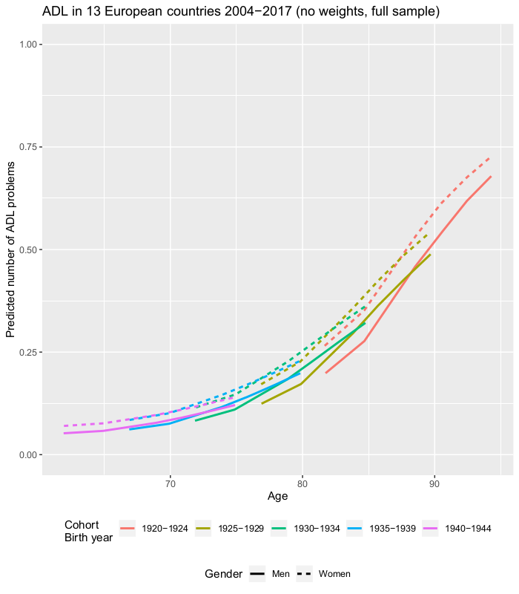

Supplementary figure 2. IADL No weights

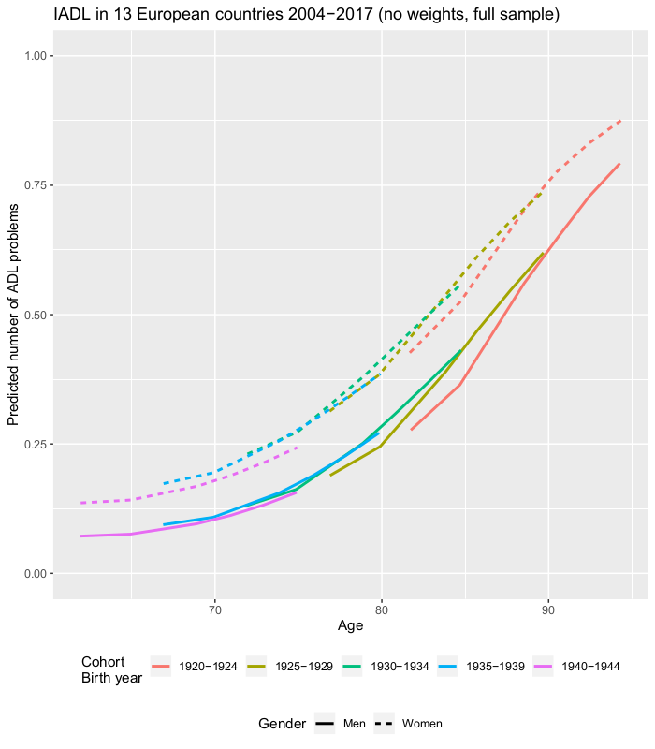

Supplementary figure 3. ADL No weights

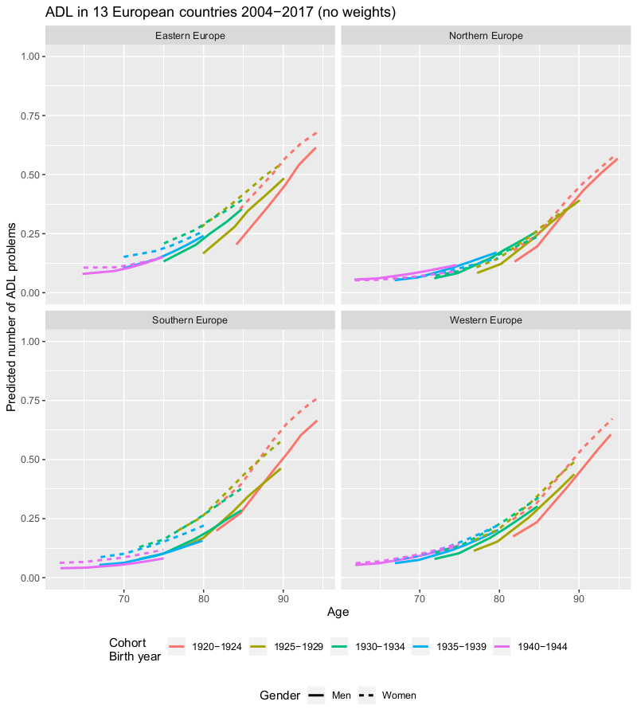

Supplementary figure 4. IADL No weights

