# Preliminary results: ADL and cohort trajectories

## Aim

The aim of this study is to describe how gender differences functional status in old age differ by country and across subsequent birth cohorts within countries.

## Method

The data consist of repeated observations for individuals that participated in SHARE wave 1 (2004) or wave 2 (2007) and at least one subsequent wave. We fit multilevel growth curve models that predict the level of ADL in wave 1 or wave 2 and the subsequent change in frailty up to wave 7 (2004–2017) dependent on five-year cohorts. Multilevel modelling can handle missing values that the unbalanced panel data in this study consist of. This methodology has previously been used in studies that examine cohort trajectories of frailty (Marshall et al., 2015; Rogers et al., 2017).

Level 1 model

ADLti = β0i + β1waveti + β2wave2ti + eti (1)

Level 2 model: intercept

β0i = γ00 + γ01 cohort + γ01 gender + γ02 cohort gender + (2)  
γ03 wave gender + γ04 wave cohort + γ05 cohort2 + u0i

Level 2 model: slope

β1i = γ00 + γ11 cohort + γ11 gender + γ12 cohort gender + (3)  
γ13 wave gender + γ14 wave cohort + γ15 cohort2 + u0i

The model above first specifies the level 1 model that predicts ADL for each individual (i) at each observed time unit (t). The time measurement in this study was the wave that the individual was observed in (from 1 to 7). We included a quadratic wave term to allow the ADL trajectories to be non-linear. In equation 1, the intercept β0i gives the mean ADL of person i in wave 1 or wave 2 while β1i and β2i give the linear and quadratic growth of ADL over time for individual i. In equation 2 and 3 the intercept and slope for each individual is defined. The inclusion of cohort and gender enables the modelling of the intercept and the slope separately for each cohort and gender. Moreover, an interaction term was included between gender and cohort, and between wave and cohort to allow for different trajectories across waves and between genders.

From these models average marginal effects (AMEs) were predicted for each cohort across waves and by gender. In the final step, wave was transformed into the average age of each cohort at each given observation.

## Results

Figure 1 shows the predicted number of ADL problems across age for each cohort and for each gender. In all cohorts, women have higher ADL problems than men. At each age, older cohorts have lower levels of ADL problems compared to younger cohorts.

In Figure 2 the same numbers are plotted split by region. ADL problems increases to a higher degree in older cohorts in Southern Europe. Gender differences in ADL problems are more pronounced in Eastern European countries and in Southern European countries compared to Northern Europe and Western Europe.

Figure 3 shows the same numbers for each included country.

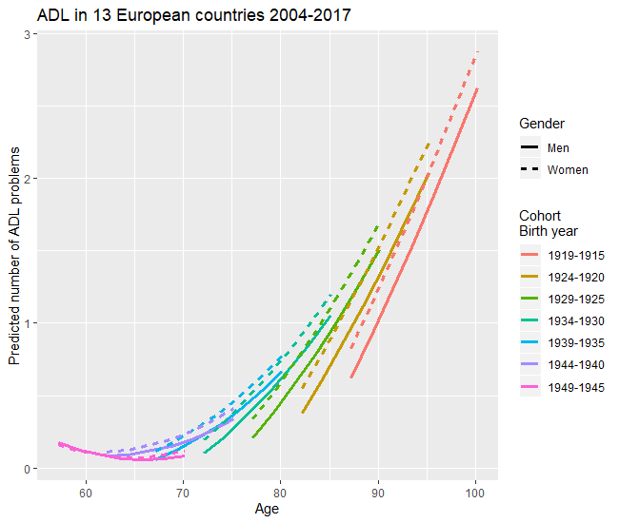

**Figure 1.** ADL in 13 European countries, 2004 – 2017. Pooled data.

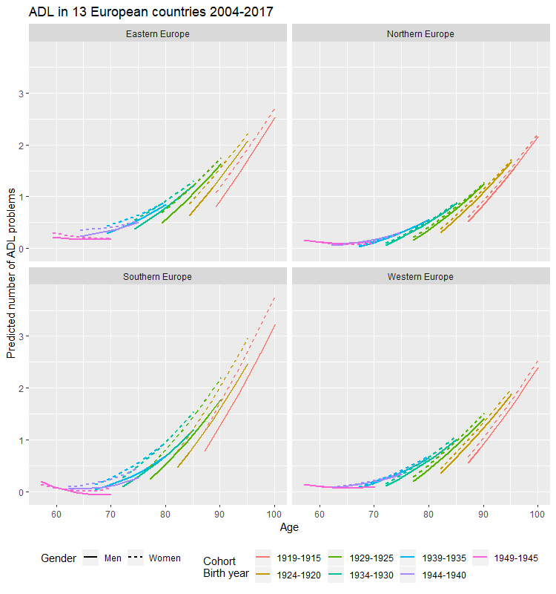

**Figure 2.** ADL in 13 European countries, 2004 – 2017. Grouped by region.

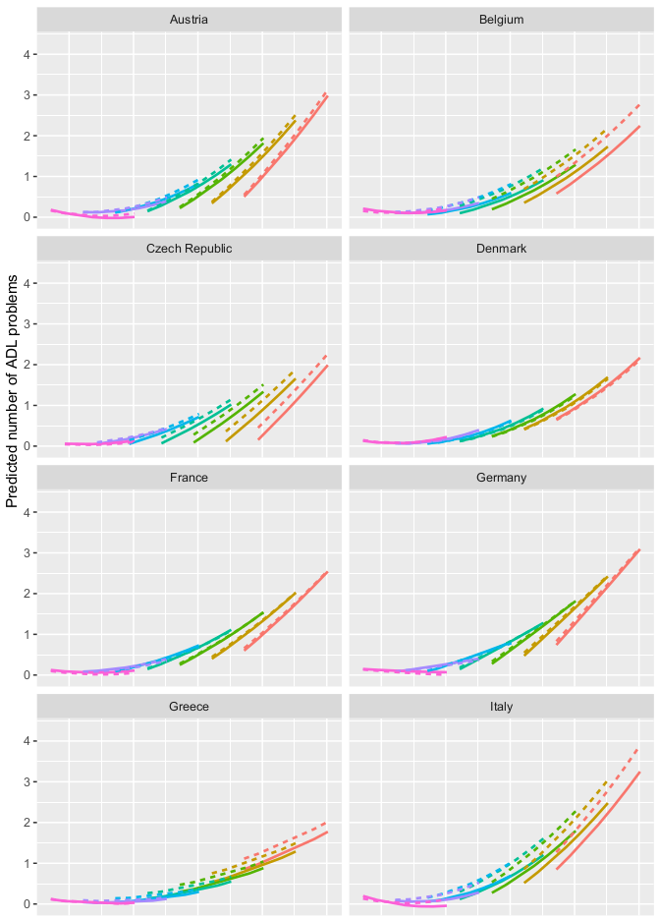

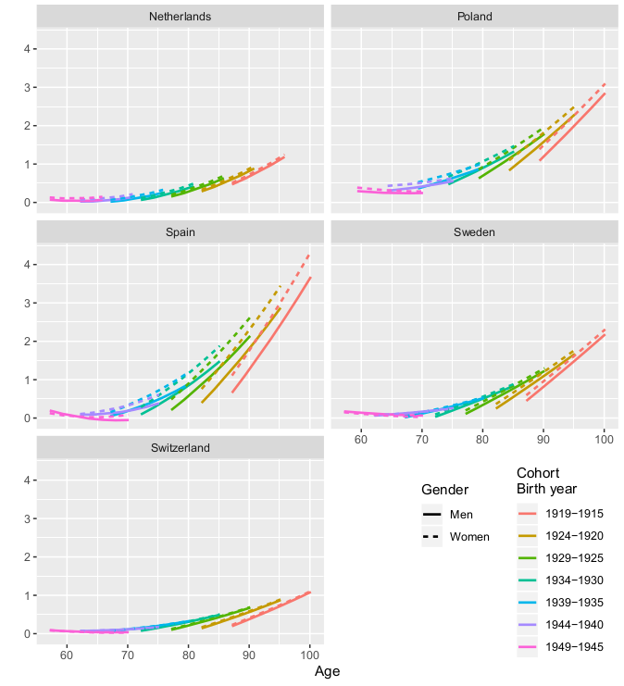

**Figure 3**. ADL in 13 European countries, 2004 – 2017.